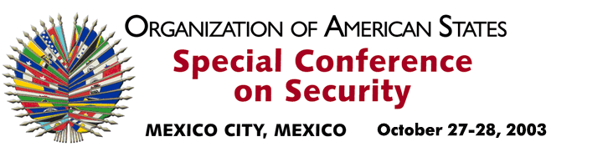

OEA/Ser.K/XXXVIII
CES/doc.1/03 add. 1 rev. 1
8 October 2003
Original: Spanish

input.doc
The Secretariat of the Permanent Council presents its compliments to the Permanent Observers and is pleased to inform that the General Assembly convened the Special Conference on Security to be held on October 27 and 28, 2003, in Mexico City, Mexico, and to request that credentials be sent to the General Secretariat by October 15, 2003.

