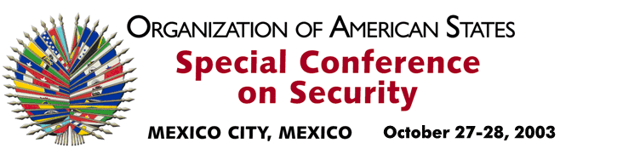

OEA/Ser.K/XXXVIII
CES/INF.4/03
27 October 2003
Original: English

STATEMENT BY COL. TREVOR THOMAS
HEAD OF DELEGATION OF ANTIGUA AND BARBUDA

http://scm.oas.org/pdfs/2003/CE00299e.pdf

input.doc

