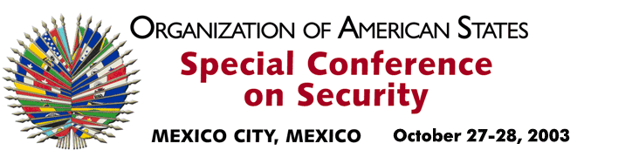

OEA/Ser. K/XXXVIII
CES/INF. 11/03
28 October 2003
Original: English

REMARKS BY HIS EXCELLENCY MARC GROSSMAN
UNDER SECRETARY FOR POLITICAL AFFAIRS
OF THE STATE DEPARTMENT OF THE UNITED STATES
http://scm.oas.org/pdfs/2003/ce00314e.pdf

input.doc

