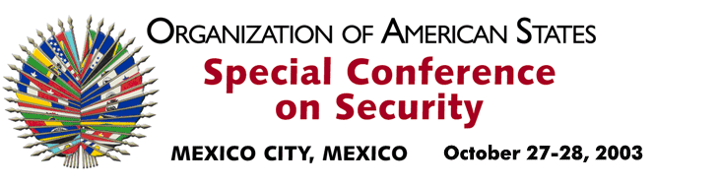

OEA/Ser.K/XXXVIII
CES/INF. 24/03
28 October 2003
Original : English

ADDRESS BY DOCTOR TIMOTHY HARRIS
MINISTER OF FOREIGN AFFAIRS OF SAINT KITTS AND NEVIS

http://scm.oas.org/pdfs/2003/ce00332e.pdf

input.doc

