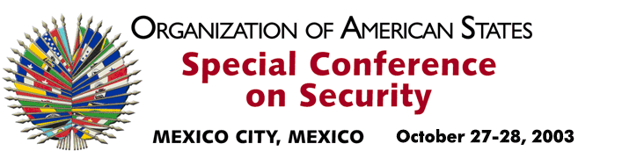

OEA/Ser.K/XXXVIII
CES/CG/ACTA 2/03
28 October 2003
Original: Spanish

GENERAL COMMITTEE

SUMMARY MINUTES OF THE SECOND MEETING

Date: October 28, 2003
Time: 9:00 a.m.
Place: Sala Magna

Chair: Ambassador Miguel Ruíz Cabañas
Permanent Representative of Mexico to the OAS

Present: Jorge Valero Venezuela
Ann-Marie Layne-Campbell Antigua and Barbuda
Martín Gómez Bustillo Argentina
Valter Pecly Moreira Brazil
Gwyneth Kutz Canada
Luis Winter Chile
Horacio Serpa Uribe Colombia
Marcelo Hervas Ecuador
Margarita Escobar El Salvador
Eli Sugarman United States
Juan José Narciso Guatemala
Jean Ricot Dorméus Haiti
Salvador Rodezno Honduras
Juan Manuel Gómez Robledo Mexico
Miriam Vásquez Nicaragua
Juan Manuel Castulovich Panama
Luis Enrique Chase Plate Paraguay
Eduardo Ferrero Costa Peru
José Elías Ramírez Dominican Republic
Kevin M. Isaac Kitts and Nevis
Jeanelle van Glaanenweygel Suriname
Jennifer Marchand Trinidad and Tobago
Juan Enrique Fischer Uruguay
The General Committee held its second meeting on Tuesday, October 28, 2003 to consider the topics listed in the order of business, CES/OD-2/03.

1. Draft Declaration of the Special Conference on Security, “The Situation in Colombia.”

The delegation of Colombia presented a revised version based on informal consultations with the delegations. The draft declaration was approved by acclamation.

2. Additional paragraph to be included in the draft Final Act (proposal presented by the delegation of Peru)

The General Committee approved, with some changes to the text, the proposal to include in the Final Act of the Special Conference on Security a new paragraph on follow-up to the draft Declaration.
input.doc

There being no further business to consider, the meeting came to a close at 12:00 p.m.

