
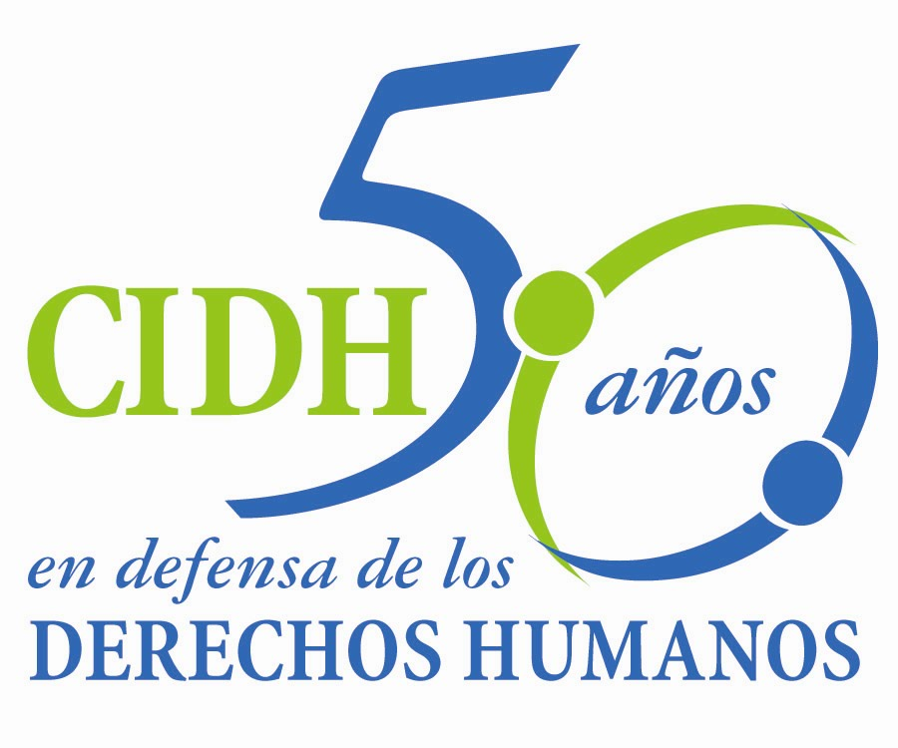
INTER - AMERICAN COMMISSION ON HUMAN RIGHTS
COMISION INTERAMERICANA DE DERECHOS HUMANOS
COMISSÃO INTERAMERICANA DE DIREITOS HUMANOS
COMMISSION INTERAMÉRICAINE DES DROITS DE L'HOMME

ORGANIZATION OF AMERICAN STATES

WASHINGTON, D.C. 2 0 0 0 6 USA

July 8, 2013

Ref.: Case No. 10.932 Santa Barbara Campesino Community

Peru

Mr. Secretary:

I have the pleasure of writing on behalf of the Inter-American Commission on Human Rights to submit to the jurisdiction of the Inter-American Court of Human Rights Case 10.932, Santa Barbara Campesino Community v. Peru (hereinafter “the State”, “the Peruvian state” or “Peru”), which concerns the forced disappearance of 15 individuals, most of whom belonged to two families and to include it seven children between the ages of eight months and seven years. These acts were committed by members of the Peruvian Army on July 4, 1991, in the community of Santa Barbara, Huancavelica Province.

Despite the fact that the criminal responsibility of the military personnel charged was suitably established in the course of the investigation conducted by the judicial authorities and that even the military justice system found six members of the military to be responsible for the alleged offenses, on January 14, 1997, the Supreme Court applied Amnesty Law 26479. Although the criminal proceeding was reopened in 2005, a final judgment has not been handed down on the perpetrators. As a result, the events remain unpunished.

The State ratified the American Convention on Human Rights on July 12, 1978, and acceded to the contentious jurisdiction of the Court on January 21, 1981. Accordingly, the facts under discussion in the case are within the Court's temporal jurisdiction. Furthermore, the State of Peru ratified the Inter-American Convention to Prevent and Punish Torture on February 27, 1990, and the Inter-American Convention on Forced Disappearance of Persons, on February 8, 2002.

Mr.
Pablo Saavedra Alessandri, Secretary
Inter-American Court of Human Rights
Apartado 6906-1000
San José, Costa Rica

Appendix

The Commission has designated Commissioner José de Jesús Orozco Henríquez and the Executive Secretary of the IACHR, Emilio Álvarez Icaza, as its delegates. Elizabeth Abi-Mershed, Assistant Executive Secretary; Silvia Serrano Guzmán, and Nerea Aparicio will serve as legal advisors.

In keeping with Article 35 of the Rules of Procedure of the Inter-American Court, the Commission encloses a copy of Report on Admissibility and Merits No. 77/11 and its annexes, prepared in accordance with Article 50 of the Convention, together with a copy of the complete record of the case before the Inter-American Commission (Appendix I) and the documents used in the preparation of the above report (Annexes). The State was informed of the report by means of a note dated August 8, 2011. In a communication dated October 7, 2011, the State of Peru requested the IACHR to grant it an extension of two months to implement the recommendations adopted by the Commission. On November 8, 2011, the Commission decided to grant the two-month extension requested by the State. The Commission has since granted six additional extensions to the State. The Commission also held a working meeting with the parties at its 147th regular session. On June 19, 2013, the State of Peru requested another extension to enable it to implement the recommendations. The Inter-American commission decided not to grant the extension but to submit the case to the Inter-American Court for lack of meaningful progress on the recommendations.

As to the recommendation to provide adequate reparation for the human rights violations found in the report in material and moral respects, elucidation and circulation of the historical truth of the events, remembrance of the disappeared victims, and implementation of an adequate program of psychosocial care for the next-of-kin of the disappeared victims, the State has informed the Commission that it is implementing that recommendation under the Comprehensive Reparations Plan (PIR for the Spanish) and the Consolidated Victims Register (RUV for the Spanish), which includes 15 of the 28 victims. The State added that two of the victims are not listed in the register and that the authorities are looking into that situation. It also mentioned that the Community of Santa Barbara has been recognized as a collective victim and, in that regard, benefited in 2007 from the award of an amount of money for the execution of a “large livestock module” project. However, the State has offered no concrete information about reparation measures ordered in favor of the individuals inscribed in the RUV, or specified precisely what measures have been adopted with regard to the other two victims. According to the information available, the victim's next of kin have not yet received the reparations recommended by the IACHR based on the criteria established in the report.

As to the recommendation to establish a mechanism that, to the extent possible, enables complete identification of the disappeared victims and the return of the mortal remains of those victims to their families, the state initially informed that budgetary constraints were hampering progress with the DNA tests. Later, it said that a number of victims had been identified. In its last report the State mentioned that it had taken certain budgetary measures to enable the process to continue. However, as yet, no concrete measures have been initiated toward the identification of all of the victims.

Regarding the recommendation to carry out and conclude, as appropriate, the domestic proceedings connected with the human rights violations found ... in order to completely clarify the events, identify the architects and material authors, and impose the appropriate penalties, the State submitted information on number of processes connected with the facts in the case. The information available does not suggest that meaningful progress has been made in the processes of identification and punishment of those who perpetrated and planned crimes. The judgments that have been issued do not cover all the suspected perpetrators, neither are they final.

With respect to the recommendations concerning strengthening the capacity of the judiciary to investigate the facts and punish those responsible; as well as measures to prevent any such events from occurring in the future, including implementing permanent education programs on human rights and international humanitarian law in the training schools of the armed forces, the State said that it had imparted multiple training courses on human rights to members of the armed forces. The State also provided information on a number of cooperation agreements between the Ministry of Defense and the Ombudsman and other civil society actors for implementing that recommendation. However, the Commission has no specific information regarding the effective implementation of a permanent course or about the component for strengthening the judiciary recommended in the report on merits of the IACHR.

Finally, the State did not offer any information about its compliance with the recommendation concerning the adoption of administrative measures against those public officials found to bear responsibility for the violations found in the report, including any judicial officers who failed to properly discharge their duties.

Considering that, to date, the State has had seven extensions and that the report on admissibility and merits was adopted two years ago, the Commission has decided to submit this case to the Inter-American Court because of the need to obtain justice for the victims and the lack of meaningful progress in implementing the recommendations.

Based on the foregoing, the IACHR requests that the Court find and declare the Peruvian State responsible for violation of:

  - The rights to personal liberty, humane treatment, life and juridical personality in accordance with Articles 7, 5, 4, and 3 of the American Convention, in conjunction with Article 1(1) of said instrument, to the detriment of the adults Francisco Hilario Torres; his wife, Dionicia Quispe Malqui; their daughters, Antonia and Magdalena Hilario Quispe; and their daughter-in-law, Mercedes Carhuapoma de la Cruz; Ramón Hilario Morán and his wife Dionicia Guillén; and Elihoref Huamaní Vergara; as well as the children: Yessenia, Miriam and Edith Osnayo Hilario; Wilmer Hilario Carhuapoma; Alex Jorge Hilario; and the brothers Raúl and Héctor Hilario Guillén;

  - the rights of the child in accordance with Article 19 of the American Convention, in conjunction with Article 1(1) thereof, to the detriment of the children: Yessenia, Miriam and Edith Osnayo Hilario; Wilmer Hilario Carhuapoma; Alex Jorge Hilario; and the brothers Raúl and Héctor Hilario Guillén;

  - the rights of the family recognized in Article 17 of the American Convention, in conjunction with Article 1(1) thereof, to the detriment of the disappeared persons: Dionicia Quispe Malqui; her daughters, Antonia and Magdalena Hilario Quispe; and her daughter-in-law, Mercedes Carhuapoma de la Cruz; Ramón Hilario Morán and his wife, Dionicia Guillén; and Elihoref Huamaní Vergara, as well as the children: Yessenia, Miriam and Edith Osnayo Hilario; Wilmer Hilario Carhuapoma, Alex Jorge Hilario, and the brothers Raúl and Héctor Hilario Guillén; and their next-of-kin: Zósimo Hilario Quispe, Marcelo Hilario Quispe, Gregorio Hilario Quispe, Zenón Cirilo Osnayo Tunque, Víctor Carhuapoma de la Cruz, Ana de la Cruz Carhuapoma, Viviano Hilario Mancha, Dolores Morán Paucar, Justiniano Guillén Ccanto, Victoria Riveros, Marino Huamaní Vergara, and Alejandro Huamaní Robles;

  - the right to a fair trial and judicial protection recognized in Articles 8 and 25 of the American Convention, taken in conjunction with Article 1(1) thereof, Article 1 of the Inter-American Convention on Forced Disappearance of Persons, and Articles 6 and 8 of the Inter-American Convention to Prevent and Punish Torture, to the detriment of the disappeared persons and their next-of-kin;

  - Articles 8(1) and 25 of the American Convention in connection with the provisions set forth in Articles 1(1) and 2 thereof and in Article III of the Inter-American Convention on Forced Disappearance of Persons, to the detriment of the victims and their next-of-kin.

  - The right to humane treatment of the victims’ next-of-kin recognized in Article 5 of the American Convention, in connection with Article 1(1) of that instrument.

The Commission believes it necessary in the instant case for the Inter-American Court to order the following reparation measures:

- Provide adequate reparation for the human rights violations found in the instant report in material as well as moral respects that take into account the special condition of the seven child victims in the case, including fair compensation, elucidation and circulation of the historical truth of the events, remembrance of the disappeared victims, and implementation of an adequate program of psychosocial care for the next-of-kin of the disappeared victims.

- Establish a mechanism that, to the extent possible, enables complete identification of the disappeared victims and the return of the mortal remains of those victims to their families.

- Carry out and conclude, as appropriate, the domestic proceedings connected with the human rights violations found in the instant report and pursue the investigations in an impartial and effective manner within a reasonable time in order to completely clarify the events, identify the architects and material authors, and impose the appropriate penalties.

- Strengthen the capacity of the judiciary to adequately and efficiently investigate the facts and punish those responsible, including through provision of the necessary material and technical resources to ensure the correct conduct of proceedings.

- Adopt such measures as may be necessary to prevent any such events from occurring in the future, in keeping with the duty to protect and ensure the human rights recognized in the American Convention. In particular, implement permanent education programs on human rights and international humanitarian law in the training schools of the armed forces.

- Take administrative measures against those public officials found to have been involved in the commission of the violations found in this report, including any judges or magistrates who failed to properly discharge their duty to protect fundamental rights.

Aside from the need for the victims to obtain justice, the Commission considers that the case concerns questions regarding the inter-American public order of human rights in relation to the duty of the State to carry out diligent investigations in the case of forced disappearance of persons–particularly where the disappearance of children is concerned–in a context of systematic disappearances within the framework of internal armed conflicts in which amnesty laws have been applied. In particular, it should be underscored that the duty to investigate and punish those responsible is especially acute since several of the victims were children. The case will also offer an opportunity for close examination of international standards on forensic methods for the identification of human remains.

Since these matters affect in a significant manner the inter-American public order of human rights, pursuant to Article 35.1(f) of the Rules of Procedure of the Inter-American Court, the Commission wishes to offer declarations by the following three experts:

1. An expert, whose name will soon be disclosed, who will refer to the international standards applicable to investigations in connection with the crime of forced disappearance of persons–with a particular emphasis on the disappearance children–in a context of systematic disappearances within the framework of internal armed conflicts in which amnesty laws have been applied.

2. An expert, whose name will soon be disclosed, who will refer to the international standards on forensic methods for the identification of victims, particularly in situations where the passage of time gives rise to particular complexities.

3. An expert, whose name will soon be disclosed, who will refer to issues of transitional justice from a comparative perspective, in relation to reparations awarded by different national institutions and international agencies.

The Commission will submit the curriculum vitae of the experts together with the annexes to Report 77/11.

Finally, the Commission would like to inform the Inter-American Court that the petitioners before the IACHR are Asociación Paz y Esperanza and the Center for Justice and International Law (CEJIL). Their contact data are:

CEJIL/WASHINGTON
Xxxxxxxxxxxxxxxxxxxxx
xxxxxxxxxxxxxxxxxxxxxxxxxxxxxxxxxx
xxxxxxxxxxxxxxxxxxxxxxxxx
xxxxxxxxxxxxxxxxxxxxxxxxxxxxxx
xxxxxxxxxxxxxxxxxxxxxxxxxxxxxxxx
xxxxxxxxxxxxxxxxxxxxxxxxxxxxxxxxx

I would like to take this opportunity to convey my very highest regards.

Sincerely,

Signed in the original
Emilio Álvarez Icaza L.
Executive Secretary

See recommendation g) of the Report of the Peruvian Truth and Reconciliation Commission. Volume IX Part Four: Recommendations of the CVR: Toward a National Commitment to Reconciliation.

