
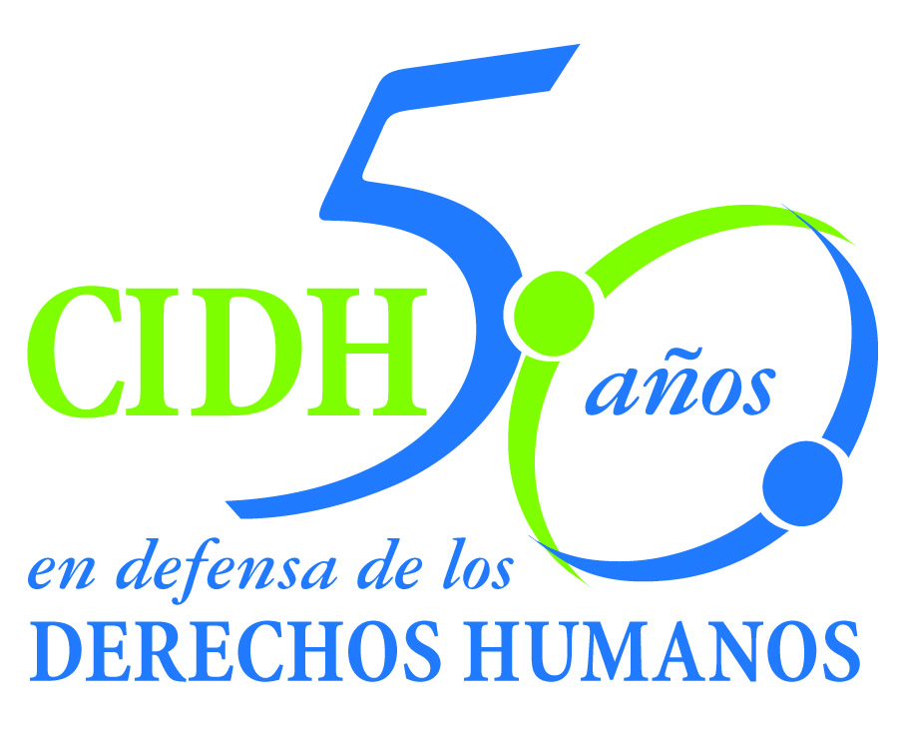
INTER - AMERICAN COMMISSION ON HUMAN RIGHTS
COMISION INTERAMERICANA DE DERECHOS HUMANOS
COMISSÃO INTERAMERICANA DE DIREITOS HUMANOS
COMMISSION INTERAMÉRICAINE DES DROITS DE L'HOMME

ORGANIZACIÓN DE LOS ESTADOS AMERICANOS
WASHINGTON, D.C. 2 0 0 0 6 EEUU

November 23, 2013
Ref.: Case No. 11.576
García Ibarra y familia
Ecuador

Mr. Secretary:

I am pleased to address you on behalf of the Inter-American Commission on Human Rights in order to file Case No. 11.576 García Ibarra and family v. Ecuador (hereinafter “the State”, “the Ecuadorian State” or “Ecuador”) before the jurisdiction of the Honorable Inter-American Court of Human Rights regarding to the extrajudicial execution of the child Jose Luis Garcia Ibarra on September 15, 1992, at the age of 16, by a member of the National Police, who was in charge of the Provincial Command of the National Police No. 14 of the city of Esmeraldas. The child García Ibarra was in a public place with a group of friends when the member of the police approached and had a fight with a teenager that was in the site. During that fight, the member of the police shut the gun to the detriment of Jose Luis Garcia Ibarra, who died immediately. The Commission concluded that this fact constituted an arbitrary deprivation of life, especially aggravated by being a teenager.

Despite the severity of the facts, after nine years of the event, the investigation and the criminal proceeding ended with a condemnatory judgment for non-intentional homicide, with 18 months of prison. The process that ended with these results failed to comply with the minimum standards that the jurisprudence of the Inter-American system has established in matter of justice in this type of facts. For example, the initial stage of the investigations focuses on resolving a conflict of competence between the police courts and the ordinary courts. The delay of more than nine months did not obey to the practice of diligences but to the negligence and inactivity of the domestic authorities. At no time during the investigation, not at the initial stage or subsequently, the minimum diligences was done which are considered by the international standards in matter of extrajudicial executions as fundamental elements to clarify an “accidental homicide” or of “encounter”. Specifically, the investigation authorities omitted to practice the testing of the ballistic trajectory and other technique expertise that could clarified the facts. Even the Supreme Court of Justice recognized the existence of certain irregularities; despite that did not adopted any measure to correct them. Summarizing, the execution of Jose Luis Garcia Ibarra is on partial impunity and his family does not count the judicial clarification of the event.

Mr.
Pablo Saavedra Alessandri, Secretario
Inter-American Court on Human Rights
Apartado 6906-1000
San José, Costa Rica

Ecuador ratified the American Convention on December 28, 1977, and accepted the contentious jurisdiction of the Court on July 24, 1984.

The Commission has designated Commissioner José de Jesús Orozco Henríquez and Emilio Álvarez Icaza L., Executive Secretary, as its delegate. Likewise, Elizabeth Abi-Mershed, Deputy Executive Secretary, Silvia Serrano Guzmán, attorney of the Executive Secretariat of the IACHR, have been designated to serve as legal advisors.

In accordance with Article 35 of the Rules of Procedure of the Inter-American Court, the Commission is enclosing a copy of Merits Report No. 33/13, prepared in compliance with Article 50 of the American Convention, as well as a copy of the entire file before the Inter-American Commission (Appendix I.) and the attachments used to prepare the Report on the Merits (Attachment). The Commission adopted its Report on the Merits No. 33/13 on August 23, 2013 and transmitted to the State on August 23, 2013, granting it two months to provide information on the measures adopted in compliance with the recommendations. The State did not respond to the requirement of the Commission.

The Commission submits this case to the jurisdiction of the Court because of the need to obtain justice for the victims of this case and in view of the failure of the State to fulfill the Commission’s recommendations.

According to the above mention, the Commission request to the Court to conclude the international responsibility of the State of Ecuador for:

- Violation of the right to life and the child’s right to special protection, established in articles 5 and 19 of the American Convention, read in conjunction with Article 1(1) thereof, to the detriment of José Luis García Ibarra.

- Violation of the rights to humane treatment, judicial guarantees and judicial protection, recognized in articles 5, 8 and 25 of the American Convention, read in conjunction with Article 1(1) thereof, to the detriment of Pura Vicenta Ibarra Ponce (mother), Alfonso Alfredo García Macias (father), and the victim’s siblings Luis Alfonso, Santo Gonzalo, Ana Lucía, Lorena Monserrate, Alfredo Vicente and Juan Carlos García Ibarra.

In consequence the IACHR recommended the State of Ecuador to:

- Conduct a thorough and effective investigation of the human rights violations established in this report.

- Make adequate material and moral reparations for the human rights violations established herein.

- Order measures of non-repetition that include the following: i) training programs for the National Police in international human rights standards in general, and with respect to children and adolescents in particular; ii) measures to ensure effective accountability in the criminal, disciplinary or administrative jurisdictions, in cases of alleged abuse of power by state law-enforcement agents; and iii) legislative, administrative or other measures to investigate, with the necessary due diligence and in keeping with relevant international standards, the necessity and proportionality of the lethal use of force by police officers, so that there are effective protocols in place by which to implement proper mechanisms to monitor the conduct of police officers and hold them accountable for their actions.

Apart from the need to obtain justice, the Commission considers the case presents issues of public Inter-American order.

Specifically, the instant case will allow to the Inter-American Court to pronounce about the problematic of the extrajudicial executions favored by the social stigmatization of teenagers of low income as possible criminals. In the Case Servellon Garcia and Others v. Honduras, the Inter-American Court pronounced in general terms of this situation and the Commission considers that the instant case offers elements that allow deepening in a matter of mayor relevance and actuality to the continent. The instant case constitutes a manifestation of a lack of control and mechanisms of accountability in the interior of the police institutions, specifically when new “anti-gangs” units are created with the objective to confront a specific sector of the population that, under the American Convention is subject of a special protection.

Moreover, the case presents fundamental aspects about how a State should respond, in terms of justice, to a severe fact of an extrajudicial execution of a teenager by a police designated to protect the population. This case presents the particularity of having a condemnatory judgment for the crime of “non intentional homicide”. The reasons why it has been considered by the Commission as a source of impunity, transcends the family of the victim and affects the inter-American public order in a context of necessary strengthening of the inter-American standards in matter of justice of severe violations of human rights, such as the extrajudicial executions. The Commission considers of the inter-American public order that the Courts takes again its jurisprudence about the minimum components that an investigation of the death of a person should have, specially when a police is responsible of the death of a child. Taking in count the existence of one version of “accidental homicide” or “of encounter”, the Court has the opportunity to establish the minimum obligations that this type of versions impose to the authorities in charge of an investigation of this nature in order to ensure, through all the possible ways, a clarification of the events and, consequently, a proportional punishment.

Considering that this matter affects significantly the Inter-American public order, according to the article 35.1 f) of the Rules of the Inter-American Court, the Commission would also like to offer the two following expert’s statements:

A person whose name will be informed shortly, who will refer to the obligations that imposes the international law on human Rights in matter of special protection to children and teenagers, in the frame of the exercise of the police functions, when the States formulates policies to respond to problematic such as the functioning of gangs. The expert will refer to the standards in matter of prevention of abuses, including arbitrary privations of life, by the state security personnel in the frame of security policies that might have a specific impact in children and teenagers.

A person whose name will be informed shortly, who will refer to the International standards in matter of access to justice in cases of extrajudicial executions. Taking in count the high incidence of this type of investigations of versions of “encounters” or “accidental death” in this type of investigations, the expert will offer to the Court a perspective about the minimum diligences that should be realize to overcome the obstacles that these versions could have in the clarification of the truth and obtaining justice to the family of the victim.

The expert’s CV will be included in the Merits Report 33/13.

Finally, the petitioners expressed the victims’ interest in the submission of the present case to the Inter-American Court and informed that the following shall be representatives of the victims:

Comisión Ecuménica de Derechos Humanos
xxxxxxxxxxxxxxxxxxxxxxxxxxxxxxxxxx
xxxxxxxxxxxxxxxxxxxxx
Quito, Ecuador
xxxxxxxxxxxxxxxxxxxxxxxxxxxxxxxxxxx
xxxxxxxxxxxxxxxxxxxxxxxxx
xxxxxxxxxxxxxxxxxxxx

Signed in the original

Elizabeth Abi-Mershed
Deputy Executive Secretary

