
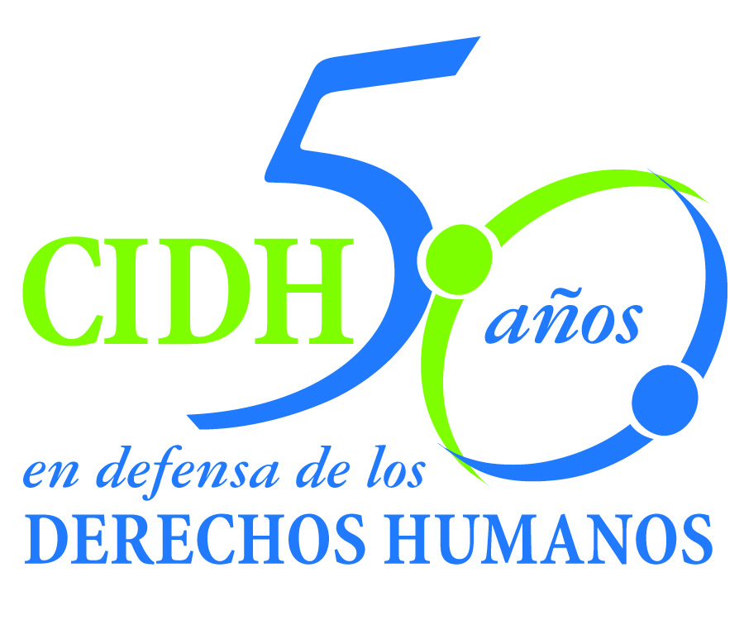
INTER - AMERICAN COMMISSION ON HUMAN RIGHTS
COMISION INTERAMERICANA DE DERECHOS HUMANOS
COMISSÃO INTERAMERICANA DE DIREITOS HUMANOS
COMMISSION INTERAMÉRICAINE DES DROITS DE L'HOMME

ORGANIZACIÓN DE LOS ESTADOS AMERICANOS
WASHINGTON, D.C. 2 0 0 0 6 EEUU

June 3, 2013
Ref.: Case No. 11.581
Tarazona Arrieta y otros
Peru

Mr. Secretary:

I am pleased to address you on behalf of the Inter-American Commission on Human Rights in order to file Case No. 11.581 Tarazona Arrieta et al. v. Peru (hereinafter “the State”, “the Peruvian State” or “Peru”) before the jurisdiction of the Honorable Inter-American Court of Human Rights regarding the murder of Zulema Tarazona Arrieta and Norma Teresa Pérez Chávez, and the injuries suffered by Mr. Luis Alberto Bejarano Laura, by members of the Peruvian Army in an incident on August 9, 1994 as a result of the shooting by a member of the Army against a public transport vehicle in which the victims were travelling. These events occurred in the context of an action by members of the Armed Forces to intercept the transport vehicle. After the shooting, the security officials left the scene without rendering assistance to the victims and without informing their superior about what happened. The Commission found that these facts constituted an arbitrary deprivation of life of the two victims who were killed, and a violation of the right to humane treatment to the detriment of the person injured.

Notwithstanding the foregoing, due to the fact that before the merits report was made it was noted the existence of a firm conviction by the judicial authorities in which it was established the relevant responsibilities and the payment of compensation for the families of Zulema Tarazona Arrieta, Norma Teresa Pérez Chávez, and Luis Alberto Bejarano Laura, the Commission stated that the violation was partially repaired.

Also, the case involves violations of the judicial guarantees and judicial protection in the criminal investigation and process for the facts of the case, and the situation of impunity in which the facts were kept for an unreasonable time due, among other things, the lack of due diligence in the initial stages of the military criminal jurisdiction, the effectiveness of Law 26,479 (Amnesty Law) and the delay in the reopening of the investigation. These aspects of the case were not subject of any compensation from the State.

Mr.
Pablo Saavedra Alessandri, Secretario
Inter-American Court on Human Rights
Apartado 6906-1000
San José, Costa Rica

Peru ratified to the American Convention on July 28, 1978, and accepted the contentious jurisdiction of the Court on January 21, 1981.

The Commission has designated Commissioner José de Jesús Orozco Henríquez and Emilio Álvarez Icaza L., Executive Secretary, as its delegate. Likewise, Elizabeth Abi-Mershed, Deputy Executive Secretary, Silvia Serrano Guzmán and Nerea Aparicio, attorneys of the Executive Secretariat of the IACHR, have been designated to serve as legal advisors.

In accordance with Article 35 of the Rules of Procedure of the Inter-American Court, the Commission is enclosing a copy of Merits Report No. 77/12, prepared in compliance with Article 50 of the American Convention, as well as a copy of the entire file before the Inter-American Commission (Appendix I.) and the attachments used to prepare the Report on the Merits (Attachment). The Commission adopted its Report on the Merits No. 77/12 on November 8, 2012 and transmitted to the State on December 3, 2012, granting it two months to provide information on the measures adopted in compliance with the recommendations.

The State of Peru requested a 3 month extension period as provided in article 51 of the American Convention, and expressly waived to file preliminary exceptions, in relation to such period, in the eventual submission of the case to the Inter-American Court. The Commission requested to the State to present a report on May 20, 2013, regarding the progress on the fulfillment of the recommendations. That day, the State submitted a report indicating that the recommendation to compensate the relatives of the victims for the violations of the right of judicial guarantees and judicial protection was non-viable. In the arguments of the State, the State said that there was no violation of the guarantee of a reasonable time insofar as the Commission had made a mistake counting the time during which the amnesty law was in effect.

The Peruvian State submitted information regarding some progress in the fulfillment of the remaining two recommendations. However, and with the express refusal of the State to explore a mechanism to comply with the recommendation to repair the denial of justice for a long period of time and in connection with the absence of a new request of extension, the Commission decided to submit the case to the jurisdiction of the Court by the need to obtain justice for the victims.

The Commission submits to the jurisdiction of the Court all the facts and violation of Human Rights described on the Merits Report 77/12. According to the above mention, the Commission request to the Court to conclude the international responsibility of the State of Ecuador for:

- Violating the right to life enshrined in Article 4.1 of the American Convention, in conjunction with Article 1.1 thereof, with respect to Zulema Tarazona Arrieta and Norma Pérez Chávez. The Commission believes that since the competent courts convicted the perpetrator and enforced the payment of moral compensation to the families of the deceased victims, the violation was remedied in part.

- Violating the right to humane treatment enshrined in Article 5.1 of the American Convention, in conjunction with Article 1.1 thereof, with respect to Luis Alberto Bejarano Laura. The Commission believes that since the competent courts convicted the perpetrator of the victim’s injuries and enforced the payment of moral compensation to the victim, the violation was remedied in part.

- Violating the right to a fair trial and to judicial protection enshrined in Articles 8 and 25 of the American Convention, in conjunction with Articles 1.1 and 2 thereof, with respect to the next-of-kin of Zulema Tarazona Arrieta and of Norma Pérez Chávez, and with respect to Alberto Bejarano Laura.

- Violating the right to humane treatment enshrined in Article 5.1 of the American Convention, in conjunction with Article 1.1 thereof, with respect to the next-of-kin of Zulema Tarazona Arrieta and of Norma Pérez Chávez, and with respect to Alberto Bejarano Laura.

In consideration of the foregoing conclusions, the Commission requests to the Court to recommend that the State:

  - Make appropriate amends for the human rights violations established in this report, with fair compensation for the 14-year delay in the judicial proceedings, to the next-of-kin of Zulema Tarazona Arrieta and Norma Pérez Chávez, and to Luis Alberto Bejarano Laura.

  - Strengthen its ability to conduce timely and duly diligent investigations of incidents in which members of the armed forces use lethal force.

  - Take the necessary steps to prevent similar events from occurring in the future, in accordance with the duty of prevention and the obligation of guaranteeing the fundamental rights recognized in the American Convention; in particular, through the implementation of human rights programs in its armed forces training schools.

The Commission submits the instant case to the jurisdiction of the Inter-American Court out of the need to obtain justice for the victims. In addition, the IACHR notes that the instant case involves issues of Inter-American public order.

Specifically, the case addresses the application of the standards developed in the jurisprudence of the bodies of the Inter-American System on the use of force by security officers and the response that must be given by the States to provide a satisfactory explanation of the facts. Moreover, in terms of justice, the case poses a series of impunity factors, both general and specific, that include the lack of due diligence, the intervention of the military jurisdiction, the validity of an Amnesty Law and excessive delays, of which the elimination of its effects, could have an impact in the case. These factors of impunity are related to the concepts of justice and opportune reparation to which the bodies of the system have given special relevance in the development of its jurisprudence.

Inasmuch as these issues significantly affect Inter-American public order, pursuant to Article 35.1 f) of the Rules of Procedure of the Inter-American Court, the Commission proffers the following expert testimony:

1. A person whose name will be informed shortly, who shall testify on the International standards on the use of force, in particular, on the criteria for the necessity, proportionality and precaution, as well as its implications in the analysis of the attribution of the international responsibility of the State when there is an ongoing debate on the accidental character or not of the use of force. The expert will also address the opportune and effective judicial response in these cases. To the extent that it is relevant, the expert will make reference to the facts of the case.

The expert’s CV will be included in the Merits Report 77/12.

Finally, the petitioners expressed the victims’ interest in the submission of the present case to the Inter-American Court and informed that the following shall be representatives of the victims:

Asociación Pro Derechos Humanos
(APRODEH)
xxxxxxxxxxxxxxxxxxxxxxxxxxxxxxxxxx
xxxxxxxxxxxxxxxxxxxxxx

Signed in the original

Elizabeth Abi-Mershed
Deputy Executive Secretary

