
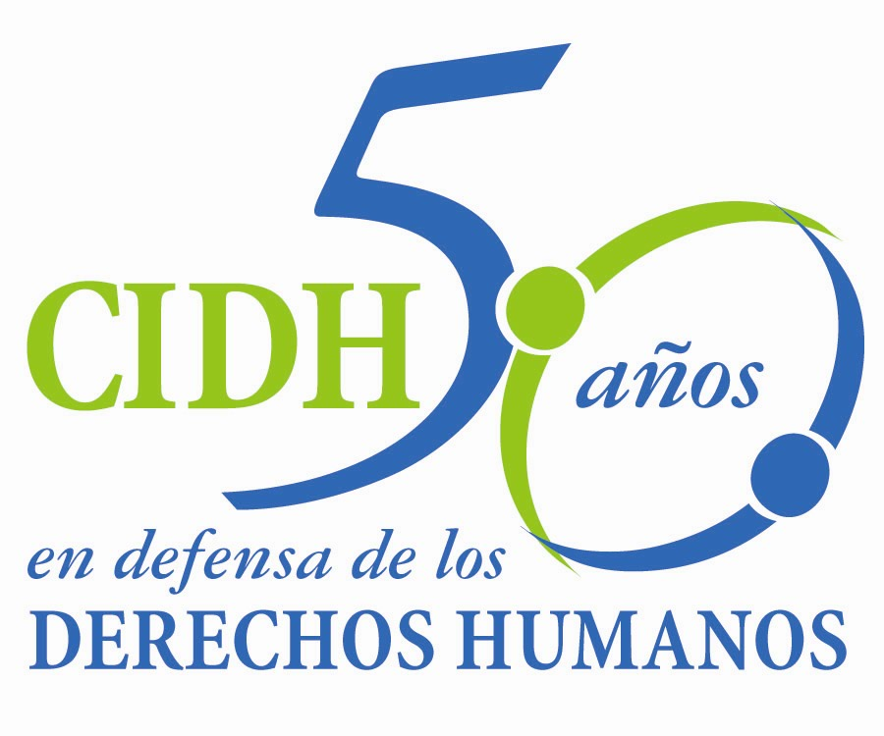
INTER - AMERICAN COMMISSION ON HUMAN RIGHTS
COMISION INTERAMERICANA DE DERECHOS HUMANOS
COMISSÃO INTERAMERICANA DE DIREITOS HUMANOS
COMMISSION INTERAMÉRICAINE DES DROITS DE L'HOMME

ORGANIZACIÓN DE LOS ESTADOS AMERICANOS

WASHINGTON, D.C. 2 0 0 0 6 E E U U

October 1, 2013

Ref.: Case No. 12.761 Comunidad Garífuna Punta Piedra

Honduras

Mr. Secretary:

I am pleased to address you on behalf of the Inter-American Commission on Human Rights in order to file Case No. 12.761 Comunidad Garífuna Punta Piedra v. Honduras (hereinafter “the State”, “the Honduran State” or “Honduras”) before the jurisdiction of the Honorable Inter-American Court of Human Right. The instant case involves Hondura’s international responsibility for the violation of the right to property against the Garifuna Community “Punta Piedra” and its members. This resulted from the breach of the duty to guarantee the right to land of the community, against the invasion, since the beginning of 1990, by non-indigenous people that were subsequently recognized by the State through the granting of a freehold title. The granting of the title was made ​​without an adequate titling process; despite the knowledge of the occupation by a group of villagers in various parts of the Community’s land, especially in “Rio Miel” and the forest area. This situation has led to the Garifuna Community of “Punta Piedra“ to only exercise the tenure of half of State-titled land, with negative subsequent effects on their way of life, livelihoods, culture and traditional customs. Furthermore, the continued occupation by non-indigenous people has created a situation of conflict that has resulted in threats, harassment, or even the death of a member of the Garifuna Community of “Punta Piedra”.

The State of Honduras has not given an effective response to this situation. So far, the initiatives have failed and the State itself has reneged on the agreements made ​​in order to achieve an effective titling of the lands and territories of the Garifuna Community of “Punta Piedra”. This situation has deepened and exacerbated the conflict situation in the area. The Community has not had an effective remedy to achieve a peaceful possession of their lands and territories.

Honduras ratified the American Convention on September 8, 1977 and accepted the jurisdiction of the Court on September 9, 1981

Mr.
Pablo Saavedra Alessandri, Secretario
Inter-American Court on Human Rights
Apartado 6906-1000
San José, Costa Rica

The Commission has designated Commissioner Tracy Robinson and Emilio Álvarez Icaza L., Executive Secretary, as its delegate. Likewise, Elizabeth Abi-Mershed, Deputy Executive Secretary, Silvia Serrano Guzmán, Isabel Madariaga y Cristina Blanco, attorney of the Executive Secretariat of the IACHR, have been designated to serve as legal advisors.

In accordance with Article 35 of the Rules of Procedure of the Inter-American Court, the Commission is enclosing a copy of Merits Report No. 30/13, prepared in compliance with Article 50 of the American Convention, as well as a copy of the entire file before the Inter-American Commission (Appendix I.) and the attachments used to prepare the Report on the Merits (Attachment). The Commission adopted its Report on the Merits No. 30/13 on March 21, 2013.

The Merits Report was transmitted to the State on April 1, 2013, granting it two months to provide information on the measures adopted in compliance with the recommendations. On June 21, 2013, the State of Honduras submitted a communication expressing its will to comply with the recommendations On June 26, 2013 the State requested an extension and expressively gave the waiver regarding article 51 of the Convention. The IACHR granted the extension requested for three months. By means of the communication of September 1, 2013, informing the State of the granting, the Commission requested to the State to present information regarding the fulfillment of the recommendations. To date, the State has not sent the requested report.

The Commission submits the case to the jurisdiction of the Court due to the needs of justice in the particular case for the victims.

Although the State of Honduras expressed its willingness to comply with the recommendations made by the Commission and formulated a proposal, that proposal does not correspond to the principal reparation involved in the case, which is the effective regularization of the lands and territories of the Garífuna Community of “Punta Piedra.” In addition, its alternative proposals were emphatically rejected by the community. Since the State was granted an initial extension of three months, it has not responded to the Commission’s request for information regarding progress made in complying with the recommendations nor has it sought an additional extension of the deadline.

In accordance to the above mentioned, the IACRH concluded that:

      - The State of Honduras violated the right to property enshrined in Article 21 of the American Convention on Human Rights, in connection with Articles 1.1 and 2 thereof, to the detriment of the Garifuna Community of Punta Piedra and its members.

      - The State of Honduras violated the right to judicial protection enshrined in Article 25 of the American Convention on Human Rights, in connection with Articles 1.1 and 2 thereof, to the detriment of the Garifuna Community of Punta Piedra and its members.

As a consequence, the Commission suggests to the Court to request to the State to:

- Adopt as soon as possible the necessary measures to make effective the right to communal property and possession of the Garifuna Community of Punta Piedra and its members, with respect to their ancestral territory; and, in particular, the legislative, administrative and other measures necessary to effectively normalize their title, in accordance with their customary law, values, practices and customs and ensure the members of the Community to be able to continue to lead their traditional way of life, in keeping with their cultural identity, social structure, economic system, distinct customs, beliefs and traditions.

- Take the necessary steps to prevent that the Garifuna Community of Punta Piedra and its members are subject to discriminatory acts and, in particular, are exposed to violence by third parties by virtue of their ethnic origin.

- Adopt an effective and simple remedy that protects the right of indigenous peoples of Honduras to claim and gain access to their traditional territories and provide for effective protection of said territories from actions of the State or third parties that infringe their right of property.

- Investigate and punish those responsible for the threats, harassment, acts of violence and intimidation, and damage to the property of the Community of Punta Piedra and its members.

- Redress individually and collectively the consequences of the violation of the aforementioned rights. Especially, considering the damages caused to the members of the Garifuna Community of Punta Piedra as a result of the failure to clear the title of their ancestral territory as well as the damages caused on the territory itself by the acts of third parties.

- Adopt the necessary measures to prevent similar acts from happening in the future, in keeping with the duty to prevent and ensure the fundamental rights recognized in the American Convention.

Apart from the need to obtain justice, the Commission considers the case presents issues of public Inter-American order.

Specifically, the case constitutes an opportunity for the Inter-American Court to deepen its jurisprudence on the rights of indigenous peoples in two ways. On the one hand, it relates to the obligation to guarantee the right to property over their lands, territories and natural resources, of indigenous peoples, against the invasion on behalf of non-indigenous third parties. Besides, the Court will be able to pronounce itself on the obligation of the State to create the conditions so that indigenous peoples’ properties over their lands, territories and natural resources can be exercised in a pacific and non-threatening manner to their way of life, social organization, uses and traditional practices.

On the other hand, it refers to the right to effective judicial protection of the indigenous peoples, when, disregarding that they have a property title in their favor, they do not have access to coercive mechanisms to ensure that their rights be respected against invasions and threats posed by non-indigenous third parties.

Taking into account that the said issues affect in a relevant manner the Inter-American public interest, the Commission offers an expert witness declaration according to Article 35.1 f) of the Rules of Procedure of the Court:

A person whose name will be informed shortly, who will give his opinion on the obligation to guarantee the right to property of the indigenous peoples over their lands, territories and natural resources. The expert will further develop on the scope of this obligation regarding the invasion of the land by non-indigenous people and the conflict situation derived from these situations. Likewise, the expert witness will present the parameters that must be taken into account to resolve these type of situations, including the effective normalization of the titles over the indigenous people’s lands and territories so that they can exercise in an effective manner their right to property.

In this same manner, the Commission allows itself to respectfully request the referral of the expert witness’s document as documentary evidence that will eventually be taken from the expert José Aylwin, offered by the Commission in the Case Comunidad Garífuna Triunfo de la Cruz vs. Honduras, which is already before the Honorable Court.

The expert’s CV will be included in the Merits Report 30/13.

Finally, the petitioners expressed the victims’ interest in the submission of the present case to the Inter-American Court and informed that the following shall be representative of the victims:

Organización Fraternal Negra Hondureña (OFRANEH)
Xxxxxxxxxxxxxxxxxxxxxxxx
Xxxxxxxxxxxxxxxxxxxxxxxxxxx
xxxxxxxxxxxxxxxxxxxxxxxxxxx

Signed in the original
Mario López Garelli
Authorized by the Executive Secretary

