
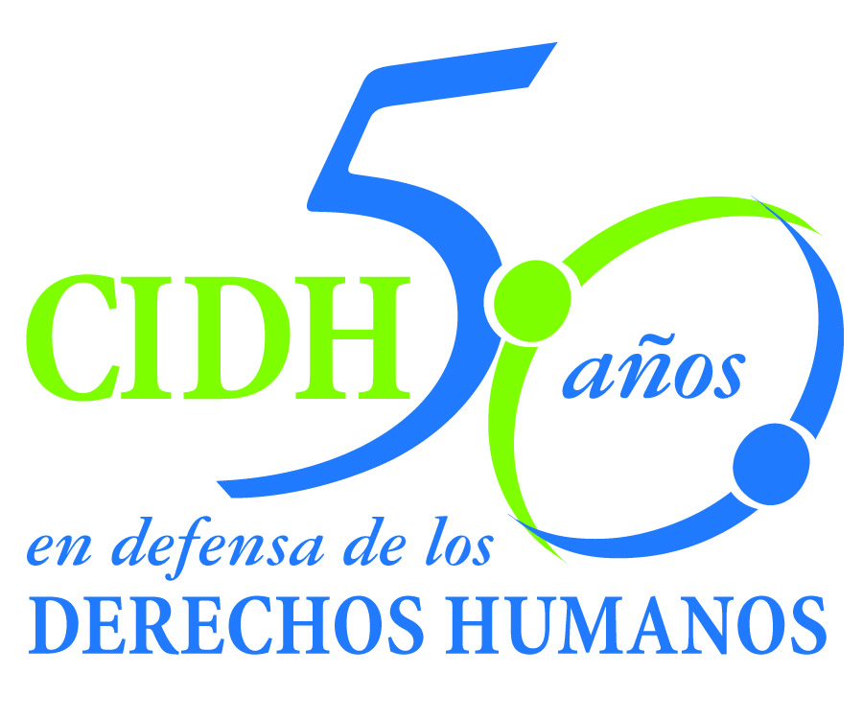
INTER - AMERICAN COMMISSION ON HUMAN RIGHTS
COMISION INTERAMERICANA DE DERECHOS HUMANOS
COMISSÃO INTERAMERICANA DE DIREITOS HUMANOS
COMMISSION INTERAMÉRICAINE DES DROITS DE L'HOMME

ORGANIZACIÓN DE LOS ESTADOS AMERICANOS
WASHINGTON, D.C. 2 0 0 0 6 EEUU

March 5, 2014
Ref.: Case No. 12.777
Claudina I. Velásquez Paiz y otros
Guatemala

Mr. Secretary:

I am pleased to address you on behalf of the Inter-American Commission on Human Rights in order to file Case No. 12.777 Claudina I. Velásquez Paiz et al. v. Guatemala (hereinafter “the State”, “the Guatemalan State” or “Guatemala”) before the jurisdiction of the Honorable Inter-American Court of Human Rights. The present case concerns the Guatemalan State’s international responsibility for failure to comply with its duty to protect Claudina Isabel Velásquez Paiz. When she did not come home, her parents went to the authorities to file a complaint concerning her disappearance, but were unable to do so because they were told that they would have to wait 24 hours before reporting the disappearance. The State thus failed to take immediate and exhaustive measures to find and protect Claudina Isabel Velásquez Paiz within the first few hours of learning of her disappearance, even though the State authorities were aware of a milieu of violence against women that clearly placed the victim in imminent danger. The lifeless body of Claudina Isabel Velásquez Paiz was discovered the next day, August 13, 2005, bearing marks indicating that the victim had been subjected to extreme violence, including sexual violence.

The Guatemalan State’s international responsibility was also incurred by virtue of the fact that it failed to conduct a serious investigation into the disappearance of Claudina Isabel Velásquez Paiz, the violence she suffered and her murder. The Commission found that from the outset, the investigation was riddled with problems, such as the mishandling and analysis of the evidence gathered; problems with managing and preserving the crime scene, and with the tests run on the evidence; irregularities in the autopsy report; a failure to do a thorough examination of various parts of the victim’s body to confirm a possible rape; irregularities in the fingerprinting of the victim, and the failure to take statements from important witnesses. The Commission also found that the considerable delay in the instant case was the fault of the State, caused mainly by a repeated reshuffling of the prosecutors assigned to the case; these changes were disruptive to the investigation; inquiries and proceedings were either not completed on time or were never examined by the new prosecutors assigned to the case.

Mr.
Pablo Saavedra Alessandri, Secretary
Inter-American Court of Human Rights
Apartado 6906-1000
San José, Costa Rica

Anexos

Furthermore, the case was also plagued by discriminatory stereotypes that took a serious toll on the diligence with which the investigation was conducted. The Commission found that the failure to protect Claudina Isabel Velásquez Paiz and the failure to properly investigate her death are a clear reflection of the underlying discrimination against women in Guatemala.

The State of Guatemala ratified the American Convention on Human Rights on May 25, 1978, and accepted the Court’s contentious jurisdiction on March 9, 1987.

The Commission has designated Commissioner James Cavallaro and Emilio Álvarez Icaza L., executive secretary, as its delegate. Likewise, Elizabeth Abi-Mershed, Deputy Executive Secretary, Silvia Serrano Guzmán Jorge H. Meza Flores and Ona Flores, attorneys of the Executive Secretariat of the IACHR, have been designated to serve as legal advisors.

In accordance with Article 35 of the Rules of Procedure of the Inter-American Court, the Commission is enclosing a copy of Merits Report No. 53/13, prepared in compliance with Article 50 of the American Convention, as well as a copy of the entire file before the Inter-American Commission (Appendix I.) and the attachments used to prepare the Report on the Merits (Attachment). The Commission transmitted the Merits Report to the State on December 5, 2013, granting it two months to provide information on the measures adopted in compliance with the recommendations. On February 5, 2014, the State filed a brief in which it argued that it bears no international responsibility for the violations declared in the merits report and therefore need not comply with the recommendations regarding reparations for the victim’s next of kin.

Taking into account the aforementioned, the Commission submits the case before the jurisdiction of the Court for the need to obtain justice for the victims of this case and insofar as the lake of fulfillment of the recommendations by the State of Guatemala.

The Inter-American Commission request to the Court to state that the State of Guatemala is responsible for violation of:

- the rights to life and humane treatment recognized in Articles 4, 5 and 11 of the American Convention, all in connection with its obligations under Article 1(1) of that treaty and Article 7 of the Convention of Belém do Pará.

- the State violated Claudina Isabel Velásquez Paiz’s rights under Article 7 of the Convention of Belém do Pará, in relation to Article 24 of the American Convention, in conjunction with the general obligation to respect and ensure rights established in Article 1(1) of the latter treaty

- the State violated the right to have one’s integrity respected, as recognized in Article 5(1) of the American Convention, in relation to the obligations established in Article 1(1) thereof, to the detriment of Jorge Rolando Velásquez Durán, Elsa Claudina Paiz Vidal de Velásquez, and Pablo Andrés Velásquez Paiz, as well as the right to a fair trial and judicial protection recognized at Articles 8(1) and 25 of the American Convention, in conjunction with the obligations under Article 1(1) thereof and Article 7 of the Convention of Belém do Pará.

Based on these findings, the Commission recommended that the State:

- Complete a timely, immediate, serious and impartial investigation to solve the murder of Claudina Isabel Velásquez Paiz and identify, prosecute and, as appropriate, punish those responsible.

- Adopt and/or, as appropriate, adapt investigation protocols and expert witness services used in all crimes connected with the disappearance, rape or murder of women, in accordance with international standards on such matters and with a gender-aware perspective.

- Make full reparations to the next of kin of Claudina Isabel Velásquez Paiz for the human rights violations herein established.

- As a measure of non-repetition, introduce a comprehensive and coordinated State policy, backed by sufficient public funds, for prevention of violence against women.

- Bolster the institutional capacity to combat impunity in cases of violence against women, through effective criminal investigations conducted from a gender perspective and that have constant judicial follow up, thereby ensuring proper punishment and redress.

- Implement a system of production of disaggregated statistics, which will allow the design and evaluation of public policies in relation to the prevention, sanction and elimination of violence against women.

- Introduce reforms in the State’s educational programs, starting in the early, formative years, so as to promote respect for women as equals and observance of their rights to nonviolence and nondiscrimination.

- Adopt comprehensive public policies and institutional programs designed to eliminate discriminatory stereotypes about the role of women and to promote the eradication of discriminatory socio-cultural patterns that prevent women’s full access to justice; this should include training programs for public officials in all sectors of government, including education, the various sectors involved in the administration of justice, the police, as well as comprehensive policies on prevention.

Apart from the need to obtain justice, the Commission considers the case raises issues of Inter-American public interest. Si bien la Corte Interamericana ya se ha pronunciado sobre el alcance de los deberes de protección e investigación de los Estados en circunstancias similares, la Comisión considera que el presente caso ofrece a la Honorable Corte la oportunidad de profundizar en la estrecha relación que existe entre violencia contra la mujer y discriminación, así como entre discriminación y la falta de investigación seria y diligente de dichos actos de violencia. Este tema podrá ser abordado a partir del contexto particular de violencia contra la mujer en Guatemala así como de la situación estructural de impunidad que persiste en estos casos en dicho país.

Because these questions significantly affect inter-American public order, under Article 35(1)(f) of the Rules of Procedure of the Inter-American Court the Commission takes the liberty of offering the following expert testimony:

1. xxxxxxxxxxxx, who will testify to the importance of examining structural contexts of violence against when analyzing the States’ international obligations, specifically the duty to guarantee the rights protected under the Convention. Therefore, the expert witness will address the impact that the presence of such contexts has on the determination of a State’s international responsibility. The expert will take into account the Guatemalan context and the facts of the present case.

2. xxxxxxxxxxxx, who will testify to the international standards that establish the correlation between violence against women, impunity and discrimination. The expert will elaborate upon the special obligations incumbent upon a State in a context of discrimination and violence against women. Furthermore, the expert will address the State’s deficient responses in terms of protection and investigation, and how they perpetuate the existing discrimination. Here, specific reference will be made to the existence of discriminatory stereotypes and their impact on cases such as this. The expert will also make reference to how this correlation is addressed in other systems for the protection of human rights and may make specific reference to the facts of this case.

Finally, the petitioners expressed the victims’ interest in the submission of the present case to the Inter-American Court and informed that the following shall be representatives of the victims:
Jorge Rolando Velásquez Durán y Carlos Pop Ac
xxxxxxxxxxxxxxxxxxxxxxxxxxxx

Signed in the original

Elizabeth Abi-Mershed
Deputy Executive Secretary

