
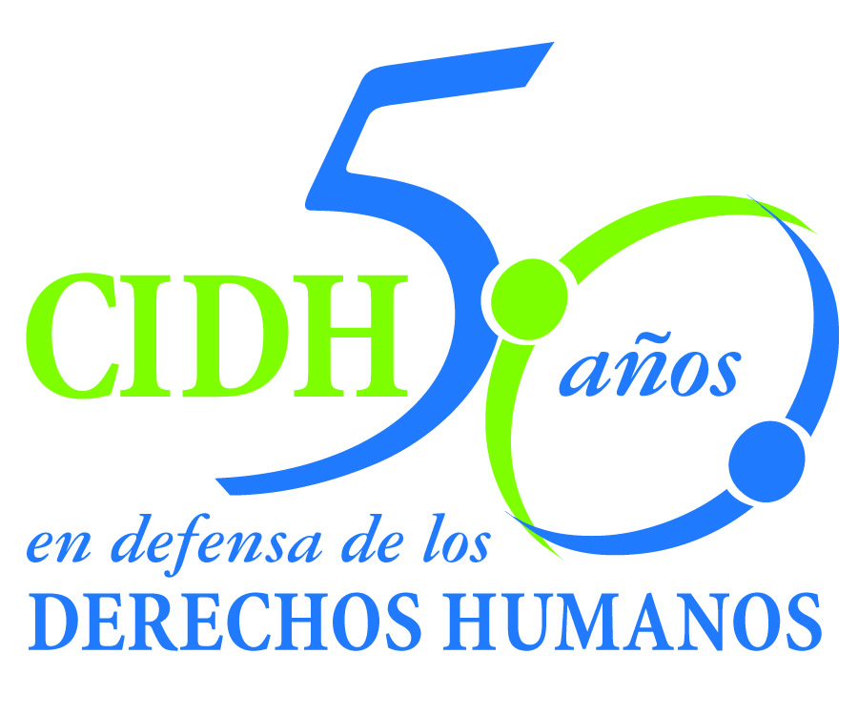
INTER - AMERICAN COMMISSION ON HUMAN RIGHTS
COMISION INTERAMERICANA DE DERECHOS HUMANOS
COMISSÃO INTERAMERICANA DE DIREITOS HUMANOS
COMMISSION INTERAMÉRICAINE DES DROITS DE L'HOMME

ORGANIZACIÓN DE LOS ESTADOS AMERICANOS
WASHINGTON, D.C. 2 0 0 0 6 EEUU

October 30, 2013

Ref.: Case No. 12.794
Wong Ho Wing
Peru

Mr. Secretary:

I am pleased to address you on behalf of the Inter-American Commission on Human Rights in order to file Case No. 12.794 Wong Ho Wing v. Peru (hereinafter “the State”, “the Peruvian State” or “Peru”) before the jurisdiction of the Honorable Inter-American Court of Human Rights regarding a series of rights violations against Mr. Wong Ho Wing, a national of the People’s Republic of China, from his arrest on October 27, 2008, and throughout the extradition process that remains ongoing to date. In its merits report the Commission found that Mr. Wong Ho Wing was and continues to be subjected to an arbitrary and excessive denial of his freedom that is not justified by procedural requirements and that has continued for more than five years under “provisional arrest” with no final ruling on his legal situation.

The Commission also concluded that in the different stages of the extradition proceedings, the domestic authorities were responsible for a series of omissions and irregularities in processing the case, and in receiving and assessing the alleged guarantees extended by the People’s Republic of China. The Commission found that in addition to violations of several aspects of due process, those omissions and irregularities constituted a failure to uphold Mr. Wong Ho Wing’s right to life and right to humane treatment.

The Commission also found that since May 24, 2011, the date on which Peru’s Constitutional Court ordered the executive branch to refrain from extraditing Mr. Wong Ho Wing, the country’s authorities have been in a state of noncompliance with a court order that is incompatible with the right to judicial protection.

The Peruvian State ratified the American Convention on Human Rights on July 12, 1978, and it accepted the Court’s contentious jurisdiction on January 21, 1981.

Mr
Pablo Saavedra Alessandri, Secretario
Inter-American Court on Human Rights
Apartado 6906-1000
San José, Costa Rica

The Commission has designated Commissioner José Orozco Henríquez and Emilio Álvarez Icaza L., Executive Secretary, as its delegate. Likewise, Elizabeth Abi-Mershed, Deputy Executive Secretary, Silvia Serrano Guzmán, attorney of the Executive Secretariat of the IACHR, have been designated to serve as legal advisors.

In accordance with Article 35 of the Rules of Procedure of the Inter-American Court, the Commission is enclosing a copy of Merits Report No. 78/13, prepared in compliance with Article 50 of the American Convention, as well as a copy of the entire file before the Inter-American Commission (Appendix I.) and the attachments used to prepare the Report on the Merits (Attachment). The Commission adopted its Report on the Merits No. 78/13 on July 18, 2012 and transmitted to the State on July 30, 2013, granting it two months to provide information on the measures adopted in compliance with the recommendations

The State of Peru submitted a document on September 30, 2013, indicating that it disagrees with the findings of the Merits Report. In this regard, the Commission is not provided with information about advances in the fulfillment of the recommendations. By contrast, the State of Peru reiterated that the extradition process continues without being resolved by the Executive. In its communication, the State did not refer to the effects of the judgments of the Constitutional Court ordered the Executive to refrain from extraditing Wong Ho Wing to the People's Republic of China

The Commission submits this case to the jurisdiction of the Court because of the need to obtain justice for the victims of this case. The Commission submits all the facts and violations of human rights described on the Merits Report 78/13

The Inter-American Commission concluded that the State of Peru was responsible for violating Mr. Wong Ho Wing’s rights to personal liberty, life, humane treatment, a fair trial, and judicial protection, as set forth in Articles 7, 4, 5, 8, and 25 of the American Convention, in conjunction with the obligations set out in Article 1.1 thereof.

In consideration of those conclusions, the Commission recommended that the State:

1. Order the measures necessary to ensure that the extradition process is brought to a conclusion as soon as possible, in accordance with the procedures set forth in the Peruvian Code of Criminal Procedure, denying the extradition in strict compliance with the Constitutional Court’s ruling of May 24, 2011. In furtherance of this recommendation the State must ensure that none of its authorities put into practice mechanisms that would obstruct or delay enforcement of that ruling

2. Order an ex officio review of Mr. Wong Ho Wing’s provisional arrest. In that review the State must take into consideration his legal situation upon the conclusion of the extradition process, effected in accordance with the terms of the recommendation made above. In particular, any court decision pertaining to the personal liberty of Mr. Wong Ho Wing must be made in strict compliance with the principles of exceptionality, necessity, and proportionality in the terms described in this report.

3. Make full reparations to Mr. Wong Ho Wing for the violations established in this merits report.

4. Within a reasonable period, order measures of non-repetition to ensure that in extradition processes, the procedures established in the Code of Criminal Procedure are followed to the letter and that the necessary safeguards are in place to ensure that any diplomatic or other assurances offered by the requesting State are procured and weighed in accordance with the standards set out in the present report on the merits.

In addition to the need to secure justice for the failure to comply with the recommendations of the merits report, the Commission believes that this case raises questions related to the inter-American public order. Specifically, it offers the first opportunity for the Inter-American Court to develop jurisprudence on the standards to be observed in processes and decisions related to extradition proceedings, in order to keep states from violating their international obligations under the American Convention. Specifically, the Court could rule on the topic of diplomatic guarantees and other types of assurances to ensure the strict enforcement of the principle of not extraditing persons who could then face the risk of suffering torture. In addition, the Court could rule on the details of the diplomatic guarantees and other types of assurances that are necessary to ensure that the death penalty is not imposed on a person extradited from a state that has already abolished capital punishment.

Since these matters have a significant impact on the inter-American public order, in compliance with Article 35.1.f of the Inter-American Court’s Rules of Procedure, the Commission proposes testimony be heard from the following experts:

1. A person whose name will be informed shortly, to testify on the guarantees of due process and the right to personal liberty in proceedings brought to decide on the extradition of a person. The expert will analyze this issue from the point of view of states’ international obligations, including references to the different regulatory and institutional designs available for extradition proceedings in order to ensure their compatibility with the minimum standards for liberty and due process.

2. A person whose name will be informed shortly, who will speak of the international standards, including the jurisprudence of the European Court of Human Rights and the rulings of the United Nations treaty Committees, and of the reception, processing, and appraisal of diplomatic guarantees and other assurances extended by requesting states in extradition proceedings, as regards both the freedom from torture and the non-enforcement of the death penalty.

Los CV de los/las peritos/as propuestos/as serán incluidos en los anexos al informe de fondo 78/13.

La Comisión pone en conocimiento de la Corte la siguiente información sobre quien ha actuado como peticionario a lo largo del trámite y sus respectivos datos de contacto:

Luis Lamas Puccio
xxxxxxxxxxxxxx
xxxxxxxxxxxx
Lima, Perú
xxxxxxxxxxxxxxxxxxxxxxxxxxxxxxxxxxxx

Aprovecho la oportunidad para saludar a usted muy atentamente,

Signed in the original

Elizabeth Abi-Mershed
Secretaria Ejecutiva Adjunta

