**CHAPTER VI  
INSTITUTIONAL DEVELOPMENT**

1. **Structure and Personnel of the IACHR**
2. In 2019, the Executive Secretariat continued to bring its staffing and resources in line with the mandates given to the IACHR. Thus, as of December 31, 2019, the IACHR Executive Secretariat was composed of 134 members (53 staff employees, 79 consultants and 2 associate professionals). The IACHR is further assisted by 13 fellows.
3. The following table highlights distribution of staff by funding source as of December 31, 2019.

|  |  |  |  |  |
| --- | --- | --- | --- | --- |
| **Source of funding by group** | | | | |
| **Category** | **Regular Fund** | **Specific Funds** | **At no cost to the IACHR** | **Total** |
| Executive Secretary | 1 | 0 | 0 | 1 |
| Assistant Executive Secretaries | 2 | 0 | 0 | 2 |
| Special Rapporteurs | 0 | 2 | 0 | 2 |
| Professionals | 33 | 3 | 0 | 36 |
| Administrative Staff | 11 | 1 | 0 | 12 |
| **Subtotal for Staff** | **47** | **6** | **0** | **53** |
| Results-Based Contracts  (RBC) CPRS) | 17 | 62 | 0 | 79 |
| Associate Staff | 0 | 1 | 1 | 2 |
| Fellows | 0 | 6 | 7 | 13 |
| **Total** | **64** | **75** | **8** | **147** |

1. In terms of geographic representation and diversity, the 134 members mentioned in paragraph 1 (staff employees, consultants and associate professionals) hail from 24 different States, 68% of whom are women and 32% are men. The table below shows staff distribution by nationality and contract type.

|  |  |  |  |
| --- | --- | --- | --- |
| **Type of contract** | **Country** | **Nationality when entering the GS/OAS** | **Current nationality** |
| **Staff** | Argentina | 6 | 5 |
|  | Barbados | 1 | 1 |
|  | Bolivia | 1 | 0 |
|  | Brazil | 7 | 6 |
|  | Chile | 2 | 2 |
|  | Colombia | 6 | 4 |
|  | Guatemala | 1 | 1 |
|  | Mexico | 4 | 4 |
|  | Panama | 1 | 1 |
|  | Paraguay | 2 | 2 |
|  | Peru | 6 | 2 |
|  | Uruguay | 4 | 4 |
|  | United States | 10 | 20 |
|  | Venezuela | 2 | 1 |
| **Staff Total** |  | **53** | **53** |
| **RBC** | Argentina | 8 | 8 |
|  | Bolivia | 3 | 3 |
|  | Brazil | 10 | 10 |
|  | Canada | 1 | 1 |
|  | Chile | 5 | 5 |
|  | Colombia | 12 | 11 |
|  | Costa Rica | 1 | 1 |
|  | Ecuador | 2 | 2 |
|  | El Salvador | 3 | 2 |
|  | Guatemala | 1 | 1 |
|  | Haiti | 1 | 1 |
|  | Italy | 2 | 2 |
|  | Mexico | 7 | 7 |
|  | Panama | 1 | 1 |
|  | Peru | 6 | 6 |
|  | Portugal | 1 | 1 |
|  | Saint Lucia | 1 | 1 |
|  | Spain | 1 | 1 |
|  | Trinidad and Tobago | 1 | 1 |
|  | Uruguay | 4 | 4 |
|  | USA | 4 | 6 |
|  | Venezuela | 4 | 4 |
| **RBC Total** |  | **79** | **79** |
| **Associate Staff** | Brazil | 2 | 2 |
| **Associate Staff Total** |  | **2** | **2** |
| **Grand Total** |  | **134** | **134** |

1. In the first quarter of 2019, the selection process for the eleven new positions approved in the 2018 IACHR Program-Budget for personnel expenses came to a close and 9 remaining staff appointments were made:

* 1 Project Officer, grade P03, for Coordination of the Planning and Projects Section
* 1 Human Rights Specialist, grade P03, for Monitoring Section II
* 1 Human Rights Specialist, grade P03, for Monitoring Section III
* 1 Human Rights Specialist, grade P03, for the Promotion and Training Section
* 2 Human Rights Specialists, grade P02, for the Office of the Executive Secretary

and for the Processing Unit.

* 1 Human Rights Specialist, grade P01, for the Admissibility Section.
* 1 Press and Communications Officer, grade P02
* 1 Human Rights Specialist, grade P02, to join the Office of the Executive Secretary

1. In addition, two positions that had been previously filled in the ES/IACHR structure were left vacant in 2018. In the first quarter of 2019, the selection process for these positions came to a close:

* Senior Human Rights Specialist, level P05.
* Human rights Specialist, level P04.
* The appointment of the level P04 position was made on November 1, 2019.

1. In the 2019 Program-Budget for personnel expenses of the IACHR, seven new positions were authorized: 1 level P04 position and 6 level P02 positions. The level P04 position was filled through transfer of a GS/OAS employee to the ES/IACHR, who joined the Office of Specialized Advisors, as an Advisor for Transparency and Access to Information. In February, competitive selection procedure EO/01/19 was announced to fill 6 level P02 positions. In July, the selection process was closed and the recommendation of the Special Selection Subcommittee was submitted for consideration to the Selection and Promotion Advisory Committee. The appointments to fill five of the six positions were made on December 1, 2019. The sixth appointment is to be made on January 1, 2020.

**Consultants, interns, fellows and associate staff:**

1. In 2019, consultant contracts continued to be renewed and new consultants were hired, strengthening the different sections of the ES/IACHR. As of December 31, 2019, the ES/IACHR has 79 consultants.
2. In 2019, through three Internship Cycles, coordinated with the Department of Human Resources of the GS/OAS, a total of 76 interns joined the Executive Secretariat of the IACHR.

|  |  |  |
| --- | --- | --- |
| **2019 Cycle** | **No. of Interns** | **Section** |
| **Winter/Spring** | 1 | Initial Review/Registry |
| 6 | Admissibility |
| 5 | Cases |
| 3 | Precautionary Measures |
| 2 | Friendly Settlements |
| 2 | Monitoring I |
| 2 | Monitoring II |
| 2 | Monitoring III |
| 2 | Monitoring Recommendations |
| 2 | Technical Cooperation and Public Policies |
| 1 | Press Office |
| 1 | Office of the Executive Secretary |
| 1 | Special Rapporteur ESCE Rights REDESCA |
| 1 | Special Rapporteur Freedom of Expression RFOE |
| **Total** | **31** |  |
| **Summer** | 3 | Admissibility |
| 4 | Cases |
| 3 | Precautionary Measures |
| 2 | Friendly Settlements |
| 1 | Monitoring I |
| 1 | Monitoring II |
| 1 | Monitoring III |
| 1 | Monitoring Recommendations |
| 1 | Technical Cooperation and PP |
| 1 | Promotion and Training |
| 2 | Office of the Executive Secretary |
| 1 | REDESCA |
| 1 | RFOE |
| **Total** | **22** |  |
| **Fall** | 4 | Admissibility |
| 4 | Cases |
| 2 | Precautionary Measures |
| 2 | Friendly Settlements |
| 1 | Monitoring I |
| 1 | Monitoring II |
| 1 | Monitoring II |
| 1 | Monitoring Recommendations |
| 1 | Technical Cooperation and Public Policies |
| 1 | Promotion and Training |
| 1 | Office of the Executive Secretary |
| 1 | Press Office |
| 1 | Technology |
| 1 | Special Rapporteurship for Freedom of Expression RELE |
| 1 | Special Rapporteurship on Economic, Social, Cultural and Environmental Rights REDESCA |
| **Total** | **23** |  |
| **Total 2019** | **76** |  |

1. Thanks to the support of several institutions, the ES/IACHR received seven new fellows over the year:

|  |  |  |  |
| --- | --- | --- | --- |
| **No.** | **Nationality** | **Fellowship** | **Assignment** |
| 1 | USA | Universidad of Monterrey | REDESCA |
| 2 | Colombia | University of the Andes | Cases |
| 3 | Colombia | University of Colorado | Admissibility |
| 4 | Colombia | University of Colorado | Register |
| 5 | Venezuela | Andrés Bello Catholic University | Friendly Settlements |
| 6 | Venezuela | Andrés Bello Catholic University | Cases |
| 7 | USA | University of Oklahoma | Monitoring III - Caribbean |

1. In 2019, IACHR Fellowships were announced and 8 fellowships were granted:

|  |  |  |
| --- | --- | --- |
| **No.** | **Nationality** | **Assignment** |
| 1 | Guatemala | Rights of LGBTI Persons |
| 2 | Colombia | Rights of Persons of African Descent and against Racial Discrimination |
| 3 | Bolivia | Human Rights Defenders |
| 4 | Peru | Human Rights Defenders |
| 5 | Haiti | Countries of the Caribbean |
| 6 | Colombia | IACHR Recommendation Monitoring |
| 7 | Bolivia | SRFE |
| 8 | Guatemala | Internal Displacement |

1. Additionally, thanks to the support of the following Institutions, in 2019, the ES/IACHR welcomed three of their employees as associate staff:

|  |  |  |
| --- | --- | --- |
| **No.** | **Institution** | **Assignment** |
| 1 | Federal Public Defender's Office Recife/PE of Brazil (DPU) | Cases |
| 2 | Federal Public Defender's Office Recife /PE of Brazil (DPU) | Cases |
| 3 | National Office of the Public Defender, Chile | Cases |

**Staff training**

1. Over the course of the year, Brown Bag Lunch events, lunch-time informational sessions held once a month on a variety of current human rights issues, were hosted for interested staff at the Executive Secretariat.
2. In collaboration with the GS/OAS Department of Human Resources, a course was held on September 9 and 10, aimed at all Section Coordinators and Chiefs of Area in charge of staff, in order to help strengthen their managerial and leadership skills.
3. Two orientation sessions were held in October and November for new incoming colleagues to become familiar with the different functions and areas of the Executive Secretariat.
4. In the last quarter of 2019, the Department of Human Resources launched an online course on the Code of Ethics and Conduct at the GS/OAS. All staff of the Executive Secretariat was required to take this mandatory course.
5. Additionally, the Program “*Cuidar–Cuidando*” was launched in order to provide support to the ES/IACHR staff through different media and tools to recognize and manage symptoms of stress, strengthen resilience and support team work.

**Jointly drafted workplace environment plan in process of implementation.**

1. Over the first half of the year, efforts were continued to draft the work plan of the Workplace Environment Committee, a group made up of staff and consultants of the IACHR Executive Secretariat. New members joined the Workplace Environment Committee in order to work on new initiatives in 2019. The “Open Door Policy” was implemented, under which staff is provided the opportunity to meet with the Executive Secretary to raise issues of concern. A suggestion box was set up and meetings were held with the Ombudsperson to work in conjunction with that office on improving the workplace environment of the Executive Secretariat. In December, the Ombudsperson gave a presentation on her duties to the ES/IACHR staff.
2. In October, a space was provided for Active Listening, where all staff had an opportunity to make comments and proposals about their level of workplace satisfaction at the ES/IACHR. The results were presented to the staff in November.
3. **Financial Resources and Budget Execution**
4. For 2019, the General Assembly approved a budget for the IACHR in the amount of $9,367,400, of which $6,974,200 was for staff outlays and $,2,393,200 for operating expenses. The year 2019 was the second year of the phase-in process of doubling the GS/OAS Regular Fund budget allocated to the IACHR over a period of 3 years.

**Figure 1. Distribution of the Approved Budget from the OAS Regular Fund in 2019**

**(in thousands of U.S. dollars)[1]**

**Total $ 82,700.00**

1. As of December 31, 2019, the original Regular Fund budget was changed to a total of $8,660,506, of which a total of $5,218,783 was allocated for personnel expenses and $3,441,723 for non-personnel costs. The personnel expense portion was under-executed because, in 2019, several positions were in the midst of competitive selection processes. Accordingly, the IACHR Executive Secretariat made several requests to the Secretariat for Administration and Finances to increase the budget available for non-personnel outlays.
2. With regards to fundraising for specific funds, we have been able to raise USD $8,130,823 in 2019, as a result of the resource mobilization strategy and thanks to the confidence vested in the IACHR. The following chart shows the distribution of funds received by the IACHR by source of funding.

**Figure 2. Funding received by the IACHR in 2019 by source of funding (Preliminary and unaudited figures in U.S. dollars)**

**Total: $16,791,329**

1. The IACHR highlights the financial contribution of Bolivia amounting to US $238,902, which made it possible to hold the 171st Regular Session in Sucre, Bolivia, between February 7 and 16, 2019, as well as the financial contribution of US $111,157.69 made by Ecuador which, along with hiring and other expenses covered directly by the State, made it possible to hold the 174th Session in Quito, Ecuador, from November 8 to 14, 2019.
2. The following table shows contributions of funds received by the IACHR in 2019 by source of funding.

**Table 1. Contributions of Funds Received by the IACHR in 2019**

**By source of financing and / or special theme**

**(Preliminary and unaudited figures in U.S. dollars)[2] [3]**



1. The following table exhibits the variations in the fund balance of projects financed by specific IACHR funds as of December 31, 2019.

**Table 2. Statement of Changes in Fund Balance of Projects financed by Specific Funds by Project. Information as of December 31, 2019[4], [5] [6]**

**(Preliminary and unaudited figures in U.S. dollars)**



25. The figure below shows the distribution of IACHR spending by source of funding as of December 31, 2019. Expenditures paid from specific funds account for 46%, and from the Regular Fund, 54%.

**Figure 3. Distribution of IACHR Spending by Source of Funding in 2019 (Preliminary and unaudited figures in thousands of U.S. dollars)**

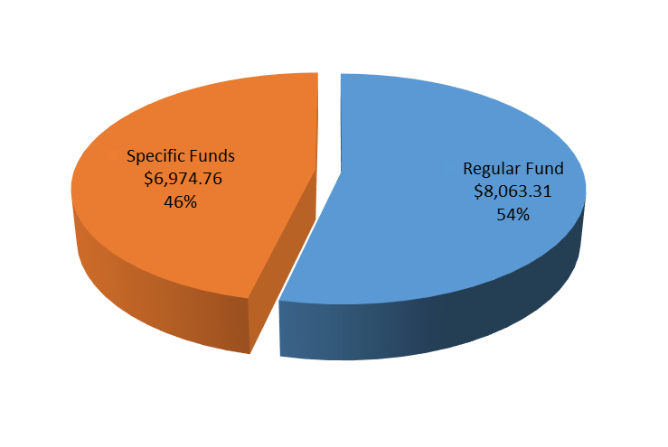

**Total: $15,038.07**

26. The following table and graph shows the distribution of IACHR spending by source of funding and item of expenditure.

**Table 3. Distribution of IACHR spending by Source of Funding in 2019 and Item of Expenditure (Preliminary and unaudited figures in U.S. dollars, rounded)**

|  |  |  |  |
| --- | --- | --- | --- |
| **Item of Expenditure** | **Regular Fund** | **Specific Funds** | **Total** |
| **Salaries** | 5,018,081 | 1,226,238 | 6,244,319 |
| **Results-Based Contracts** | 2,136,416 | 4,107,856 | 6,244,272 |
| **Fellowships** | - | 207,807 | 207,807 |
| **Travel** | 380,288 | 562,365 | 942,653 |
| **Documents** | 22,698 | 33,988 | 56,686 |
| **Equipment and Supplies** | 235,543 | 49,624 | 285,167 |
| **Building Lease and Maintenance** | 20,844 | 64,882 | 85,726 |
| **Other Costs** | 249,437 | 51,664 | 301,101 |
| **Indirect Cost Recovery (RCI)** | - | 670,335 | 670,335 |
| **Total** | **8,063,306** | **6,974,760** | **15,038.07** |

**Figure 4. Distribution of IACHR Spending by Source of Funding in 2019 and Item of Expenditure (Preliminary and unaudited figures in thousands of U.S. dollars)**

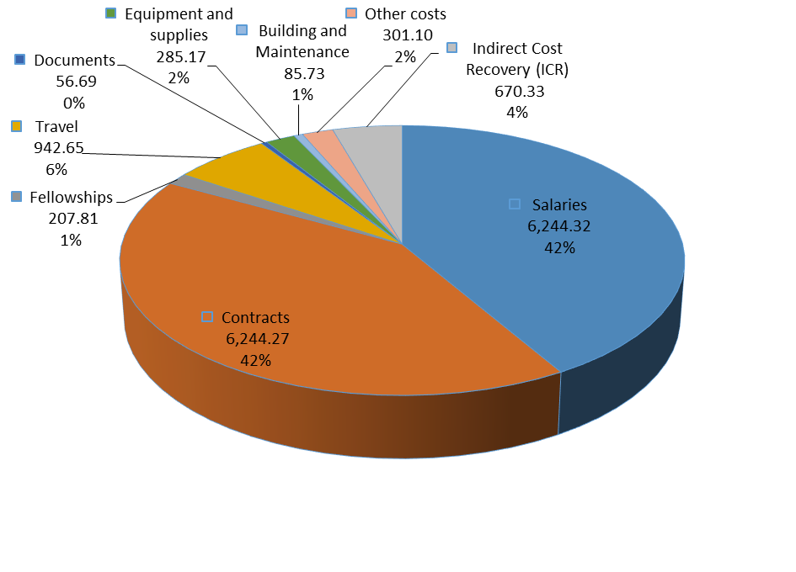

**Total: $15,038.07**

Notes:

1. The distribution includes only 2019 spending which was funded by contributions received in 2019 and previous years (in the case of specific funds).
2. Personnel costs are included under salaries.
3. Under results-based contracts, the following items are included: conference services, professional fees, special services of commissioners, interpreting, translation, administrative and professional support, and consultants.
4. Other costs include office and equipment rental, courier services, other conference services, local area network (LAN), telephone, transportation, and office expenses.
5. **Planning, Resource Mobilization, and Project Administration**
6. **Financial Planning of the IACHR**
7. The Executive Secretariat moved forward with annual financial planning for 2019 based on funding sources from the Regular Fund (total of $10.6 million) and specific funds (estimated at $6.2 million), for a total amount of $16.8 million. For this purpose, the status of execution of ongoing projects, the forecast of potential income based on multi-year projects and ongoing negotiations, underwent a revision process.

**2. Projects Implemented in 2019**

1. In 2019, the IACHR Executive Secretariat drafted and submitted 34 mid-term or final narrative reports, pertaining to 25 projects. A list of completed and ongoing projects for 2019 along with the respective donors appears below:

|  |  |  |  |  |
| --- | --- | --- | --- | --- |
|  | **Project** | **Total Project Amount** | **Donor** | **Reports Submitted** |
| 1 | “Fellowship on international protection and internal displacement and support for institutional capacity-building 2018” | $85,784 USD | UNHCR | Final Report |
| 2 | “Fellowship on international protection and internal displacement and support for institutional capacity-building 2019” | $141,650 USD | UNHCR | Mid-Term Report |
| 3 | Protection and promotion of the Rights of Lesbian, Gay, Bisexual, Trans and Intersex Persons | $100,000 USD | ARCUS | Final Report |
| 4 | GIEI Nicaragua | 200,674 euros | Germany | Final Report |
| 5 | “Promoting compliance with recommendations and decisions on the rights of women and children by the IACHR in the member states of Latin America and the Caribbean.” | 1,988,609 CAD | Canada | Yearly and half-yearly report |
| 6 | Access to international justice through individual petitions submitted to the IACHR by alleged victims of human rights violations in the hemisphere | 1,000,000 euros | European Commission | Ongoing |
| 7 | Support for the work of the IACHR Rapporteurship on the Rights of LGBTI Persons | $250,000 USD | Fundación para las Americas | Mid-Term Report |
| 8 | Increasing the effectiveness of the IACHR’s work in 2018-2021. | $4,388,888 USD  Additional $4,950,000 | United States | 4 Quarterly reports |
| 9 | MESENI Nicaragua | $300,000 USD | United States DOS- CSO | 3 Quarterly Reports |
| 10 | Strengthening Legal Standards and Recommendations to Combat Structural Racial Discrimination in the Americas | $289,468 USD | Spanish Fund | Mid-Term Report |
| 11 | GIEI Nicaragua | $116,160 USD | Spanish Fund | Final Report |
| 12 | MESENI Nicaragua (CDH1707) | $116,160 USD | Spanish Fund | Mid-Term Report |
| 13 | “Promoting and protecting economic, social and cultural rights in the Inter-American human rights system - Phase I (emphasis on the issue of human rights and business)” | $397,350 USD | Spanish Fund | Final Report |
| 14 | Improving available tools to enhance the protection of the right to life and humane treatment of human rights defenders in Latin America | $131,675 USD | Spanish Fund | Mid-Term Report |
| 15 | “Promoting and protecting economic, social and cultural rights in the Inter-American human rights system – (Phase II)” | $131,675 USD | Spanish Fund | Mid-Term Report |
| 16 | GIEI Nicaragua | $240,691 USD | Freedom House | Final Report |
| 17 | “Supporting the IACHR in implementing its Strategic Plan for 2017-2021”. | 1,120,000 USD | Netherlands | Yearly Report |
| 18 | GIEI - Nicaragua | $80,000 USD | Italy | Final Report |
| 19 | “Access to international justice by processing petitions submitted to the IACHR for persons discriminated against in the Hemisphere” | 50,000 euros | Ireland | Final Report |
| 20 | Training Course for Human Rights Defenders 1st Edition | 50,000 euros | Balearic Islands | Final Report |
| 21 | MESENI Nicaragua | 100,000 euros | Luxembourg | Final Report |
| 22 | “Promoting and protecting human rights in the Northern Triangle of Central America.” | 1,030,953 USD | PADF | 3 Quarterly Reports and 1 Yearly Report |
| 23 | Country Visit to Honduras | $50,000 USD | Switzerland | Final Report |
| 24 | GIEI Nicaragua | $200,000 USD | Switzerland | Final Report |
| 25 | “Strengthening governance and human rights in Central America” | $1,208,000 USD | Switzerland | Bi-monthy Reports, Mid-Term Report |

**3. Project Proposals for Financing**

1. In 2019, the IACHR Executive Secretariat drafted 18 project funding proposals for submission to donors. Most of the proposals were approved.
2. Drafting and submittal of the proposal for additional funding of $4,950,000 to the project “Boosting the effectiveness of the IACHR’s work in 2018-2020” to the United States Department of State. The proposal for additional funding to the “Boosting the effectiveness of the IACHR’s work in 2018-2020” project amounting to $4,950,000 which was approved and implementation began on November 21, 2019.
3. Drafting and submittal of the proposal for the “Regional Human Rights and Democracy Program in Central America - Phase II” to the Swiss Cooperation Agency in Central America - COSUDE, for the amount of $2,600,000, to be implemented in 2019-2022. The project was approved, and the contract has been signed with implementation beggining on December 1, 2019.
4. Drafting and submittal the project proposal to the Autonomous Community of the Balearic Islands for human rights defender capacity-building in the Americas. Ed. 2, for the amount of $50,000 Euros. The proposal was approved and project implementation began in August 2019.
5. Drafting and submittal the project proposal to the Autonomous Community of the Balearic Islands “Promoting and Training on the Inter-American Human Rights System and Public Policy Making with a human rights approach in the Americans,” for the amount of $120,000 Euros. The proposal is currently under review.
6. Drafting the concept note for “Strengthening human rights promotion and protection efforts of human rights defenders and operators of justice in Latin America” for the amount of $131,675. Project implementation began in April 2019.
7. Drafting the project concept note for the Promotion of ESCE rights, for the amount of $131,675. Project implementation is ongoing.
8. Drafting and submittal of the project proposal for implementation of the Special Protection Oversight Group in the amount of $350,000 to the Ford Foundation. The proposal was approved and the contract was recently signed, and is to begin implementation in 2020.
9. Drafting and submitting to UNHCR a proposal on Protecting the rights of migrants for the amount of $142,000. The proposal was approved. Under the signed contract, implementation began in April 2019.
10. Drafting of a project proposal on Supporting the Protection of Citizens and Monitoring Human Rights Violations in Nicaragua for the amount of €193.379.3, submitted to Belgium. (It was not approved.)
11. Drafting a proposal to *Freedom House* on “Promoting and protecting the Human Rights of Nicaraguans” for USD $200,000. ((Not approved).
12. Drafting a project proposal for the expansion of friendly settlements as part of the procedural backlog reduction program. Presented at a meeting of Observer Countries.
13. Drafting and submitting to ARCUS Foundation a proposal to support the Rapporteurship on LGBTI Persons for the amount of $ 100,000 over the 2019-2020 period. The proposal was approved and implementation began on June 1, 2019.
14. Drafting a proposal to *Freedom House* to monitor the human rights situation in Venezuela for the amount of USD $130,000. The proposal was approved and the contract is in the negotiation stage so it conforms to OAS policies.
15. Drafting a project proposal for technical assistance to build the capacity of state authorities in protecting and guaranteeing human rights in Haiti. (fundraising in process).
16. Drafting a project to author a report on the human rights situation in Cuba, which was submitted to the PADF and to *Freedom House* for the amount of $267,000. (Not approved)
17. Drafting and submitting a project proposal “Access to international justice through processing petitions filed with the IACHR, whose admissibility review is pending” to the government of Ireland for 50,000 Euros. The project was approved and implementation began on December 1, 2019.
18. Drafting a proposal to write a report on the right to health of exiled Venezuelans. The proposal is being distributed for fundraising purposes.
19. Drafting and submitting to the PADF a project proposal to build the capacity of the Nicaraguan diaspora on the subject of transitional justice for $260,000. The proposal is undergoing editing and expansion.
20. **Technological Breakthroughs**
21. The online form for submitting requests for precautionary measures through the Individual Petition System Portal was launched in the 4 official languages of the organization. The form will make it easier for users of the system to provide the information that the Commission requires to be able to assess requests as soon as possible and provide a timelier response to safeguard rights. This launch is part of the efforts being made by the IACHR to implement mechanisms that make information more readily accessible to people who resort to the Inter-American human rights system. The use of technologies and systems for the defense of human rights continues to be a priority in the Commission’s Strategic Plan.
22. Additionally, 2,624 new accounts in the Individual Petition System Portal were created in 2019, of which 1,448 are active. The IACHR Executive Secretariat also replied to 3,069 user queries, which were submitted via the email box of the Individual Petition System Portal in 2019.
23. In response to feedback from our users of the Individual Petition System Portal, Member States and Civil Society, we have implemented features, that allow users to view, in chronological order, procedural status and proceedings of cases. In addition, when a user logs into the portal, the most recent proceeding will automatically be displayed along with letters linked to the proceeding and attachments, which will only be displayed for the most recent proceeding. Alongside each letter will also appear the name of the person to whom the letter is addressed, whether it is addressed to the petitioner or the state. Lastly, users will be able to find a help message describing the changes to help users navigate the new features described above.
24. Four new procedures were introduced into our central information management system for precautionary measures, making it easier to apply resolution 3/18 to deactivate precautionary measures.
25. We are in the phase of data, function and process analysis in order to identify which of the central systems of the IACHR are key to the work of the Executive Secretariat. These renovated systems will enable us to move forward in a more streamlined manner in processing information, responding more rapidly to our users and stabilizing and enhancing automated efforts.
26. We have also made progress in building the electronic voting system for IACHR consultations, E-Vote. This system centralizes the internal consultations of the Commission, providing ready access to respond more quickly to consultations, by centralizing and organizing the information. The system will be highly secure in order to safeguard the information under discussion and the system will be simple and user friendly.
27. In furtherance of implementation of the Recommendation Monitoring System (SIMORE), we have worked closely with the Department of Information and Technology Services (DOITS) of the GS/OAS to make sure that the system meets the needs and requirements of the IACHR in terms of content and processing information on recommendation follow-up for the users of the Inter-American Human Rights System (SIDH). We also endeavor to comply with technical and data security guidelines regulating the governance of digital information.
28. An additional multimedia videoconference system smart room was created, which features a variety of cutting edge technologies and facilities for presentation projection, audio and video conferencing, smart blackboard and collaboration tools, allowing us to provide virtual meeting space to the IACHR members as well as to users of the Inter-American human rights system.
29. The Executive Secretariat has made a great effort to support the new computer hardware planning process to modernize the technology used by the IACHR. In early 2019, we had 152 computers and over the course of the year that total rose to 184, a 17% increase of computer hardware with up-to-date operating systems and the features required to go about the business of the Secretariat in a more streamlined and efficient manner. A total of 58 computer hardware units have been installed in 2019.
30. Modernizing equipment and technology is a never-ending project, inasmuch as technology is constantly advancing and we must keep up-to-date through the Executive Secretariat’s efforts to incorporate new hardware and follow the latest technological trends in the everyday work of the staff.
31. Additionally, the Executive Secretariat coordinated and implemented 6 training sessions about the different IACHR systems and technological resources available to the organization, for 103 users, including employees, consultants, fellows and interns. At the trainings, attendees were provided instruction materials, given presentations, additional documentation pertaining to protocols and procedures and system user manuals.
32. The IACHR Executive Secretariat participated in the 6th Annual Edition of *IFI Women in IT Forum*, on the panel: “Building a path and ensuring better retention of women in IT.” At the forum, issues were addressed relating to innovation, diversity, inclusion and what we can do as an organization to attract new women professionals to the information technology area and retain them so they become part of the organization. Women leaders shared experiences on the topic and discussed the importance of creating a safe and diverse workplace environment with a view toward professional development over time.
33. The following automated systems were brought online to aid in information collection, which are free of charge and easy-to-access for users. This has been helping us manage data and response times in the different areas of the IACHR Executive Secretariat:

* Requests for Hearing/Working Meeting – 171st to 174th Sessions, in the 4 official languages.
* Call to participate in the hearings requested by the IACHR – 171st to 174th Sessions.
* Call to participate in hearing requested by the State – 172nd Session.
* General call for Fellows 2019 -Rights of Persons of African Descent and against Racial Discrimination, Countries of the Caribbean, Human Rights Defenders, Rights of LGBTI Persons, International Protection and Internal Displacement.

1. The figures reflect the distribution of the program-budget approved on October 30, 2018 under AG/RES. 1 (LIII-E/18) for the period of January 1 to December 31, 2019. The amount provided under Administration applies to the Secretariat of Administration and Finances (Chapter 11).
2. The IACHR entered into an assistance agreement with the United States for the amount of USD $9.3 millions over the period of 2018 to 2021. Under this agreement, funds are disbursed as each Project Budget is executed. The Special Rapporteurship for Freedom of Expression has been allocated USD $1 million under this agreement.
3. In December 2019, Mexico made a contribution in the amount of USD $300,000 for the operation of the mechanism for monitoring the precautionary measures registered under file MC-409-12 Students of the rural school "Raul Isidro Burgos", whose exact destination would be notified at a later date. This contribution was recorded under Funds to be Programmed.
4. This table summarizes the Report “Statement of Changes in Fund Balance of Projects financed by Specific Funds of the IACHR" by activity and donor, published by the Department of Financial Services of the GS/OAS.
5. In December 2019, Mexico made a contribution in the amount of USD $300,000 for the operation of the mechanism for monitoring the precautionary measures registered under file MC-409-12 Students of the rural school "Raul Isidro Burgos", whose exact destination would be notified at a later date. This contribution was recorded under Funds to be Programmed.
6. The final balances are negative because the donors disburse funds upon execution.