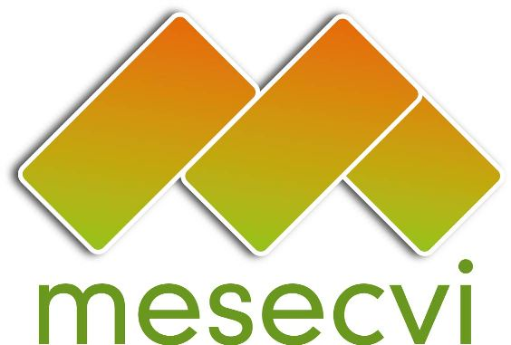
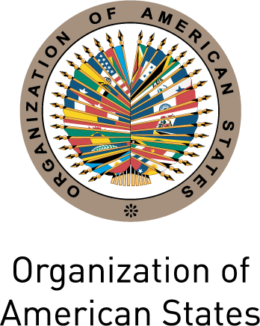

Mechanism to Follow Up on the OEA/Ser.L/ II.7.10
Convention of Belém do Pará (MESECVI) MESECVI/I-CE/doc.11/14.rev2
FIRST SPECIAL CONFERENCE October 24th, 2014
OF THE STATES PARTIES TO THE Original: Spanish
Convention of Belém do Pará
October 23rd and 24th, 2014

Mexico City

Agreements of the FIRST SPECIAL Conference of States PartIES to the Mechanism to Follow Up on the Implementation of the Inter-American Convention on the Prevention, Punishment and Eradication of Violence against Women, “Convention of Belém do Pará” (MESECVI)

The States Party to the Inter-American Convention on the Prevention, Punishment and Eradication of Violence against Women, Convention of Belém do Pará, gathered at the First Special Conference of States Party to the MESECVI, from October 23rd to 24th 2014 in Mexico City.

RECALLING that, with the aim of ensuring the effective implementation of the provisions of the Convention, on October 26th 2004 the First Conference of States Party was organized at the headquarters of the Organization of American States (OAS) and adopted the “Statute of the Mechanism to Follow Up on the Implementation of the Inter-American Convention on the Prevention, Punishment and Eradication of Violence against Women, “Convention of Belém do Pará” (MESECVI);

CONSIDERING the importance of the MESECVI as a tool that contributes to the implementation of the Belém do Pará Convention, with respect for the diversity of the countries of region;

REITERATING that strengthening the MESECVI is one of the priorities adopted by the Conference of States Party;

BEARING IN MIND that, at the beginning of the Second Multi-lateral Evaluation Round, the Conference of States Party, which took place on March 24th and 25th 2011 in Antigua, Guatemala, agreed to generate different formulas for strengthening the MESECVI, in particular its Committee of Experts (CEVI), that would ensure its institutional recognition and the full implementation of its recommendations;

BEARING IN MIND that, in accordance with Art. 25 of the CEVI Rules of Procedure, on July 30th and 31^{st,} 2013, the Follow-up Phase of the Second Multi-lateral Evaluation Round was initiated with the circulation of the document “Progress indicators to measure the implementation of the Belém do Pará Convention,” document MESECVI/CEVI/doc.188/13 rev.1;

TAKING INTO ACCOUNT that 19 States Party to the Belém do Pará Convention participated in the Follow-Up Phase of the Second Multi-lateral Evaluation Round by filling in the “Progress indicators to measure the implementation of the Belém do Pará Convention”, document MESECVI/CEVI/doc.188/13 rev.1;

REITERATING the importance of dialogue between the Competent National Authorities; the CEVI; women’s organizations and movements; and organizations for the defense of women’s human rights;

RECOGNIZING the commitment and contributions of the Committee of Experts (CEVI) to the States Party through the Second Follow-up Report on the Recommendations, as well as the collaboration of civil society organizations and other social actors with the activities of the Mechanism;

EXPRESING ITS THANKS FOR the important work of the Working Group for the strengthening of the MESECVI, which was attended by the Permanent Missions to the Organization of American States, the Competent National Authorities and the President and Vice-President of the CEVI, created as a result of the agreements of the V Conference of States Party, held on November 18 and 19, 2013. The Working Group has held seven meetings from January to September 2014 in order to consider and submit to the Conference its recommendations on the MESECVI Strategic Plan 2014-2017; the Guidelines for conducting discussions and / or meetings between the Conference of States Party and CEVI; Recommendations on tools to promote broad participation of experts in meetings of the CEVI; and Guidelines for the participation of civil society organizations in OAS activities;

REAFFIRMING the need to foster mechanisms for cooperation and the exchange of information and good practices between the States Party to the Convention, States that are not party, Permanent Observers to the OAS and other entities that address the issue at the sub-regional, regional and international levels;

THANKING the governments of Argentina, Mexico, Nicaragua and Trinidad and Tobago for the financial support that they have provided to the MESECVI during 2014;

CONVINCED that the strengthening of the MESEVI requires both the support of the States Party in terms of human and financial resources, and that the importance of the Mechanism is included in the regular budget of the OAS.

AGREE TO:

- Encourage the States Party who have not yet done so, to designate their Principal and Alternate Experts, according to the Statute of the Mechanism; with the objective of strengthening the function of the Committee of Experts;

- Reaffirm the commitments of the States to strengthening the MESECVI and the importance of disseminating the progress, good practices and challenges after 20 years of the Inter-American Convention on the Prevention, Punishment and Eradication of Violence against Women, “Convention of Belém do Pará” and 10 years after the establishment of its Follow up Mechanism;

- Urge Member States and Permanent Observers to the OAS to consider, as a matter of priority, increasing their contribution of the financial and human resources necessary to strengthen the work of the Mechanism in order to effectively address the situation of violence against women;

- Urge the States Party to make contributions of funds, within their capabilities, in order to provide assistance in extraordinary circumstances for the participation of experts in the CEVI meetings.

- Approve the following documents and request that the Technical Secretariat and the entities of the MESECVI take them into account in the effective strengthening of the Mechanism;

a) The MESECVI Strategic Plan, document MESECVI/I-CE/doc.4/14;

b) The Guidelines for the development of dialogues between the Competent National Authorities (CNA) and the Committee of Experts (CEVI) of the MESECVI, document MESECVI/I-CE/doc.6/14;

c) The Procedure and criteria for the use of funds to extraordinary finance the participation of experts in the meetings of the Committee of Experts of the Mechanism to Follow Up on the Implementation of the Inter-American Convention on the Prevention, Punishment and Eradication of Violence against Women - Convention of Belém do Pará, document MESECVI/I-CE/doc.5/14.rev2;

d) The Recommendations on tools for promoting broad participation of the experts in CEVI meetings, document MESECVI/I-CE/doc.8/14.rev2;

- Take note of the Second Follow-Up Report on the Implementation of the Recommendations of the Committee of Experts of the MESECVI, document MESECVI/I-CE/doc.10/14, and approve its publication which should incorporate the observations and the contributions of the States Party;

- Request that the Technical Secretariat of the MESECVI to propose the States that request them tools for exchange, training and technical assistance, in order to achieve the effective implementation of the “Second Follow-Up Report on the Implementation of the Recommendations of the Committee of Experts (CEVI) of the MESECVI,” document MESECVI/I-CE/doc.10/14,

- Invite the State who have not yet done so, to provide in a periodic way information to the “Progress indicators to measure the implementation of the Belém do Pará Convention,” (MESECVI/CEVI/doc.188/13 rev.1); taking advantage of the exchange that could be conducted with other States that have advanced further in this area, which would allow the Mechanism to develop a broader view of the efforts undertaken by the States Party have developed;

- Establish a dialogue among the entities of the MESECVI with regard to the Indicators to measure for the development of the Hemispheric Reports, and request that the Technical Secretariat formulate technical assistance to strengthen national capacities on indicators on gender based violence, according to 2.1 of the MESECVI Strategic Plan (2014-2017).

- Continue promoting, with the support of the Technical Secretariat of the MESECVI, cooperation and exchange of good practices and information between the Mechanism and other entities that address violence against women at the sub-regional, regional and international levels, such as the justice institutions of the region, the organisms that bring them together, and any multi-lateral mechanisms that bring together authorities on gender and women’s issues, including the Central American Council of Women Ministers (COMMCA), the Council on Human and Social Development of the Caribbean Community (CARICOM), The Mechanism for the Andean Region (CAAAMI), the Network of Women’s Ministries and High Authorities of MERCOSUR (RMAAM),The Ministerial Committee of Women and Equality of Opportunities of the Alliance Bolivarian for the Peoples of the Americas (ALBA-TCP) the Meeting of Ministers and Highest Authorities on Women’s Affairs of the MERCOSUR (RMAAM), and other specialized organs such as the Economic Commission for Latin America and the Caribbean (ECLAC), the Inter-American Development Bank (IADB), the United Nations Entity for Gender Equality and Empowerment of Women (UN Women), the Council of Europe, the Commission on the Status of Women (CSW) and the World Bank, among others;

- In addition, continue fostering and motivating the participation of civil society and other actors in the activities of the MESECVI, in the framework of Article 10.2 of the Statute of the MESECVI, taking into consideration the Guidelines for the Participation of Civil Society Organizations in OAS Activities, document CP/RES. 759 (1217/99);

- Express its thanks for the support of the Government of Mexico in hosting the First Special Conference of the States Party and warmly welcomes the offer made by the Government of Peru to host the Sixth Conference of States Party, to be held in the City of Lima, the first two weeks of October, 2015.

CIM03650E01

MESECVI, 2012. Agreements of the Fifth Conference of the States Party of the MESECVI, document MESECVI-V doc.109/13 rev.4 corr.1. Agreement 12.
Nicaragua does not approve the Second Follow-up Report on the Implementation of the Recommendations by the Committee of Experts (CEVI) of the MESECVI, document MESECVI/GT/ doc.8/14, given that the country was not part of the preparation of the cited report.
In accordance with Art. 25 of the Rules of Procedure of the Committee of Experts of the MESECVI

