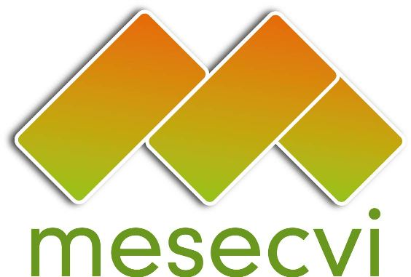
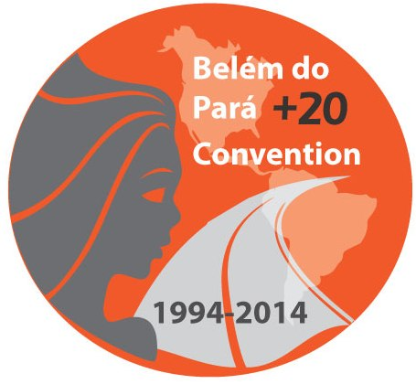
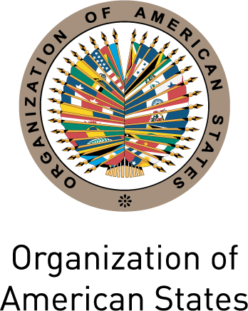

FOLLOW-UP MECHANISM TO THE OEA/Ser.L/ II.7.10
BELÉM DO PARÁ CONVENTION (MESECVI) MESECVI/I-CE/doc.2/14
FIRST SPECIAL CONFERENCE OF October 17th 2014
STATES PARTY TO THE BELÉM DO PARÁ CONVENTION Original: Spanish
October 22nd, 23rd and 24th 2014
Mexico City

input.doc

AGENDA

(Draft)

- Consideration and approval of the Draft Agenda and Organization of Work

- Presentation of Reports:
  - Report of the Technical Secretariat of the MESECVI (MESECVI/I-CE/doc.9/14)
  - Report of the Working Group on Strengthening of the MESECVI

- Process of strengthening the Follow Up Mechanism to the Belém do Pará Convention (MESECVI)
Consideration and approval of documents:
    - “Guidelines for the development of dialogues between the CNA and the CEVI” (MESECVI/I-CE/doc.6/14)
    - “MESECVI Strategic Plan 2014-2017” (MESECVI/I-CE/doc.4/14)
    - “Procedure and criteria for the use of funds to extraordinary finance the participation of experts in the meetings of the Committee of Experts of the MESECVI (CEVI)” (MESECVI/I-CE/doc.5/14)
    - Recommendations on tools for promoting broad participation of the Experts in CEVI meetings (MESECVI/I-CE/doc.8/14)

- Second Follow-up Report on the Recommendations of the Committee of Experts (MESECVI/I-CE/doc.10/14)

- Definition of the date of the Sixth Conference of States Party

- Adoption of Agreements of the First Special Conference of States Party to the MESECVI (MESECVI/I-CE/doc.11/14)

- Other matters

