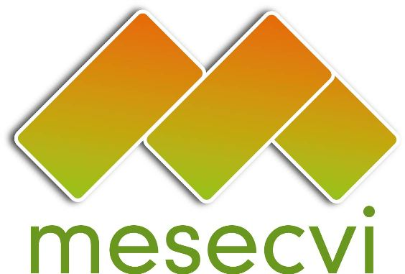
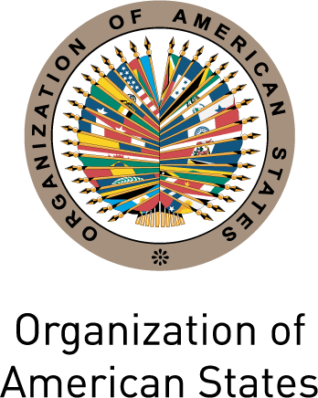
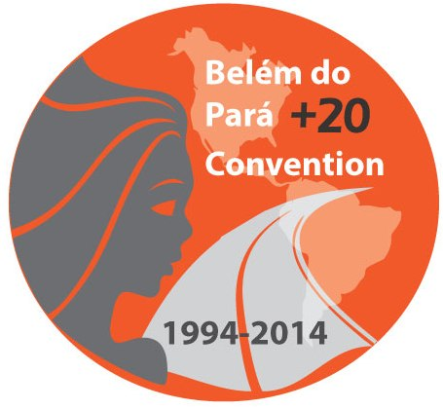

FOLLOW-UP MECHANISM TO THE OEA/Ser.L/ II.7.10
BELÉM DO PARÁ CONVENTION (MESECVI) MESECVI/I-CE/doc.4/14.rev1
FIRST SPECIAL CONFERENCE OF October 23th 2014
STATES PARTY TO THE BELÉM DO PARÁ CONVENTION Original: Spanish
October 23rd and 24th 2014
Mexico City

MESECVI STRATEGIC PLAN 2014-2017

Article 1 of the Mechanism’s Statute states: the Mechanism should follow up on the commitments undertaken by the States Parties to the Belém do Pará Convention; the purpose of the MESECVI is to promote the implementation of the Convention and contribute to the achievement of the objectives established therein; and, the Mechanism shall establish a system of technical cooperation among the States Parties, which shall be open to other Member States and Permanent Observer States.

Based on the document “Performance and impact of the First Multilateral Evaluation Round of the MESECVI: An examination based on the opinions of key players,” submitted at the Third Conference of States Parties (MESECVI-III/doc.56/11), the present Strategic Plan has as an objective the dissemination of the Convention of Belém do Pará, along with its historical significance, the rights enshrined in the Convention, and the mechanisms to promote and protect them.

In this sense, the present Strategic Plan was developed taking into consideration the importance of: 1) strengthening the institutionalism of the MESECVI; 2) strengthening the technical capacities of the national mechanisms on women’s affairs; 3) providing an intersectoral answer to problems regarding violence against women; and 4) raising societal awareness about these problems, as well as promote the Belém do Pará Convention.

- Strengthening the institutionalism of the MESECVI
In 2014, the MESECVI will celebrate 10 years of institutional development. According to the evaluation of its overall functioning and the impact of the First Multilateral Evaluation Round of the MESECVI, the Third Conference of States Parties of the MESECVI considered beginning an institutional strengthening process for the Mechanism. The study indicated that “six years after its creation, the MESECVI has managed to influence laws and policies for the prevention and punishment of violence against women in the region.” However, the conclusions of the report highlight that “the MESECVI has not yet had a significant impact,” although “it may be too soon to tell.”

The evaluation also noted the “scarce knowledge of the MESECVI’s existence, its functions, and modus operandi,” and the fact that “civil society organizations have had a relatively small degree of participation.” From this stems the need to “to encourage the kinds of changes that will turn this situation around,” developing a strategy to promote increased participation of the Experts in the meetings of the Committee of Experts of the MESECVI (CEVI), greater interaction among the Competent National Authorities and the Experts, and greater social participation in the implementation process, follow up, and visibility of the Convention.

- Strengthening the technical capacities of the national mechanisms on women’s affairs
The Belém do Pará Convention established an international obligation for States Parties—the duty to act with due diligence to prevent, investigate, and punish all forms of violence, whether it takes place in the home, the community, or the public sphere. However, the Hemispheric Report of 2007 indicated that most States still mistakenly confuse violence against women with domestic violence, which evidences limitations “in terms of fulfilling the broader fulfilment of violence against women contained in the Convention.”.

The report also indicates that most of the States “do not have a long-term plan for providing information to legislators that includes the delivery of documentation and the convening of workshops and events” to strengthen their capacities to implement the Convention. Thus, “it is imperative that the States address this problem by applying clear, appropriate, and effective policies,” as a way to address the phenomenon of violence against women as a human rights violation.

Similarly, the study of the Mechanism’s functioning, submitted at the Third Conference of States Parties, stressed that the National Reports are not disseminated, while the MESECVI and CIM Secretariat analyses “are not locally publicized by the States.” These failures to communicate about the MESECVI and its work in the region “make it difficult for the MESECVI to become an authority on the subject of violence against women for the individuals and organizations who work on this subject.”

- Intersectoral response to the problems of violence against women
In this context and despite the existence of the Convention, violence against women is present in every sphere of life in the region, and specifically at home, in schools and health centers, and at work. As the Inter-American Commission on Human Rights (IACHR) indicates in its “Report on Justice for Women Victims of Sexual Violence: Education and Health,” schools, universities, and health institutions, both public and private, are places where women exercise their economic, social, and cultural rights in the Americas. However, many times they also put women at risk. In these institutions different kinds of physical, psychological, institutional and sexual violence are manifested with terrible consequences for the health and wellbeing of thousands of women, girls, and teenagers in the region.

Justice, health, and education are the central tenets of the reparation process; access to justice and the eradication of stereotypes are likewise fundamental in the fight against violence in the region and are also central elements of the Mechanism. For this reason they have been considered the three most important areas for the follow-up on Convention obligations.

Moreover, the MESECVI has identified the improvement of protection guarantees for women’s human rights from a diversity and intercultural perspective as a prevailing need. For this reason the Strategic Plan of the MESECVI aims to influence public policies in these three sectors with a transversal vision, promoting an intercultural vision of women’s rights within a context of democratic governability.

- Societal awareness-raising regarding the problem of violence against women, as well as the promotion of the Belém do Pará Convention

The Hemispheric Report states that “the wealth of experience that the MESECVI has amassed” in monitoring the situation of violence against women in the region “has been underutilized thus far” and stresses that if the MESECVI “wants to take on a leadership role among the region’s institutions on the issue of violence against women, then it has to establish and pursue a clear policy of communicating its objectives, activities, strategies, and outcomes.”

The effective and sustainable implementation of the Belém do Pará Convention requires an independent and continual follow-up process, supported by the States Parties to the Convention, by individual women as well as by social and women’s movements, which requires interacting with the international community in order to demand and to advance in the attainment of their human rights.

From this analysis emerge the opportunity and the importance to promote more actively the visibility and the validity of the Convention in the countries of the region, both in legal practice as well as in society as a whole, and the usefulness of the MESECVI as a tool in the defense of women’s human rights.

For all these reasons, the following is proposed:

Goals | Actions | Outcome indicators  (annual frequency unless otherwise indicated) | Responsible/  Coordinators
- Institutional strengthening of the MESECVI | - Institutionalize dialogues between the organs of the MESECVI according to the document (MESECVI/GT/doc.6)  - Strengthen the dialogue between the organs of the MESECVI regarding measurement indicators for the elaboration of hemispheric reports.  - Appointment and effective participation of experts in the activities and meetings of the CEVI.  Promote the participation of civil society under the framework of the “Guidelines for the participation of Civil Society Organizations in the activities of the OAS”, as appropriate.  - Disseminate at the national level the guidelines for civil society participation in the OAS, in order to promote the registration of a large number of women’s organizations.  - Disseminate the mandate of the MESECVI at the national level and through electronic media  - Develop workshops and virtual forums  Set concrete goals for development and cooperation with the Inter-American Court of Human Rights and the Inter-American Commission on Human Rights as well as other international organs or organisms.  - Identify effective fundraising plans to increment the raise of funds, including the request to the General Secretariat of the OAS to grant additional regular funds to the MESECVI. | - Number of meetings developed  - Number of meetings held and agreements reached.  - Experts appointed and number of experts that have participated in the CEVI meetings  - Number of civil society organizations that participate in the forums, workshops, and other MESECVI events  - Number of ongoing activities/cooperation projects  - Variation of raised funds | NCA and CEVI with TS support  NCA and CEVI with TS support  NCA  NCA with TS support  TS in consultation with NCA  NCA and TS
- Strengthening national mechanisms on women’s affairs’ technical capacities for the prevention, punishment, and eradication of violence against women | - Formulate technical assistance programs to:  - Incorporate and use the indicators for the measurement of violence against woman in States Parties  - Strengthen national capacities in the design of indicators and data collection.  - Strengthen or develop mechanisms to advance in homogeneous and comparable indicators  - Develop a needs-based analysis to continue strengthening the technical capacities of national mechanisms of women’s affairs.  - Compile, publish, and exchange of good practices and public policies between competent authorities of respective countries for the prevention, punishment, and eradication of violence against women. | - Number of States that have received technical assistance from the MESECVI.  Number of States that have submitted their indicators to the MESECVI on time and in the proper format.  Number of countries for which data is statistically comparable and/or number of initiatives implemented to this end  - Information available on the needs of existing technical cooperation in States Parties.  - Number of publications compiling good practices  Exchange forums about good practices that have been developed. | TS in consultation with NCA and CEVI  TS in consultation with NCA and CEVI  TS in consultation with NCA and CEVI
- Intersectoral answer to problems regarding violence against women | - Strengthen communication channels between the national competent authorities of the MESECVI and other relevant national sectors, particularly in justice, education, health, public security, and authorities responsible for migrant women and authorities responsible for combating poverty, among others, as appropriate.  - Promote intersectoral initiatives for the elaboration and application of public policies oriented to follow up on obligations under the Belém do Pará Convention  - Adequate progressively national norms on protection standards and Inter-American jurisprudence.  - Disseminate good practices and public policies for the prevention, punishment, and eradication of violence against women in all relevant sectors, particularly in justice, education, health, public security, and authorities responsible for migrant women and authorities responsible for combating poverty, among others.  - Design and development of workshops and training materials for personnel from the relevant sectors mentioned before.  - Strengthen capacities in educational systems in the development of programmatic contents and curricula about the Belém do Pará Convention. | - Number of actions taken to institutionalize communication channels, like meetings, agreements or other actions.  - Public policies implemented and advances made on the adequacy of norms and standards of Inter-American protection and jurisprudence.  - Advancement in adequate national norms on protection standards and Inter-American jurisprudence.  - Number of actions taken, including disseminated publications, training materials that have been produced and distributed, designed and developed workshops, number of people that have been trained, disaggregated by sex and kind of personnel among which the training has been implemented and the training materials have been disseminated | NCA  NCA  NCA  NCA
4. Awareness and sensitization about the situation of violence against women and promotion of the Belém do Pará Convention. | - Disseminate information about the situation of violence against woman in the region, taking into consideration, among others, the situations of vulnerability mentioned in art.9 of the Convention.  - Promote communication strategies about the right of women to live without violence, aimed at the deconstruction of cultural stereotypes causing violence against women  - Organize public information campaigns in order to increase the visibility of the importance of the Belém do Pará Convention and the work of the MESECVI.  - Develop of a media directory of national and hemispheric relevance.  - Strengthen relations with the media and journalists sensitive to this issue.  - Design of training and awareness workshops for journalist and media outlets  - Promote partnerships with universities, film schools, and other arts schools, in order to include the issue of violence against women in their workshops, performances, contests, and other activities that could be taken as the centerpiece of the creative process, so that they constitute instances of awareness and dissemination, with multiplying effects. | Circulated publications, including materials to sensitize and to raise awareness that have been produced, workshops that have been held, and type and number of participants  Number of activities, elaborated and disseminated communication materials with media, journalists and television channels  Number of actions including, among others, elaborating training materials and number of annual workshops to sensitize journalists and media outlets. | NCA and TS  NCA and TS  NCA and TS
input.doc

Article 1.Purposes / objectives 1.1 The purposes of the mechanism shall be: a. To follow up on the commitments undertaken by the states parties to the Convention and review how they are being implemented; b. To promote the implementation of the Convention and contribute to achievement of the objectives established therein; c. To establish a system of technical cooperation among the states parties, which shall be open to other member states and permanent observer states, for the exchange of information, experiences, and best practices as a means to update and harmonize their domestic legislation, as appropriate, and attain other common objectives associated with the Convention.
MESECVI. Performance and impact of the First Multilateral Evaluation Round of the MESECVI: An examination based on the opinions of key players. OEA/Ser.L/II.7.10. MESECVI-III/doc.56/11. Antigua, Guatemala, 18 February 2011.
Ídem.
Ídem.
Ídem.
MESECVI. Hemispheric Report, First Multilateral Evaluation Round. Second Conference of States Parties. Caracas, Venezuela, July 9th-10th, 2008.
Ídem.
MESECVI. Performance and impact of the First Multilateral Evaluation Round of the MESECVI: An examination based on the opinions of key players. OEA/Ser.L/II.7.10. MESECVI-III/doc.56/11. Antigua, Guatemala, 18 February 2011
Ídem.
The Working Group for the Strengthening of the MESECVI has the mandate from the V Conference of States Parties of the Mechanism to elaborate a proposal of guidelines to develop the dialogues. Once the document would be approved its name will be provided.
[Art. 9 Convention of Belém do Pará: “(…) the States Parties shall take special account of the vulnerability of women to violence by reason of among others, their race or ethnic background or their status as migrants, refugees or displaced persons. Similar consideration shall be given to women subjected to violence while pregnant or who are disabled, of minor age, elderly, socio-economically disadvantaged, affected by armed conflict or deprived of their freedom.”

