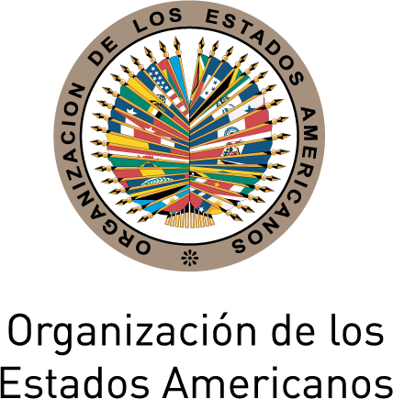
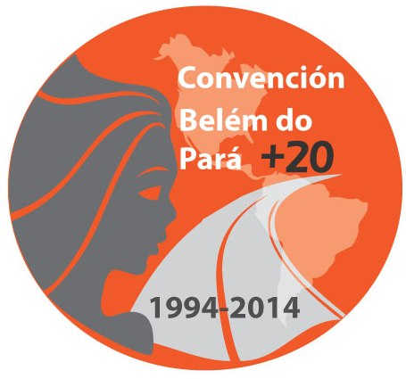
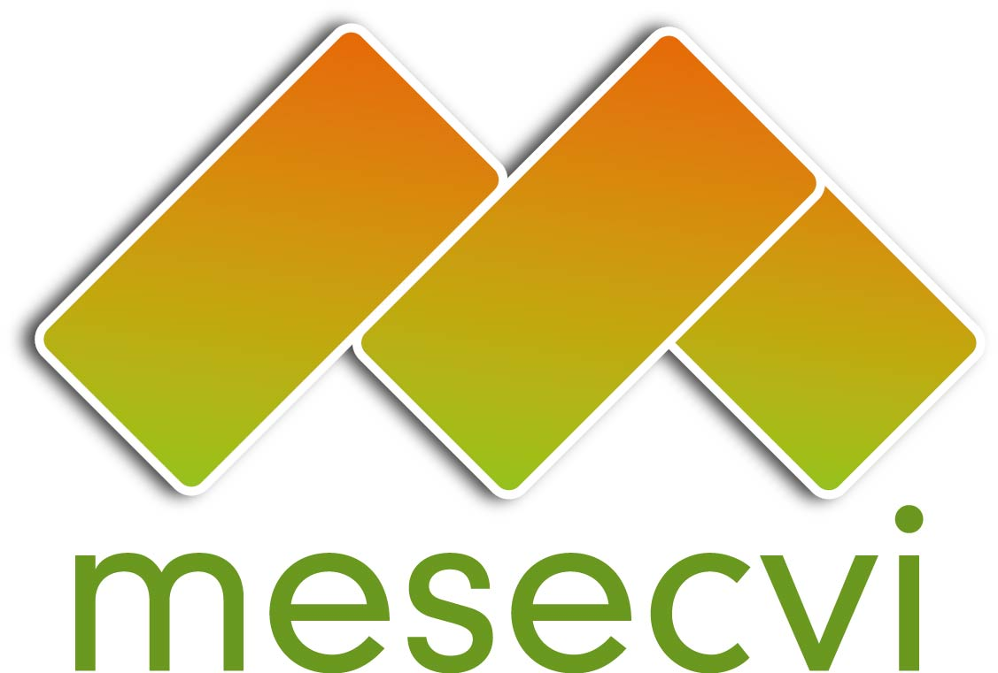

FOLLOW-UP MECHANISM TO THE OEA/Ser.L/II.7.10
BELÉM DO PARÁ CONVENTION (MESECVI) MESECVI/I-CE/doc.9/14
FIRST SPECIAL CONFERENCE OF October 21st 2014
STATES PARTY TO THE BELÉM DO PARÁ CONVENTION Original: Spanish
October 22nd, 23rd and 24th 2014

Mexico City

REPORT OF THE TECHNICAL SECRETARIAT OF THE MESECVI TO THE FIRST SPECIAL CONFERENCE OF STATES PARTY TO THE BELÉM DO PARÁ CONVENTION
(Item 2 on the Agenda)

This report provides a detailed account of the MESECVI’s activities of the Fifth Conference of States Party to the Belém do Pará Convention, held in Washington, D.C. from November 18-19, 2013, to September 30, 2014.

- OAS GENERAL ASSEMBLY MANDATES

The forty-fourth regular session of the General Assembly of the Organization of American States (OAS) was held on June 3-5, 2014, in Asunción, Paraguay. The President of the Inter-American Commission of Women (CIM), Alejandra Mora, presented the annual reports of the CIM and of the MESECVI. Once those reports had been presented, the General Assembly adopted resolution AG/RES. 2803 (XLIII-O/13), “Implementation of the Inter-American Convention on the Prevention, Punishment, and Eradication of Violence Against Women, ‘Belém do Pará Convention,” with the objective of strengthening the work of the MESECVI to ensure the effective exercise of the right of women to a life free from violence in accordance with the Belém do Pará Convention.

In fulfillment of the mandates emanating from the resolution, the MESECVI Technical Secretariat has urged the States Party to:

- Implement the recommendations of the MESECVI to encourage full compliance with the Belém do Pará Convention;

- Foster coordination between the bodies responsible for implementing public policy on prevention, punishment, and assistance in cases of violence against women, and civil society organizations involved in the issue at the national, regional, and international level;

- Promote the adoption of action protocols to guarantee access to justice for women that are victims of violence through technical cooperation with national mechanisms for women and other state agencies/;

- Make voluntary contributions to the MESECVI Fund in order to furnish the Mechanism with the necessary human and financial resources to ensure its full, stable, and effective operation;

- Establish or support mechanisms that facilitate technical assistance and cooperation at the national, regional, and international level for sharing information, experiences, and best practices in implementing the Convention, in keeping with Articles 1(1)(c) and 10(4) of the MESECVI Statute;

- Appoint their Competent National Authorities and experts to the Mechanism if they have not already done so; and

- Support the participation of their Competent National Authorities and Experts in the MESECVI process to ensure the continuous and effective operation thereof.

Furthermore, to date, the MESECVI Technical Secretariat has been engaged in:

  - Identifying new and emerging areas to be included in the draft questionnaire for the Evaluation Rounds of the MESECVI, in accordance with Article 7(b) of the Rules of Procedure of the CEVI and within the available financial resources;

  - Providing advice to the Permanent Council and its respective organs on specific and relevant aspects of the situation of violence against women in the States Party; and

  - Continuing to promote cooperation at subregional, regional and international level for the sharing of experiences and information between the MESECVI and other agencies tackling violence against women.

  - PROGRESS MADE IN THE SECOND MULTILATERAL EVALUATION ROUND (2013/2014)

The Second Multilateral Evaluation Round began in July 2013 with distribution to the States Party of the Progress Indicators for Measuring the Implementation of the Inter-American Convention on the Prevention, Punishment, and Eradication of Violence against Women, “Belém do Pará Convention.”

A total of nineteen (19) states, of the 32 States Party to the Convention, have submitted their responses to the questionnaire, to wit: Argentina, Barbados, Bolivia, Brazil, Chile, Colombia, Costa Rica, the Dominican Republic, Ecuador, El Salvador, Grenada, Guatemala, Mexico, Panama, Paraguay, Peru, Suriname, Uruguay and Venezuela.

The Committee of Experts, with the support of the MESECVI Technical Secretariat, has analyzed the information received for the preparation of the Second Follow-Up Report to the Recommendations of the Committee of Experts.

Eleventh Meeting of the Committee of Experts of the MESECVI

The Eleventh Meeting of the Committee of Experts of the MESECVI was held on September 18-19, 2014, in the city of Montevideo, Uruguay. Participating in the meeting’s opening session were Daniel Olesker, Minister of Social Development of the Oriental Republic of Uruguay; Beatriz Ramírez, Director of the National Women’s Institute (INMUJERES) and Competent National Authority of the Follow-Up Mechanism to the Belém do Pará Convention (MESECVI); Alejandra Mora Mora, Minister for the Status of Women, National Women’s Institute (INAMU) and President of the Inter-American Commission of Women; Flor de María Díaz, President of the Committee of Experts of the MESECVI; Ambassador John Biehl del Río, Representative of the Organization of American States in Uruguay; Silvana Guerra, President of the Gender Affairs Commission of the Ministry of Foreign Affairs of the Oriental Republic of Uruguay; Collin Cadier, of Mercado Común del Sur (MERCOSUR) and Luz Patricia Mejía, Technical Secretary of the MESECVI.

At the request of the host country, a Forum was held on “Women’s Human Rights: Violence and Sexual and Reproductive Rights,” with the participation, as speakers, of Sergio Araujo Gambaro, Legal Advisor on Sexual and Reproductive Health, Uruguayan Ministry of Public Health; Soledad García Muñoz, of the Inter-American Institute of Human Rights (IIDH); Diana González Perrett, Expert of Uruguay to the CEVI; Barbara Bailey, Expert of Jamaica to the CEVI, and Susana Chiarotti, Expert of Argentina to the CEVI. Throughout these presentations, Experts were given the opportunity to exchange concerns and observations with the guest speakers, and a dialogue was opened with the civil society organizations in attendance at the forum.

This meeting was also the stage for the approval of the Declaration on Violence and Sexual and Reproductive Rights,” which contains the states’ principal obligations in guaranteeing the exercise of the sexual and reproductive rights of women, free from violence.

During the meeting, the Experts then reviewed the Draft Second Follow-Up Report on the Recommendations of the Committee of Experts and the corresponding Country Reports, and an agreement was reached to submit these to the First Special Conference of States Party to the MESECVI in accordance with Article 25 of the Rules of Procedure of the CEVI. On October 2, 2014, the Technical Secretariat of the MESECVI distributed the document to the Competent National Authorities and the Permanent Missions to the OAS for consideration.

- III. STRENGTHENING OF THE MESECVI

In issues relating to the strengthening of the MESECVI, the Fifth Conference of States Party took place on November 18-19, 2013 in Washington, D.C. Two (2) preparatory meetings were held prior to this conference and as a result of the Fifth Conference of States Party, the Working Group for the Strengthening of the MESECVI was created.

The first and second preparatory meetings for the Fifth Conference of States Party took place on November 6, 2013 and November 13, 2013 at the OAS’s General Services Building in Washington, D.C. During the first preparatory meeting, an agreement was reached to create an informal working group, which met on November 7, 2013. The objective of the working group was to agree on the documents to be covered during the second preparatory meeting. In both preparatory meetings, work was done, and consensus reached, on the list of documents to be presented at the Conference of States Party, on the order of topics on the schedule of activities, and on the order of precedence to be followed. Both preparatory meetings were attended by a significant number of states: nineteen (19) states at the first meeting and twenty (20) at the second meeting, according to the attendance lists they signed.

Regarding civil society participation at the Conference, on November 7, 2013, we informed the Centro de Derechos Reproductivos [Center for Reproductive Rights] (Colombia) about the procedure for registering as a civil society organization with the OAS in response to its request to attend the Fifth Conference of States Party. Likewise, on November 14, 2013, an invitation to take part in the Fifth Conference of States Party to the Belém Do Pará Convention was extended to the civil society organizations registered with the OAS.

The Fifth Conference of States Party took place on November 18-19, 2013, and was attended by twenty-one (21) states the first and second days; detailed information on the participation of the states is provided in the table contained in the corresponding annex. At the meeting, the Agreements document (MESECVI-V doc.109/13 rev. 4 corr. 1) was approved. Included in this document was the mandate to create a Working Group for the Strengthening of the MESECVI to be chaired by the Permanent Mission of Peru to the OAS. The instructions to the Working Group would be to consider and make the corresponding recommendations on the topics below to the Conference:
  - The Strategic Plan of the MESECVI 2014-2017. The Strategic Plan should adhere to the scope of mechanism and is to take into account the competencies established in the Statute of the MESECVI for the Conference of States Party and the Committee of Experts;
  - Guidelines for holding dialogues and/or meetings between the Conference of States Party and the CEVI;
  - Recommendations on tools for promoting broad participation of the experts in CEVI meetings, including financing their participation in official CEVI meetings using the MESECVI Specific Fund created under Article 11 of the Mechanism’s Statute;
  - Promotion of the participation of civil society and other actors within society in accordance with the “Guidelines for the Participation of Civil Society Organizations in OAS Activities” [CP/RES. 759 (1217/99)]”

In order to fulfill its mandate, the Working Group met seven times prior to the First Special Conference of States Party to the MESECVI, details of which are provided in the Report of the Working Group for the Strengthening of the MESECVI, document MESECVI/I-CE/doc.12/14.

- Promotion of the MESECVI

To commemorate the 20th Anniversary of the Belém do Pará Convention, a live-streamed side event was held on March 10, 2014, at the 58th Session of the UN Commission on the Status of Women in New York City on “The Belém do Pará Convention and the Istanbul Convention of the Council of Europe: A response to violence against women worldwide.” At this event, the publication entitled “Regional Tools to Fight Violence Against Women: The Belém do Pará and Istanbul Conventions” was presented, a joint work by the Technical Secretariat of the MESECVI and the Council of Europe, which contains a welcome contribution from the Permanent Mission of Argentina to the United Nations.

With the support of the Technical Secretariat, the CEVI Experts produced a Guide to the Interpretation of the Belém do Pará Convention, with a foreword kindly provided by Linda Poole, former Executive Secretary of the CIM and architect of the Convention, which will be presented at the First Special Conference of States Party to the MESECVI.

To mark the anniversary of the Belém do Pará Convention, the Secretariat designed a commemorative anniversary logo and organized the "Wear Red for Women” Campaign to Prevent and Eradicate Violence Against Women, held on May 2 in the Hall of the Americas in the Main Building of the OAS. This event consisted of the presentation of a video on violence against women and some brief remarks from OAS Secretary General, José Miguel Insulza, and by a number of permanent representatives to the OAS and observer countries. Invitees included OAS staff, representatives of the permanent missions, permanent observers, civil society, and representatives of academia

On May 13, the Executive Secretary of the CIM and with the President of the CEVI, were invited to take part in an event on Sexual Violence in Armed Conflict: Reflections from Latin America.

The Belém do Pará +20 Hemispheric Forum: "Prevention of violence against women: Good practices and proposals for the future,” was held in the city of Pachuca, Hidalgo, in Mexico, on May 14-16. Participating in the opening ceremony were OAS Secretary General, José Miguel Insulza; José Francisco Olvera Ruiz, Governor of the State of Hidalgo; Lía Limón, Undersecretary for Legal Affairs and Human Rights, Ministry of the Interior of Mexico; Rebeca Grynspan, Secretary General of the Ibero-American General Secretariat (SEGIB); and Lorena Cruz, President of the National Women’s Institute and the Competent National Authority of México to the CIM, among other senior authorities.

The Competent National Authorities of the MESECVI, the CEVI Experts and other guests took part in the event. The meeting adopted the Declaration of Pachuca: “Strengthening efforts to prevent violence against women,” a document that brings together proposals and recommendations on how to prevent violence against women effectively.

The States Party to the Belém do Pará Convention agreed at the Fifth Conference of States Party “To continue motivating and promoting the participation of civil society and other actors within society in the activities of the MESECVI under the framework of Article 10.2 of its Statute, taking into consideration the “Guidelines for the participation of civil society organizations in OAS activities” [CP/RES. 759 (1217/99)]” Pursuant to this agreement, the Technical Secretariat of the MESECVI implemented two strategies:

- It developed a campaign, which started in June, to provide key information and support to organizations promoting the human rights of women, interested in registering with the OAS. The campaign consisted of preparing e-bulletins, disseminating information on assistance on the MESECVI website and through social media, and condensing and simplifying information on requirements.

As a result thereof, 14 organizations and three human rights defenders from six countries responded to the campaign requesting information on the Mechanism and how to register. The MESECVI provided information and support to help strengthen their processes and capacities, which would enable them to register in the coming months.

This assistance has so far resulted in two organizations – Comunicación para la Igualdad, and JASS Asociadas por lo Justo – filing applications that contained all the documents required to register. The Center for Reproductive Rights has sought support from the Secretariat to follow up its application, which it filed some months prior to the campaign.

- In early June, the Technical Secretariat identified almost one hundred organizations promoting the human rights of women registered with the OAS and contacted them with information on how to send in submissions for the preparation of the Second Follow-Up Report. This step has the objective of promoting the participation of these organizations, pursuant to the legal instruments of the MESCVI. Following these actions, eight organizations registered with the OAS sent submissions (shadow reports) for the preparation of the Second Follow-Up Report, the largest ever participation for a follow-up report..

Continuing the commemoration of the 20th Anniversary of the Belém do Para Convention, on September 16-17, the National Women’s Institute of Uruguay invited the President of the CEVI, Argentine Expert Susana Chiarotti, Brazilian Expert Leila Linhares, and the Secretary of the MESECVI to take part in the event.

On September 29, the Technical Secretariat was invited to take part in a meeting with the Parliamentary Women’s Group in El Salvador. That same day, it took part in a meeting of civil society addressing sexual and reproductive rights in El Salvador. On September 30, a visit was made to the women’s prison in Xilopango.

On October 1-9, Costa Rica hosted the International Congress on Inclusiveness, Non-Discrimination and Access to Justice, organized by the Supreme Court of Justice of Costa Rica, which was attended by the Technical Secretariat.

- Financing the MESECVI

In 2014, the fund created for the MESECVI received contributions from Argentina, Mexico and Nicaragua.
Country | Amount  (in US$)
Argentina | $2,863.37
Mexico | $817.18
France | $1,840.86
Total | $5,521.41

All OAS and CIM Assemblies have repeated the call to governments to contribute human or financial resources to the MESECVI. In September 2012, the Secretary General of the OAS sent a letter to all foreign ministers of the States Party to the Conference requesting financial contributions, human resources, or other in-kind donations for the MESECVI.

It is worth noting that, presently, the MESECVI has very limited resources for fully complying with its multiple mandates and its objectives as a hemispheric authority on the prevention, punishment, and eradication of violence against women. In this respect, a key aspect of the efforts to strengthen the MESECVI lies in focusing on mobilizing resources from both the States Party to the Convention and other potential donors through the development and implementation of specific projects.

This situation is long-standing. As the table below illustrates, contributions to the Mechanism have always been limited and thus, within the strengthening process, it is necessary to take into account both the objectives laid out and the resources required to meet them.

Contributions to the MESECVI (Annual)

Sum of Contributions (US$)
Year | Donor | Total
2004 | Mexico | 29,970.00
2004 Total |  | 29,970.00
2005 | Brazil | 10,000.00
 | Mexico | 55,575.00
2005 Total |  | 65,575.00
2006 | Mexico | 54,151.62
2006 Total |  | 54,151.62
2007 | Argentina | 9,535.40
 | France | 10,000.00
 | Mexico | 54,894.78
2007 Total |  | 74,430.18
2008 | China | 15,000.00
 | Mexico | 42,938.00
 | Venezuela | 76,466.00
2008 Total |  | 134,404.00
2009 | Argentina | 5,000.00
 | China | 30,000.00
 | Mexico | 34,349.00
 | Trinidad and Tobago | 15,000.00
2009 Total |  | 84,349.00
2010 | Mexico | 25,478.00
 | Trinidad and Tobago | 15,000.00
2010 Total |  | 40,478.00
2011 | Argentina | 20,000.00
 | Mexico | 19,110.00
 | Trinidad and Tobago | 15,000.00
2011 Total |  | 54,110.00
2012 | Argentina | 15,000.00
 | Mexico | 14,333.00
 | Trinidad and Tobago | 15,000.00
2012 Total |  | 44,333.00
2013 | Argentina  France  Mexico | 15,000.00  2,091.89
 | Argentina  France  Mexico | 29,453.11
 | Nicaragua | 5,000.00
 | Suriname | 2,000.00
 | Trinidad and Tobago | 15,000.00
2013 Total |  | 68,545.00
2014 | Argentina | 15,000.00
 | Mexico | 34,529.59
 | Nicaragua | 6,000.00
2014 Total |  | 55,529.59
Grand Total |  | 705,875.39

ANNEX I

Second Multilateral Evaluation Round (2010-2013):
Responses to the questionnaire, preliminary reports, comments from the CNAs, final reports, and final observations on the country reports adopted by the CEVI
Country | EVALUATION |  |  |  |  | FOLLOW-UP
Country | Response to the questionnaire | Preliminary Report | Comments – CNAs | Final Report | Final Observations – CNAs |  | Response – indicators
- Antigua and Barbuda | YES | YES | NO | YES | NO |  | NO
- Argentina | YES | YES | YES | YES | YES |  | YES
- Bahamas | YES | YES | YES | YES | YES |  | NO
- Barbados | YES | YES | YES | YES | YES |  | YES
- Belize | YES | YES | YES | YES | YES |  | NO
- Bolivia | YES | YES | NO | YES | YES |  | YES
- Brazil | YES | YES | NO | YES | YES |  | YES
- Chile | YES | YES | YES | YES | YES |  | YES
- Colombia | YES | YES | YES | YES | YES |  | YES
- Costa Rica | YES | YES | YES | YES | NO |  | YES
- Dominica | YES | YES | YES | YES | YES |  | NO
- Ecuador | YES | YES | YES | YES | YES |  | YES
- El Salvador | YES | YES | YES | YES | YES |  | YES
- Grenada | NO | NO | NO | NO | NO |  | YES
- Guatemala | YES | YES | YES | YES | YES |  | YES
- Guyana | YES | YES | NO | YES | NO |  | NO
- Haití | NO | NO | NO | NO | NO |  | NO
- Honduras | NO | NO | NO | NO | NO |  | NO
- Jamaica | YES | YES | YES | YES | YES |  | NO
- Mexico | YES | YES | YES | YES | YES |  | YES
- Nicaragua | NO | NO | NO | NO | NO |  | NO
- Panama | YES | YES | NO | YES | YES |  | YES
- Paraguay | YES | YES | YES | YES | NO |  | YES
- Peru | YES | YES | YES | YES | YES |  | YES
- Dominican Republic | YES | YES | YES | YES | YES |  | YES
- Saint Kitts and Nevis | YES | YES | YES | YES | YES |  | NO
- Saint Lucia | YES | YES | NO | YES | NO |  | NO
- Saint Vincent and the Grenadines | YES | YES | NO | YES | NO |  | NO
- Suriname | YES | YES | YES | YES | YES |  | YES
- Trinidad and Tobago | YES | YES | YES | YES | NO |  | NO
- Uruguay | YES | YES | YES | YES | YES |  | YES
- Venezuela | YES | YES | YES | YES | YES |  | YES
TOTAL | 28 | 28 | 21 | 28 | 21 |  | 19

ANNEX II
Status of Designation of Experts and Competent National Authorities during the First and Second Multilateral Evaluation Rounds

COUNTRY | EXPERTS |  | CNA
COUNTRY | 1st MER | 2nd MER (2013) | 1st MER | 2nd MER (2014)
- Antigua and Barbuda | YES | YES | YES | YES
- Argentina | YES | YES | YES | YES
- Bahamas | YES | YES | YES | YES
- Barbados | YES | YES | YES | YES
- Belize | YES | YES | YES | NO
- Bolivia | YES | YES | YES | NO
- Brazil | YES | YES | YES | YES
- Chile | YES | NO | YES | YES
- Colombia | YES | YES | YES | YES
- Costa Rica | YES | YES | YES | YES
- Dominica | YES | YES | YES | YES
- Ecuador | YES | NO | YES | YES
- El Salvador | YES | YES | YES | YES
- Grenada | NO | YES | NO | YES
- Guatemala | YES | YES | YES | YES
- Guyana | YES | YES | YES | YES
- Haití | YES | YES | YES | YES
- Honduras | YES | NO | YES | NO
- Jamaica | YES | YES | YES | YES
- Mexico | YES | YES | YES | YES
- Nicaragua | YES | NO | YES | YES
- Panama | YES | YES | YES | YES
- Paraguay | YES | YES | YES | YES
- Peru | YES | YES | YES | YES
- Dominican Republic | YES | YES | YES | YES
- Saint Kitts and Nevis | NO | YES | NO | YES
- Saint Lucia | NO | YES | YES | YES
- Saint Vincent and the Grenadines | YES | YES | NO | YES
- Suriname | YES | YES | NO | NO
- Trinidad and Tobago | YES | NO | YES | YES
- Uruguay | YES | YES | YES | YES
- Venezuela | YES | YES | YES | YES
TOTAL | 29 | 26 | 28 | 28

ANNEX III
Participation in the Conferences of States Party during the First and Second Multilateral Evaluation Rounds

COUNTRY / PAÍS | 1st MER |  | 2nd MER
COUNTRY / PAÍS | 1st CONFERENCE  (2004) | 2nd CONFERENCE  (2008) | 3rd CONFERENCE  (2011) | 4th CONFERENCE  (2012) | 5th CONFERENCE  (2013)
- Antigua and Barbuda | NO | NO | YES | NO | NO
- Argentina | YES | YES | YES | YES | YES
- Bahamas | YES | NO | NO | NO | YES
- Barbados | YES | YES | NO | YES | YES
- Belize | YES | NO | NO | YES | NO
- Bolivia | YES | YES | YES | YES | YES
- Brazil | YES | YES | YES | YES | YES
- Canada/ | YES | NO | NO | NO | NO
- Chile | YES | YES | YES | YES | YES
- Colombia | YES | YES | YES | YES | YES
- Costa Rica | YES | YES | YES | YES | YES
- Dominica | NO | NO | YES | NO | NO
- Ecuador | YES | YES | YES | YES | YES
- El Salvador | YES | YES | YES | YES | YES
- Grenada | NO | NO | YES | NO | NO
- Guatemala | YES | YES | YES | YES | YES
- Guyana | NO | NO | NO | NO | YES
- Haití | NO | YES | NO | YES | YES
- Honduras | YES | YES | NO | YES | NO
- Jamaica | NO | YES | NO | NO | NO
- Mexico | YES | YES | YES | YES | YES
- Nicaragua | YES | YES | NO | YES | YES
- Panama | YES | YES | YES | YES | YES
- Paraguay | YES | YES | NO | YES | YES
- Peru | YES | YES | YES | YES | YES
- Dominican Republic | YES | YES | YES | YES | YES
- Saint Kitts and Nevis | YES | NO | YES | NO | NO
- Saint Lucia | YES | NO | YES | YES | YES
- Saint Vincent and the Grenadines | NO | NO | YES | YES | NO
- Suriname | NO | NO | NO | NO | NO
- Trinidad and Tobago | YES | YES | YES | YES | YES
- United States/ | YES | NO | YES | NO | NO
- Uruguay | YES | NO | YES | YES | YES
- Venezuela | YES | YES | YES | YES | YES
TOTAL | 26 | 21 | 23 | 24 | 23

ANNEX IV
Participation of Experts in the Meetings of the Committee of Experts (2005-2013)

Country | First Meeting  (2005) | Second Meeting (2006) | Third Meeting (2007) | Fourth Meeting (2008) | Fifth Meeting (2009) | Sixth  Meeting (2010) | Seventh Meeting  (2011) | Eighth Meeting  (2012) | Ninth  Meeting  (2012) | Tenth Meeting (2013) | Eleventh Meeting (2014)
Antigua and Barbuda | NO | YES | YES | YES | YES | YES | NO | NO | NO | NO | NO
Argentina | YES | YES | YES | YES | YES | YES | YES | YES | YES | YES | YES
Bahamas | YES | YES | NO | NO | NO | YES | NO | NO | YES | NO | NO
Barbados | NO | NO | NO | NO | NO | NO | YES | NO | NO | YES | NO
Belize | YES | NO | NO | NO | YES | YES | YES | NO | YES | NO | NO
Bolivia | YES | NO | YES | NO | NO | NO | NO | NO | NO | NO | NO
Brazil | YES | YES | YES | YES | YES | YES | NO | NO | YES | YES | YES
Chile | NO | YES | YES | YES | YES | YES | YES | YES | NO | NO | NO
Colombia | YES | NO | NO | YES | YES | NO | NO | NO | YES | YES | YES
Costa Rica | YES | YES | YES | YES | YES | YES | YES | NO | YES | NO | YES
Dominica | NO | NO | NO | NO | NO | YES | YES | NO | NO | NO | NO
Ecuador | YES | YES | YES | YES | YES | YES | YES | NO | YES | NO | NO
El Salvador | YES | YES | YES | YES | NO | YES | YES | YES | YES | YES | YES
Grenada | NO | NO | NO | NO | NO | YES | YES | NO | YES | YES | NO
Guatemala | YES | YES | YES | YES | YES | YES | YES | YES | YES | YES | NO
Guyana | NO | NO | NO | NO | NO | NO | NO | NO | NO | NO | NO
Haití | YES | NO | YES | YES | YES | NO | NO | NO | NO | NO | NO
Honduras | YES | YES | NO | YES | NO | NO | NO | NO | NO | NO | NO
Jamaica | NO | YES | YES | NO | NO | NO | NO | NO | YES | NO | YES
Mexico | YES | YES | YES | YES | YES | YES | YES | YES | YES | YES | NO
Nicaragua | YES | YES | NO | NO | NO | NO | NO | NO | NO | NO | NO
Panama | YES | NO | YES | NO | NO | YES | YES | YES | YES | NO | YES
Paraguay | YES | YES | YES | YES | YES | YES | YES | YES | YES | YES | YES
Peru | YES | YES | YES | NO | NO | YES | NO | NO | NO | YES | NO
Dominican Republic | YES | NO | YES | NO | NO | YES | YES | NO | YES | NO | YES
Saint Kitts and Nevis | NO | NO | NO | NO | NO | NO | YES | NO | YES | YES | YES
Saint Lucia | YES | YES | NO | NO | NO | YES | YES | NO | NO | YES | YES
Saint Vincent and the Grenadines | NO | NO | NO | NO | NO | YES | YES | NO | YES | YES | YES
Suriname | NO | YES | NO | NO | NO | NO | NO | NO | NO | NO | NO
Trinidad and Tobago | NO | NO | NO | NO | NO | YES | YES | NO | NO | NO | NO
Uruguay | YES | NO | YES | YES | NO | NO | YES | NO | YES | YES | YES
Venezuela | NO | NO | YES | YES | YES | YES | NO | YES | NO | NO | YES
TOTAL | 20 | 17 | 18 | 15 | 13 | 21 | 19 | 8 | 18 | 14 | 14

Annex V

States with Appointment or Official Notification of Expert Pending in February 2014
at October 2014

Country |  | Name
1 | Chile | Appointment of Experts (P and A) pending
2 | Ecuador | Appointment of Principal Expert pending
3 | Honduras | Appointment of Experts (P and A) pending
4 | Nicaragua | Appointment of Experts (P and A) pending
5 | Trinidad and Tobago | Appointment of Principal Expert pending

input.doc

?. The states of Guatemala and Ecuador state that their national legislation recognizes the right to life at conception.
For more information, see Annex I.
CLADEM (Regional and Country-specific reports: Brazil, Colombia, the Dominican Republic, El Salvador, Nicaragua, Paraguay, Peru and Uruguay); MERCOSUR Women’s Forum (Argentina); ORMUSA and CEJIL (El Salvador); the Mexican Commission for the Defense and Promotion of Human Rights – CMDPDH (Mexico); Regional Coalition Against Trafficking in Women and Girls in Latin America and the Caribbean (Mexico); Women’s Global Network for Reproductive Rights – WGNRR et al (Dominican Republic); and Fundación Construir (Bolivia).
- , The Competent National Authority of Grenada submitted its response to the CEVI’s questionnaire after the Seventh Meeting of the Committee and consequently, such response could not be analyzed during that meeting.
- . The OAS General Assembly lifted its suspension of the Government of Honduras in June 2011.
- , Participated as an observer (Article 4 of the MESECVI Statute).
- , Idem.

