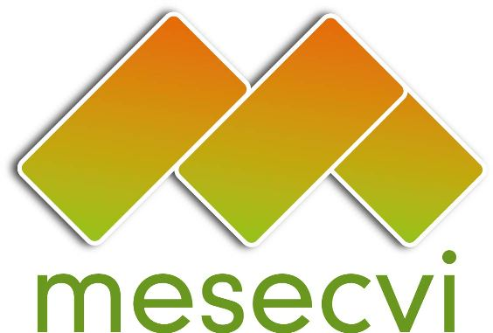
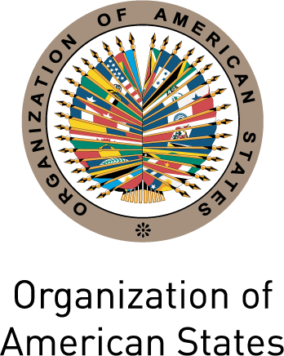

FOLLOW-UP MECHANISM OEA/Ser.L/II.7.10
CONVENTION OF BELÉM DO PARÁ (MESECVI) MESECVI-IV/doc.101/12 rev.1
FOURTH CONFERENCE OF STATES PARTIES 16 April 2012
April 16, 2012 Original: Spanish
Washington DC

AGREEMENTS OF THE FOURTH CONFERENCE OF STATES PARTIES TO
THE MECHANISM TO FOLLOW UP ON THE IMPLEMENTATION OF THE
INTER-AMERICAN CONVENTION ON THE PREVENTION, PUNISHMENT,
AND ERADICATION OF VIOLENCE AGAINST WOMEN,
“CONVENTION OF BELÉM DO PARÁ” (MESECVI)

The States Parties to the Inter-American Convention on the Prevention, Punishment, and Eradication of Violence against Women, “Convention of Belém do Pará,” convened for the Fourth Conference of States Parties of the MESECVI on April 16, 2012, in Washington DC;

RECALLING that, the First Conference of States Parties was held at the Organization of American States (OAS) headquarters, on October 26, 2004, and adopted the Statute of the Mechanism to Follow Up on the Implementation of the Inter-American Convention on the Prevention, Punishment, and Eradication of Violence against Women, “Convention of Belém do Pará,” (MESECVI); to ensure implementation of the provisions contained in the Convention;

REAFFIRMING the importance of the MESECVI as an instrument that contributes to the implementation of the Convention of Belém do Pará; and which takes into account the diversity of the countries of the region;

BEARING IN MIND that, during the Third Conference of States Parties, held in Antigua, Guatemala, on March 24-25, 2011, the First Multilateral Evaluation Round was officially concluded with the adoption of the Follow-Up Report on the Recommendations made by the CEVI to the governments, as well as agreements aimed at the strengthening of the Mechanism;

CONSIDERING that the Second Multilateral Evaluation Round, started on April 2010, successfully concluded its evaluation phase with consideration of the corresponding Final Report of the Committee of Experts (CEVI), comprising 28 Country Reports and the Hemispheric Report, submitted to this Fourth Conference;

RECALLING that, in preparation for the follow-up phase of the Second Multilateral Evaluation Round, the Third Conference of States Parties expressed interest in contributing to the debate on follow-up indicators by requesting that the Technical Secretariat prepare a consolidated document of the presentations and results of Panel II on “Indicators on Violence against Women; Comparative Analysis of the Initiatives promoted by the Inter-governmental Mechanisms: Evaluation of the existing ones in the International Organizations”; and accepting the offer made by the Government of Mexico to prepare a proposal with indicators on violence against women. The Conference also recommended that the CEVI take into account the indicators on violence against women used by the United Nations (UN) Statistics Division and the Economic Commission for Latin America and the Caribbean (ECLAC);

RECALLING ALSO that, the Third Conference of States Parties agreed that the MESECVI Technical Secretariat should prepare the draft Rules of Procedure of the Solidarity Sub-Fund, in accordance with Article 12 of the CEVI Rules of Procedure, submitted as document MESECVI-IV/doc.98/12 to the Fourth Conference; in order to support the governments which under special circumstances, are unable to finance the participation of its Experts in the meetings of the Committee,

RECOGNIZING the commitment and contributions of the Committee of Experts (CEVI) to the States Parties through the Multilateral Evaluation Rounds, as well as the collaboration of civil society organizations in the activities of the Mechanism;

BEARING IN MIND that the Third Conference of States Parties, requested that the Technical Secretariat prepare a proposal based on the MESECVI legal instruments, in order to establish clear procedures for the appointment of Experts, regarding the profile of Experts and procedures for their appointment; which has been submitted to this Fourth Conference (document MESECVI-IV/doc.99/12)

REAFFIRMING the need to continue making progress on public policies, plans, programs and actions for the prevention and punishment of violence against women, girls and adolescents; as well as promoting cooperation mechanisms for exchange of information and good practices among the States Parties to the Convention, non-States Parties, Permanent Observers to the OAS and other entities that address violence against women at the sub-regional, regional and international level;

REAFFIRMING their desire to establish a dialogue between the Competent National Authorities and the CEVI;

THANKING the governments of Argentina, Mexico, Trinidad and Tobago, and Venezuela for their financial support to the MESECVI during 2011, and also to the government of Guatemala for hosting the Third Conference of States Parties;

NOTING WITH CONVICTION that the strengthening of the MESECVI requires the support of the States Parties through human and/or financial resources, as well as giving priority to the Mechanism being included in the OAS’ program budget for the Regular Fund;

AGREE:

- To adopt the Hemispheric Report (documents MESECVI-IV/doc.95/12 and MESECVI-IV/doc.96/12) of the Second Multilateral Evaluation Round.

- To take note of the Country Reports (documents MESECVI-IV/doc.67/12 to MESECVI-IV/doc.94/12) submitted by the Committee of Experts (CEVI) to the Fourth Conference of States Parties.

- To request that the Presidency of the Fourth Conference of States Parties of MESECVI, in accordance with Articles 13.1 and 6.1 of the Statute of the MESECVI, and Articles 4 c) and 6 g) and h) of the Rules of Procedure of the Conference of States Parties, proceed with dissemination of the Hemispheric Report; especially among the inter-governmental mechanisms for the advancement of women like the Central American Council of Ministers of Women’s Affairs (COMMCA), the Council for Human and Social Development of the Caribbean Community (CARICOM), the Network of Mechanisms for the Advancement of Women of the Andean Region (REMMA), the Meeting of Ministers and High Authorities on Women Affairs of the MERCOSUR (RMAAMM) and the Economic Commission for Latin America and the Caribbean (ECLAC).

- To urge States Parties to incorporate in policies, national plans, programs, actions or strategies to prevent, punish and eradicate violence against women, the recommendations made in the Hemispheric Report of the Second Multilateral Evaluation Round and the Country Reports, submitted to the Fourth Conference of States Parties.

- To urge States Parties to update the information in the Reference Tables of the Hemispheric Report of the Second Multilateral Evaluation Round (MESECVI-IV/doc.96/12) so that it can be systematized and published on the webpage.

- To request that the Secretariat restructure the webpage of the MESECVI.

- To request that the Technical Secretariat distribute to the States Parties the following drafts amended by contributions of the participant delegations of the Fourth Conference of States Parties:

a) The Rules of Procedure of the Solidarity Subfund (document MESECVI-IV/doc.98/12 rev.1)
b) Recommendations for the appointment of Experts to the CEVI by the States Parties (document MESECVI-IV/doc.99/12 rev.1).

To request that the States Parties send in their comments to the documents within thirty (30) days in order for them to be adopted by consensus or, in any case, submitted for consideration of the Fifth Conference of States Parties.

- To request that the Technical Secretariat send to the Committee of Experts, the document MESECVI-IV/doc.66/12.add.1, which consolidates the presentations of Panel II, organized during the Third Conference of States Parties, on “Indicators on Violence against Women; Comparative Analysis of the Initiatives promoted by the Inter-governmental Mechanisms;” and the report presented by the government of Mexico (document MESECVI-IV/doc.66/12) in order to contribute to the work of the CEVI in the preparation of the follow-up phase of the recommendations of the Second Multilateral Evaluation Round.

- To request that the Technical Secretariat organize thematic videoconferences to establish a constructive dialogue with the CEVI Experts and, in situations where conditions are optimal, to promote their participation in the sub-regional meetings of the gender mechanisms.

- To continue promoting, with the support of the Technical Secretariat, the cooperation and exchange of best practices and information between the Mechanism and other entities that address violence against women at the sub-regional, regional and international levels.

- To reiterate the request for the Member States and Permanent Observers to the OAS to consider contributing the necessary financial and human resources to fully implement the Mechanism and to strengthen its Technical Secretariat.

- To request that the Technical Secretariat organize a meeting of the President of the Conference of States Parties and the Coordinator of the CEVI with the Committee on Administrative and Budgetary Affairs (CAAP) of the OAS, to make a presentation on the MESECVI and the importance of its inclusion in the OAS’ program budget for the Regular Fund.

- To urge the States Parties to support, the requests made by the President of the Conference of States Parties before said Committee through their delegates to the CAAP.

- To urge the OAS Secretary General to consider allocating the necessary human, technical and financial resources for the proper functioning of the Technical Secretariat and the Mechanism, including identification of external sources of funding, as well as convening a donor’s meeting for this purpose.

- To continue encouraging the participation of civil society organizations accredited to the OAS in the activities of the Mechanism, in accordance with the regulations of the MESECVI.

- To urge the States Parties to continue promoting the work of the Mechanism at the national level and to request that the Technical Secretariat publicize the MESECVI through its website and other media.

- To request that the President of this Conference present a report to the Fifth Conference of States Parties based on the follow-up monitoring and periodic reports from CEVI and the Technical Secretariat, as applicable, on the measures adopted and the progress made in implementing these agreements.

- To express its appreciation for the presentation of the UN Secretary-General Campaign “UNiTE to End Violence against Women”, and to highlight the importance in establishing joint mechanisms to support the accomplishment of the recommendations of the Hemispheric Report of the Second Multilateral Evaluation Round of the MESECVI.

- To thank the Technical Secretariat of the MESECVI for the work it has undertaken since the creation of the MESECVI.

input.doc

Article 13.Report to the OAS General Assembly 13.1. The Conference, in collaboration with the Secretariat, shall report every two years to the OAS General Assembly on work done during that period concerning progress, challenges, and best practices that emerge from the final reports and, if appropriate, shall issue general recommendations, if it sees fit.
Article 6. Responsibilities 6.1. The responsibilities of the Conference are: a. Establish overall guidelines for the work of the Committee and serve as its advisory body; b. Receive, analyze, and evaluate the reports of the Committee; c. Publish and disseminate the final report of the Mechanism, in coordination with the OAS General Secretariat; and d. Settle any matter relating to the operations of the Mechanism.
Article 4. Functions. The functions of the Conference are: (…) - To publish and disseminate the final report of the Mechanism, in coordination with the OAS General Secretariat; (…)
Article 6. Functions. The functions of the President are: (…) - To represent the Conference before the CEVI; - To represent the Mechanism before the Organs of the OAS and participate in acts, conferences or activities to which he/she is invited;

