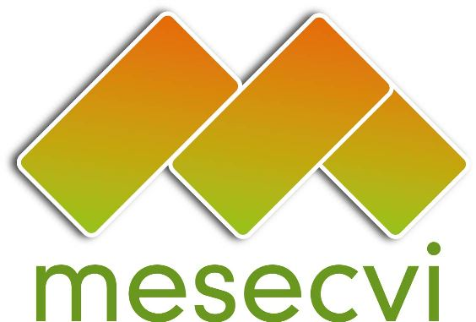


FOLLOW UP MECHANISM TO THE OEA/Ser.L/II.7.10
BELEM DO PARÁ CONVENTION (MESECVI) MESECVI-V/doc.107/13.rev.4 corr.2
FIFTH CONFERENCE OF STATES PARTY November 16th, 2013
November 18th – 19th, 2013 Original: Spanish

Washington D.C.

AGENDA

(Draft)

- Adoption of the Agenda and Calendar of activities

- Election of Authorities of the Conference: Chair, Vice Chairs, Rapporteur

- Reflection Process for strengthening the MESECVI
  - Strategic Plan
  - Dialogue between the Competent National Authorities and the CEVI Experts
- General Guidelines for the functioning of the CEVI
CIM03514E01
- Participation of the Presidency of the Conference of States Parties in the CEVI meetings
  - Invitation to a complete integration of the CEVI
  - Considerations on the procedure of modification of the Rules of Procedure of the CEVI (on reference to the Tenth Meeting of the Committee of Experts)
  - Promotion of the participation of the civil society and other actors in the activities of the MESECVI, according to the Article 10.2 of the Statute of the MESECVI
  - Creation of the Solidarity Sub fund
  - Constitution of a working group
- Conformation
- Term
- Objectives

- Report about the Progress Indicators to Measure the Implementation of the Belém do Pará Convention

- Good practices in Gender Justice

- Violence against Women: Advances and challenges in 20 years of the Belém do Pará Convention. Ministerial dialogue on advances and challenges on the application of the Belém do Pará Convention. Regional experiences

- Definition of the date and offer to host the Sixth Conference of State Parties

- Adoption of the Agreements of the Fifth Conference of State Parties of the MESECVI

- Rapporteur’s Report of the Conference

- Other matters

