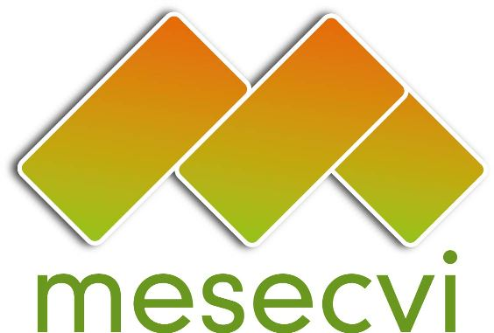
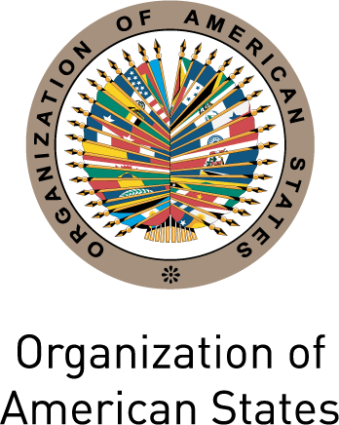

FOLLOW-UP MECHANISM OEA/Ser.L/II.7.10
BELÉM DO PARÁ CONVENTION (MESECVI) MESECVI-IV/doc.195/13
Tenth Meeting of the Committee of Experts September 24th, 2013
September 11^{h}-12th 2013 Original: Spanish
Washington D.C.

AGREEMENTS

The Committee of Experts, during the X Meeting held in Washington, on September 11th and 12th, as part of its statutory and regulatory competence, approved the following agreements:

- Recommend to the Conference of States Parties the revision of the legal instruments in order to harmonize the changes made to the CEVI Regulations and strengthen the Mechanism. In this regard, it was requested that the Technical Secretariat prepares the corresponding texts and the suggestions to which they are entitled.

- Request that the Secretariat for Multidimensional Security of the Organization of American States incorporate women’s human rights and the prevention of violence against women to its Strategic Plan. Additionally, the Committee suggested that they take into account the United Nations normative regarding violence against women in security programs.

- Reiterate the request to countries that they incorporate the rights and measures contemplated in the Convention of Belém do Pará in the implementation process of United Nations Security Council Resolution 1325 on women, peace and security.

- Request that the Technical Secretariat sends a note to the Paraguay’s National Congress requesting the incorporation of the Convention of Belém do Pará standards in the Comprehensive Bill on violence against women and the Bill’s swift approval; in said letter, the Committee offers the necessary technical support to advance in such direction.

- Request that the Technical Secretariat sends a letter to the President, to the Attorney General and to the Minister of Health of the State of Guatemala about the alarming situation of pregnant girls in the State, in accordance with the recommendations outlined in the II Hemispheric Report.

- Request the State of Guatemala’s good offices for the a visit of a delegation from the Committee of Experts to Guatemala, in light of the concerns expressed by the Committee about the high rate of pregnant girls in this state.

- Invite the United States and Canada to appoint experts on gender and violence to participate as observers in the Committee of Experts meetings.

- Request that the Technical Secretariat sends a letter to the President of Colombia asking that the Constitutional Court’s Ruling C-355 be applied and expressing the Committee’s concern about any measure that might restrict, limit or reverse the contents of said ruling on the protection of women’s rights.

- Reiterate the request to States Parties that have not yet designated an Expert, that they nominate their Principal and Alternate Experts.

- Request that the Technical Secretariat sends a letter to Argentina’s Senate asking that they take into account the II Hemispheric Report’s recommendations regarding Law 26.485 “Comprehensive Law on the Prevention, Punishment and Elimination of Violence against Women in their Interpersonal Relations”; suggesting that they incorporate the Convention’s content to the State’s legislation and that the norms already adopted be implemented.

- Request that the Technical Secretariat sends a letter to the Parliament of Uruguay asking that women’s human rights and the Inter-American System standards developed by the Convention of Belém do Pará be incorporated in the revision process for their Criminal and Criminal Process Codes.

- Request that the Technical Secretariat sends a letter to the President of the Superior Court of Justice on the restrictive interpretation of the Maria da Penha Law that is being applied and its effects this interpretation has on access to justice for women who have been victims of violence in the State of Brazil.

- Request that the Technical Secretariat informs the Committee of situations that might warrant the formulation of specific recommendations to States Parties in favor of women's human rights.

- Gather the necessary information on “Parental Alienation Syndrome”, in order to carry out a dialogue on the matter in the Committee of Experts.

- Approve the table of contents of Recommendation No. 2 on sexual violence and its effects on the sexual and reproductive rights of women, girls and adolescents. The Committee of Experts has a period of 15 days to review, propose and provide inputs to improve the draft, counting from the day they receive draft recommendation No. 2.

- Ask the Technical Secretariat to circulate the Declaration of the Committee of Experts on the celebration of the twentieth anniversary of the adoption of the Convention of Belém do Pará among the National Competent Authorities belonging to the Conference of States Parties and to publish the document on MESECVI’s website.

input.doc1

