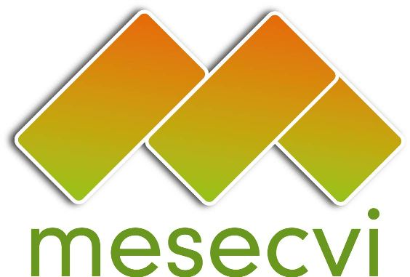
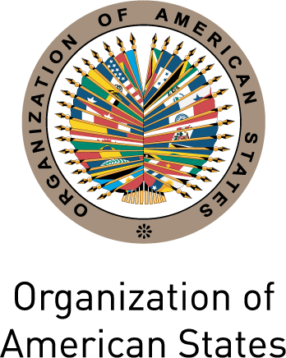

FOLLOW-UP MECHANISM OEA/Ser.L/II.7.10
BELÉM DO PARÁ CONVENTION (MESECVI) MESECVI/CEVI/doc.185/12 rev.4
Ninth Meeting of the Committee of Experts November 14th 2012
November 12th to 14th 2012 Original: Spanish
Mexico City, Mexico

AGREEMENTS

Agreement 1
Within the framework of the 57th Session of the United Nations’ Commission on the Status of Women (CSW), to be held from March 4th to 15th 2013, the Committee of Experts of the MESECVI, at the request of the International Forum of Indigenous Women, will promote the adoption of a specific resolution on violence against indigenous women.

Agreement 2
In the defense of women’s rights, and particularly in the establishment of Ombudspersons’ offices and other bodies responsible for the promotion and protection of these rights, the Committee of Experts of the MESECVI emphasizes the importance of diversity and inter-culturalism in the identification, analysis and defense of human rights, and urges States to apply these approaches in a participatory and inclusive manner.

Agreement 3
In view of the fact that the priority theme of the 57th Session of the CSW is “Elimination and prevention of all forms of violence against women and girls”, the Committee of Experts of the MESECVI requests that States Party to the Convention, and those States that are not party, include experts on this issue in their national delegations.

Agreement 4
In order to ensure that indigenous women are able to enjoy their right to a life free of violence in conditions of equality, the Committee of Experts of the MESECVI calls on the relevant local, state and national authorities of the Government of Mexico to fully comply with the decisions of the Inter-American Court of Human Rights in Cases 12.579 (Valentina Rosendo Cantú and others v. the United States of Mexico) and 12.580 (Inés Fernández Ortega v. the the United States of Mexico).

Agreement 5
Concerned about the high cost that violence against women represents in terms of physical and mental health services, the Committee of Experts of the MESECVI reminds States of the provisions of Article 8 of the Convention of Belém do Pará and urges then to adopt measures and programs to “…promote awareness and observance of the right of women to be free from violence…” and “…modify social and cultural patterns of conduct of men and women…” in this regard.

Agreement 6
The Committee of Experts of the MESECVI expresses its solidarity with the Inter-American Human Rights System, of which it is an integral part, and emphasizes the importance of continuing to strengthen this system in order to ensure the validity and full exercise of human rights in the region.

Agreement 7
With a view to maximizing the impact of the work of the MESECVI in the States Party to the Convention, the Committee of Experts highlights the importance of collaboration between the Mechanism and other international organizations, in particular UN Women and the United Nations’ Secretary-General’s Campaign “Unite to End Violence against Women”, and requests that the Technical Secretariat explore and pursue joint project and activities with these entities.

Agreement 8
Concerned about the proliferation of small arms in the region, and the role that they play in aggravating violence against women and its consequences, the Committee of Experts urges the Organization of American States and its Member States to integrate and gender and women’s rights perspective in efforts to address the proliferation of these arms.

Agreement 9
The Committee of Experts of the MESECVI congratulates the ethnic authorities of the Embera Chamí indigenous community for their receptiveness to the elimination of the harmful traditional practice of female genital mutilation, which achieved through and expedited resolution of the Assembly and the Congress between 2010 and 2011, in collaboration with the MDG Fund and the High Council for Women’s Equity of Colombia.

Agreement 10
The Committee of Experts of the MESECVI urges the States Party to the Belém do Pará Convention, on the occasion of November 25th, International Day for the Elimination of Violence against Women, to evaluate their advances in the implementation of the Convention and identify priority areas where it is necessary to strengthen efforts.

Agreement 11
The Committee of Experts of the MESECVI recognizes the importance of the participation of civil society organizations in the work of the Mechanism and requests that the Technical Secretariat prepare a proposal to strengthen this participation through formal measures.

Agreement 12
The Committee of Experts of the MESECVI expresses its profound thanks to the Secretariat of External Relations of Mexico for the support provided to the celebration of the 9th meeting of the Committee.
input.doc

