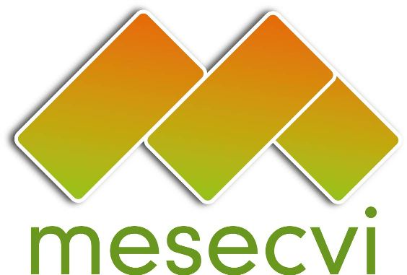
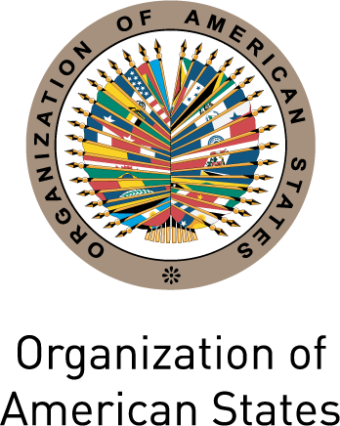

FOLLOW-UP MECHANISM OEA/Ser.L/II.7.10
BELÉM DO PARÁ CONVENTION (MESECVI) MESECVI/CEVI/doc.184/12
Ninth Meeting of the Committee of Experts November 14th 2012
November 12th to 14th 2012 Original: Spanish
Mexico City, Mexico

DECLARATION OF MEXICO ON THE RIGHTS OF WOMEN IN REFORMS TO
CRIMINAL CODES

The Committee of Experts of the Follow-up Mechanism to the Belém do Pará Convention (MESECVI), gathered in Mexico City on November 14th 2012;

Recognizing the progress in terms of legislation on all forms of violence against women in the States Party to the Inter-American Convention on the Prevention, Punishment and Eradication of Violence against Women (Belém do Pará Covention);

Conscious of the significant advances made in the creation of jurisprudence on violence against women in some States Party and at the inter-American level;

Welcoming of the increasing consciousness of violence against women in the context of the Belém do Pará Convention among those responsible for the administration of justice;

Concerned by some of the proposed reforms to criminal codes and other norms of the region and their possible implications for the provision of a just and effective State response to violence against women;

Conscious of the fact that some of the proposed reforms will limit the definition of violence against women or some of its manifestations, including femicide;

Conscious also of the fact that some of the proposed reforms will reduce the penalties applicable against perpetrators of violence against women or some of its manifestations, including rape and incestuous sexual abuse;

Recalling that, in their ratification of the Belém do Pará Convention, the States Party defined violence against women as “…any act or conduct, based on gender, which causes death or physical, sexual or psychological harm or suffering to women, whether in the public or the private sphere.”

Recalling also that, in their ratification of this Convention, the States Party committed to condemning “…all forms of violence against women…” and agreed to “…pursue, by all appropriate means and without delay, policies to prevent, punish and eradicate such violence…;”

- Calls on States Party to the Belém do Pará Convention to respect the provisions of the Convention in their definition of violence against women and not impose limitations or qualifiers that might permit the perpetuation of violations of the human rights of women;

- Urges the States Party to the Convention to avoid regressive reforms in the definition of penalties applicable to perpetrators of violence against women, particularly in its gravest forms, such as rape or femicide.
input.doc

