
ORGANIZACION DE LOS ESTADOS AMERICANOS
Consejo Interamericano para el Desarrollo Integral
(CIDI)


SECOND REGULAR MEETING OF THE OEA/Ser.W/II.9
INTER-AMERICAN COMMITTEE ON EDUCATION CIDI/CIE/doc. 6/04
October 18 – 19, 2004 18 October 2004
Washington, D. C. Original: Spanish

HEMISFERIC PROJECT
SHOOL MANAGEMENT AND CERTIFICATION FOR DEVELOPMENT AND ACCREDITATION OF KEY LABOR COMPETENCIES AR THE UPPER SECONDARY LEVEL

PROGRESS REPORT ON ACTIVITIES CONDUCTED IN 2004

HEMISFERIC PROJECT
SHOOL MANAGEMENT AND CERTIFICATION FOR DEVELOPMENT AND ACCREDITATION OF KEY LABOR COMPETENCIES AR THE UPPER SECONDARY LEVEL

PROGRESS REPORT ON ACTIVITIES CONDUCTED IN 2004

- General Information:

Project title: “School management and certification for development and accreditation of key labor competencies at the upper secondary level”.

SEDI/AICD/AE- 183 /03

Project type: Multinational

Hemispheric Coordinator/Executing country: Costa Rica
Hemispheric Office, San José Costa Rica, Fax 258 3101
Web Page, www.ebnc.cipet.ac.cr
wcordero@ebnc.cipet.ac.cr

Technical Hemispheric Coordinator: Mexico

Participating countries: Costa Rica (Subregional Coordinator), El Salvador, Guatemala, Honduras, Nicaragua, Panama, Brazil (Subregional Coordinator), Argentina, Bolivia, Chile, Paraguay, Uruguay, Antigua and Barbuda (Subregional Coordinator), Barbados, Belize, Dominica, Granada, Guyana, Haiti, Jamaica, The Bahamas, St. Kitts and Nevis, St. Vincent, St. Lucía, Suriname, Trinidad and Tobago, and Mexico.

Executing Institution by subregion: Ministry of Public Education of Costa Rica, Central America; Ministry of Education of Antigua and Barbuda, CARICOM; Ministry of Education of Brazil (Department of Vocational and Technological Education - SETEC) MERCOSUR,

Total Project amount (2004): US$330,048

Total amount disbursed (first disbursement): US$117,000
Expenditures to date (first disbursement): US$11,800
Period covered by this report: 1 July - 30 September 2004

II. Execution timetable:

The Project officially began on 1 July 2004, although a number of preliminary activities had already been conducted by the subregional coordinators and through hemispheric coordination. The web page has now been put in place at: www.ebnc.cipet.ac.cr .

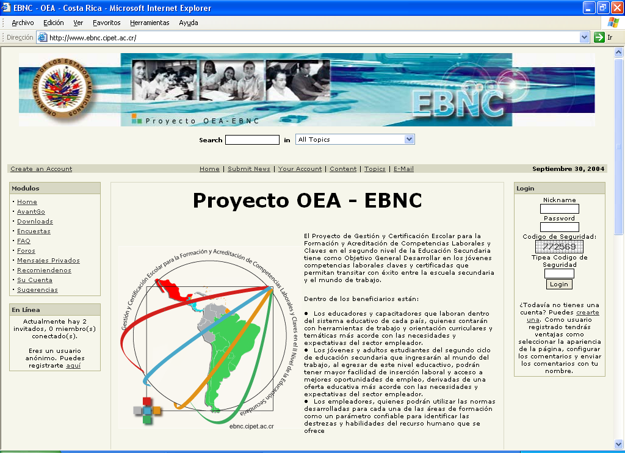
The improvements made to the 2004 execution plan by the subregional coordinators, have improved its reliability in terms of all planned processes and activities, because they address a reality in each of the subregions and countries connected with the project; the products they generate will therefore be relevant—educational and labor requirements for each education system in the area of national accreditation and certification.

The timetable, as adjusted, was adopted at the First Hemispheric Meeting, held with the participation of sub-regional coordinators, in Costa Rica on 25, 26, and 27 August, as part of the first activity under the execution plan for 2004.

The adjustments, as unanimously accepted by the subregional coordinators at the First Hemispheric Meeting, were as follows:

- The time limit for full execution of the 2004 Plan was set at nine months, from July 2004 to 31 March 2005.
- The disbursement periods were reduced from four months to three months, as follows:

  - July - September
  - October - December 2004
  - January - March 2005

MERCOSUR Subregion:

The adjustments made to the 2004 execution plan enabled the region to continue correcting the activities/product sequencing disconnect, permitting completion by December 2007, as originally programmed.

The results of the aforementioned meeting of subregional coordinators in Costa Rica were presented to the other MERCOSUR countries at the Ninth Meeting of MERCOSUR's Regional Coordinating Committee on Technological Education (CRC-ET), held on 13, 14, and 15 September 2004 (see Annex).

However, within the same subregion, the date for the meeting of National Coordinators for the project was scheduled for 4-5 October 2004, in Curitiba-PR-Brazil, in the technical school “Centro Federal de Educación Profesional de Paraná (CEFET-PR)”, to discuss and approve the plan of action for the MERCOSUR subregion. The subregional experts will be elected at this meeting following a review of curricula vitae submitted by the countries.

It is reported that implementation began in the MERCOSUR subregion at the time of the
First Hemispheric Meeting, in late August 2004, when background information was provided and the timetable approved. The first subregional activities will be completed in October.

CARICOM Subregion:

Within the framework of the Hemispheric Project, the Caribbean subregion organized an international workshop on labor competency-based education, inviting the hemispheric Project coordinators to participate. The workshop was not one of the activities programmed in the execution plan, but Trinidad and Tobago saw a need to train its officials for the purposes of more effective execution of the Hemispheric Project, and to keep the project moving in the subregion. In cooperation with the OAS, the needs of Trinidad and Tobago were linked to the objectives of the Hemispheric Project. The event was financed mainly by Trinidad and Tobago, and the OAS contributed 10 travel grants and two specialists to help design and conduct the workshop. Mexico contributed in-kind resources, taking charge of the training component. The five of subregional coordinators were invited. The meeting was attended from Trinidad and Tobago by 20 technical/vocational curriculum officials with the Ministry of Education and the Ministry of Science, Technology, and Higher Education. Specialists from NTA Trinidad; the Jamaica Heart Trust; CXC; OECS/OERU; CARICOM; the Office of Industrial Training of Guyana; representatives of the Ministries of Education of The Bahamas, Antigua and Barbuda, Costa Rica, and Peru; SENAI of Brazil; and PMETyC, CONOCER, CONALEP, and INEA of Mexico.

The first objective was to share lessons learned from past and present initiatives in the Caribbean in the definition, development, and certification of labor competencies, including feedback and the exchange of experiences in Mexico, Brazil, Costa Rica and Peru. The second objective was to provide initial training in the methodology for competency-based curriculum development. All of the activities were carried out within the framework of the Hemispheric Project. The workshop helped to strengthen the project by training the individuals who will participate in the project, and building important alliances among different actors and institutions, such as the ILO.

III Compliance in terms of products/components and activities.

Amounts are in US$. | 2004
HEMISPHERIC REPORT | First disbursement
 | July-October
Products/Components and Activities | Prog | Spent | %
1 - School management model
1.1 Hemispheric Project web page
1.1.1 Design and development of the web page
(Contract) Programmer contract (US$2,000, 3 months) | $2,000 | $0 | 0%
1.2 Hemispheric Committee
Activity 1. Convene, organize and coordinate the meeting of the team of subregional coordinators to document priorities. San José Costa Rica.
1.2.1 Subregional coordinators meeting
(Travel) (airline ticket and per diem x 4 days x 3 subregional coordinators. Average US$2,000) | $6,000 | $6,000 | 100%
(Equipment) Communication equipment and 4 computers. | $8,000 | $4,000 | 50%
1.3 Hemispheric network for the selection of
specialists in education reform,
curricula and secondary education.
1.4 Analysis and systematization of lessons
learned in each subregion.
1.4.1 Conduct a hemispheric diagnostic assessment
(Contracts) Eight international consultant contracts (US$1,000.- x 3 months). | $24,000 | $0 | 0%
(Travel) (Tickets and per diem US$3,000 each 6 specialists from the 2 subregions) | $18,000 | $0 | 0%
(Travel) (Tickets and per diem for 3 subregional coordinators x 4 days US$2,000 each x 2 subregions) | $6,000 | $0 | 0%
(Travel) (Tickets and per diem for 3 subregional coordinators x 4 days US$2,000 each x 2 subregions) | $6,000 | $0 | 0%
(Other costs) Miscellaneous | $1,000 | $0 | 0%
1.5 Analysis of basic curricular structures
for secondary education in the hemisphere.
(Contracts) Eight international consultant contracts (US$1,000 x 2 months). | $16,000 | $0 | 0%
( Documents ) Translation of the guidelines in Spanish, English
( Documents ) Printing of the 28 guidelines in Spanish
(Travel) (Tickets and per diem for 2 subregional coordinators x 4 days US$2,000 each x 1 subregions)
1.6 Definition of the operating model for the certification of
basic labor competencies.²
(Contracts) Eight international consultant contracts (US$1,000 x 4 months).
( Documents ) Translation of the guidelines in Spanish, English
( Documents ) Printing of the 28 guidelines in Spanish
1.7 Heightening awareness in the education, productive, and social sectors.²
(Training) Heightening awareness about the project | $30,000 | $1,800 | 6%
in the labor and education sectors
TOTAL * | $117,000 | $11,800 | 16%

*Partial expenditure figures: expenditures from the CARICOM region need to be added.

Distribution of financial resources by subregion and disbursements in 2004
 | I disbursement | II disbursement | III disbursement | Total
Subregion
Central America | $28000 | $67048 | $33000 | $128,048
CARICOM | $50000 | $60000 | $10000 | $120,000
MERCOSUR | $39000 | $39000 | $4000 | $82,000
TOTAL | $117,000 | $166,048 | $47,000 | $330,048

 | 2004
CENTRAL AMERICA | First disbursement
 | July-October
 | Prog | Spent | %
Component 1.
1 - School management model
1.1 Hemispheric Project web page
1.1.1 Design and development of the web page
(Contract) Programmer contract (US$2,000 3 months) | $2,000 | $0 | 0%
1.2 Hemispheric Committee
Activity 1. Convene, organize and coordinate the meeting of the team of subregional coordinators to establish and document priorities. San José Costa Rica.
1.2.1 Subregional coordinators meeting
(Travel) (air travel and per diem x 4 days x 3 subregional coordinators, Average US$2,000) | $2,000 | $2,000 | 100%
(Equipment) Communication equipment and 4 computers. | $4,000 | $4,000 | 100%
1.3 Hemispheric network for the selection of
specialists in education reform,
curricula and secondary education. |  |  | 30%
1.4 Analysis and systematization of lessons
learned in each subregion.
1.4.1 Hemispheric diagnostic assessment
(Contracts) Eight international consultant contracts (US$1,000.- x 3 months). | $6,000 | $0 | 0%
(Travel) (Tickets and per diem, US$3,000 each, 6 specialists from the 2 subregions)
(Travel) (Tickets and per diem for 3 subregional coordinators x 4 days, US$2,000 each x 2 subregions)
(Travel) (Tickets and per diem for 3 subregional coordinators x 4 days, US$2,000 each x 2 subregions)
(Other costs) Miscellaneous
1.5 Analysis of basic curricular structures
for secondary education in the hemisphere.
(Contracts) Eight international consultant contracts (US$1,000 x 2 months). | $4,000 | $0 | 0%
( Documents ) Translation of the guidelines in Spanish, English
( Documents ) Printing of the 28 guidelines in Spanish
(Travel) (Tickets and per diem for 2 subregional coordinators x 4 days US$2,000 each x 1 subregions)
1.6 Definition of the operating model for the certification of
basic labor competencies.²
(Contracts) Eight international consultant contracts (US$1,000 x 4 months).
( Documents ) Translation of the guidelines in Spanish, English
( Documents ) Printing of the 28 guidelines in Spanish
1.7 Heightening awareness in the education, productive, and social sectors.²
(Training) Heightening awareness about the project, | $10,000 | $1,800 | 18%
awareness in the labor and education sectors
TOTAL | $28,000 | $7,800 | 35%

To date, the first disbursement of FEMCIDI financial resources, corresponding to the July - September trimester have been deposited.

The concrete results achieved to date are as follows:

- First teleconference of hemispheric and subregional coordinators and OAS officials.

- The web page was approved and placed online, Annex 5.

- Computer equipment purchased for communication among the hemispheric and subregional coordinators; it is planted to establish the hemispheric network using this equipment.

- Two awareness-heightening workshops were held for 5 secondary school directors and 20 academic education advisers from the Ministry of Public Education of Costa Rica (Annex 6).

- The first two experts on competency-based education were hired, applying OAS criteria.

The results of all of these activities have been as expected.

There have admittedly been delays in the appointment of experts on competency-based education for the CARICOM and MERCOSUR subregions, which has thus far made it difficult to formally establish the hemispheric network of experts.

The First Hemispheric Meeting, held on 25, 26 and 27 August, in Costa Rica, with the participation of Jorge Baxter of the OAS; Miguel Angel Tamayo, Co-Technical Coordinator, Mexico; Reginald Peterson of CARICOM; Claudia Carvalho Baena Soares of MERCOSUR; and Sergio Calvo Vargas for Central America.

AGREEMENTS REACHED AT THE FIRST HEMISPHERIC MEETING WITHIN THE FRAMEWORK OF THE HEMISPHERIC PROJECT – OAS, 25 - 26 AUGUST 2004

The agreements approved on 25 August 2004, at the First Hemispheric Meeting by the Subregional Coordinators for Central America, MERCOSUR and CARICOM, were as follows:

- Use of the logo presented at this session to represent the Hemispheric Project and all subregional coordinators thereof.
- Revision of the project title, replacing the word " basic" with the word "key", as follows:
<< School management and certification for development and accreditation of key labor competencies at the upper secondary level >>.
- Preparation of a glossary defining the terms used in developing the Hemispheric Project
- Presentation of a report on actions taken and progress made in carrying out the Hemispheric Project for the purposes of monitoring and evaluation at the next meeting of the CIE in Washington, on 15 October 2004. It will later be presented at the meeting of Heads of State in Argentina.
- Harmonization of the original project text with the 2004 action plan.
- Request for technical support for the Hemispheric Project from the United States and Canada, in the North American subregion.
- Connection of countries in the Andean subregion, led by Peru, once endorsement from the OAS has been obtained.
- For the purposes of resource allocation, Mexico falls within the CARICOM subregion, coordinated by Antigua and Barbuda, although geographically speaking it lies within the North American subregion.
- Confirmation of the general objective, as follows:
To design methodologies and instruments permitting the construction of models for the project enabling young people to gain certified key labor competencies and enabling them to move from secondary education to the world of employment.

AGREEMENTS OF THURSDAY 26 AUGUST 2004.

- Contribution to the course on competency issues offered through the Portal of the Americas in 2005 by UDSE/OAS.
- Request for support from UDSE/OAS for the design of a project questionnaire, modeled after the OAS Questionnaire on Educational Dissemination Practices, for the purposes of compiling and systematizing relevant national information to support the work of the specialists.
- Approval of the adjustments to the timetable and logical framework for the Hemispheric Project, during the First Meeting of Subregional Coordinators, in Costa Rica, for the purposes of harmonizing the documents to be presented to the National Coordinators. Copies of the documents will be sent to UDSE and AICD.
- Convocation of the hemispheric network of specialists to conduct activities 1.4 and 1.5 of the School Management Model component, following the guidelines contained in Annex I, prepared at the First Hemispheric Meeting.
- Validation of the proposed timetable contained in Annex II, for project activities related to each topic.
- The Second Hemispheric Meeting will be held on 23 and 24 Nov 2004, in Cancun, Mexico.
- Validation of the job description for the project technical coordinator, which includes:
- Providing technical support for the Hemispheric Project.
- Applying to the project the experiences of the Program for the Modernization of Technical Education and Training in Mexico.
- Preparing the official reports for the OAS, jointly with the Hemispheric Coordinator.
- Facilitating the technical and financial participation of other entities in support of the project.
- Supporting the subregions in respect of technical project decisions, upon request.

VI. Financial execution of the project.

There were no activities over budget, indicating that the products programmed will likely be delivered on time.

The project has not been affected by economic changes, despite the constant increases in oil prices. But if the latter leads to increased airfares, that would affect the cost of travel for experts and coordinators.

In order to deliver the national, subregional, and hemispheric products in March, and comply with the 2004 Plan of Execution, the subregional coordinators will have to dedicate more time to the project.

- Annexes for reference in analyzing this progress report.

Annexes

Annex 1. MERCOSUR Report.

Principal results of the First Meeting of National Coordinators from the MERCOSUR Subregion
(Curitiba, 4 - 5 October 2004)

Progress in executing activities included in the
PLAN OF EXECUTION FOR 2004

1) Definition of National Coordinators (with the exception of Paraguay, which was unable to participate more indicate preferences due to internal matters):
-ARGENTINA
Silvia Braumüller
Adviser to the Instituto Nacional de Educação e Tecnologia
-BRAZIL
Francisco Luiz Danna
Coordinador General de Políticas de Educación Profesional and Tecnológica
-BOLIVIA
Victor Hugo Navarro Michel
Profissional em Secundária Técnica
-CHILE
Martin Miranda Oyarzún
Chefe de Formação Técnica
-URUGUAY
Juan J. Villanueva
Secretário Docente

2) Selection of the firm “Corporation for the Promotion of Labor Education” (PRODUAL), of Chile, to execute Activity 1.4 “Analysis of basic curriculum structures for secondary education in the hemisphere”. A total of US$4,000.00 will be paid for the work, to be concluded in December 2004. The guidelines will be considered during the First Meeting of the Hemispheric Coordinators (Costa Rica, August), with the exception of the item on “progress in adopting the competencies model”.

3) Activity 1.5 (Analysis and systematization of lessons learned in each subregion).
Six experts will be hired for this activity, one from each country, and the names will be sent on Monday, 11 October. The resources (US$6,000.00) will be distributed among them
The lessons learned will refer to “National policies with respect to education for key labor competencies and their scope”.

4) Activity 1.6 (Definition of the operating model for the certification of labor competencies).

A study will be conducted on “Progress in the adoption of a competencies model, the use of standards, curricular designs, evaluation and certification of competencies”.
The terms of reference will include:
Context, assumptions, criteria.
Certification of competencies gained informally
Certification of competencies in addition to training that enable students to enter vocational training or intermediate and higher learning programs.
The roles of the business, unions, educators, and the state.
Regulatory progress.
Analysis of convergence and divergence.
Countries should send their criteria by 15 October.

5) Activity 1.7 (Heightening awareness in the education, productive, and social sectors).
Countries will present the timetable for awareness-heightening events by 20 November.
Each country will receive approximately US$3,334.00.

6) Activity 2.2. (Methodology for curricular adaptation for the development of labor competencies)

The comparative study will cover the following:

- Competency-based and other approaches to curricular design.
- Criteria for the selection, production, procurement, and use of learning resources.
- Teacher training and retraining needs (appropriate methodologies)
- Rotation, internships, business/organization practices, and supplemental training with businesses/organizations
- Accreditation of technical and vocational training establishments.
Countries should send their criteria by 20 November 2004.

7) Activity 3.1 (Methodology for the evaluation of labor competencies).

The study will be entitled: “Comparative study on methodology for the evaluation of labor competencies”.
The terms of reference for the study will include the following:
Strategies for the evaluation of competencies gained informally.
Strategies for the evaluation of competencies in addition to training that enable students to enter vocational training or intermediate and higher learning programs.
Different alternatives for the design of technical and vocational training curriculum–competency-based and other approaches.
Analysis of convergence and divergence.
Countries should send their criteria by 20 November 2004.

8) Activity 3.2 (Methodology for the certification of labor competencies).
The study will be entitled: “Comparative study on methodology for the certification of labor competencies”.
The terms of reference will include:
Experiences with certification by the state, enterprises, and unions.
Evaluation and certification methodologies.
Strategies for the certification of competencies gained informally.
Strategies for the certification of competencies in addition to training that enable students to enter vocational training or intermediate and higher learning programs.
Analysis of convergence and divergence.
Countries should send their criteria by 20 November 2004.

Team of hemispheric and subregional coordinators

Hemispheric Coordinator

William Cordero Gamboa Ministry of Public Education C. R. wcordero@ebnc.cipet.ac.cr

Subregional Coordinator, Central America
Sergio Calvo Vargas Ministry of Public Education C. R.
scalvo@ebnc.cipet.ac.cr

Technical Coordinator, Mexico
Miguel A. Tamayo Department of Public Education
mtamayo@sep.gob.mx

Subregional Coordinator, Antigua and Barbuda
Reginald Peterson Ministry of Education
petersonr_25@hotmail.com

Subregional Coordinators, Brazil
Francisco Danna Ministry of Education
ilfranciscodanna@mec.gov.br

Claudia Carvalho B. Ministry of Education
claudiasoares@mec.gov.br

CIDI01354E

