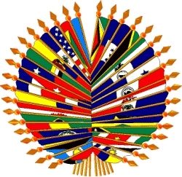
Organización de los Estados Americanos
Organização dos Estados Americanos
Organisation des États américains
Organization of American States

V MEETING OF AUTHORITIES AND EXECUTIVE COMMITTEE
OF THE INTERAMERICAN COMMITTEE ON EDUCATION (CIE)
November 9-10, 2005

Information Flyer

1. Meeting Location

Room 404, Organization of American States General Secretariat Building (GSB),
1889 F Street N.W., Washington, D.C., 20006, USA

2. Hotel Information

The Technical Secretariat recommends making reservations at one of the following:

STATE PLAZA HOTEL
2117 E Street, N.W.
Washington, D.C.
Tel. (202) 861-8200 – Fax (202) 659-8601
Standard: US$ 143 + taxes (14.5%)

CONCORDIA HOTEL
1250 New Hampshire Avenue, N.W.
Washington, D.C.
Tel. (202) 973-5500 – 202-973-5401
Standard: US$ 124

CARLYLE SUITES
1731 New Hampshire Avenue, N.W.
Washington, D.C.
Tel. (202) 234-3200
Standard: US$ 179 + taxes (14.5%)

ONE WASHINGTON CIRCLE
1 Washington Circle, N.W.
(202) 872-1680
Standard: US$ 199 + taxes (14.5%)

3. Restaurants

Bobby Van’s Steakhouse (Steak, expensive) Downtown 809 15th St., NW Washington, DC. 202-589-0060
Gerard’s Place (French, very expensive) Downtown 915 15th St., NW Washington, DC
202-737-4445
Jaleo (Spanish, moderate) Downtown 480 Seventh St., NW Washington, DC 202-628-7949
Les Halles (French, moderate) Downtown 1201 Pennsylvania Ave., NW Washington, DC
202-347-6848

Luigino (Italian, moderate) Downtown 1100 New York Ave., NW Washington, DC

202-371-0595

4. U.S. entry and exit policies

The general U.S. entry requirements can be found in detail on the U.S. Department of State website: http://travel.state.gov/visa/index.html . You can also find specific information on the U.S. embassy’s webpage in your country.

5. Participant Registration

You are asked to send your registration information via email or fax to slopez@oas.org, arivas@oas.org ; Fax (202) 458 3149. The registration form is attached to the back of this flyer and can also be found on the OECT website: www.oest.oas.org

6. Languages and Working Documents

There will be simultaneous interpretation in English and Spanish.

7. Climate

November in Washington is between Fall/Winter. Temperatures can range between –1 and 16 C° or 30 F to 60 F. It is recommended that you bring a sweater and a coat.

8. Local Time

Washington DC is on Eastern Standard Time.

9. Electrical current

110 volts

10. Places of Interest

National Gallery of Art
National Air and Space Museum
Museum of the American Indian
American History History
Hirshhorn Museum and Sculpture Garden
Ford’s Theater
National Cathedral
Pentagon City Mall
Arena Theater
The Corcoran Gallery

11. Business Hours

From 9 am to 5 PM in Washington, D.C.

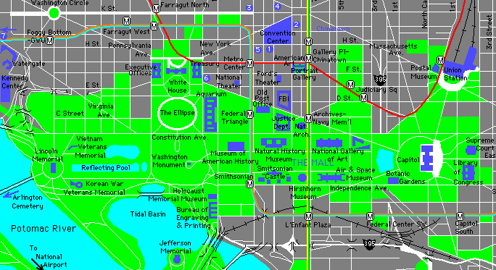
OAS
OAS/GSB

OAS: OAS Main Building: 17th and Constitution Ave. NW
OAS/GSB: OAS General Secretariat Building: 1889 F. St. NW

FORMULARIO DE INSCRIPCIÓN / REGISTRATION FORM

V MEETING OF AUTHORITIES AND EXECUTIVE COMMITTEE ON EDUCATION (CIE)
V REUNION DE AUTORIDADES Y COMITÉ EJECUTIVO DE EDUCACIÓN (CIE)

November 9-10, 2005
Washington DC

PAÍS U ORGANIZACIÓN/
COUNTRY or ORGANIZATION :

NOMBRE / NAME: _____________________________________________________________

CARGO / POSITION: ___________________________________________________________

DIRECCIÓN PERMANENTE/

PERMANENT ADDRESS: _______________________________________________________

______________________________________________________

TELÉFONO / TELEPHONE:__________________________FAX:________________________

EMAIL:________________________________________________________________________

DIRECCIÓN EN WASHINGTON / ADDRESS IN WASHINGTON:

___________________________________________

TELÉFONO /TELEPHONE:________________________________________________________

EN CASO DE EMERGENCIA, AVISAR /

IN CASE OF EMERGENCY, NOTIFY:_______________________________________________

Please note that these prices are approximate and are subject to change.

