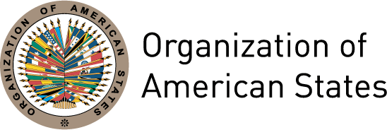
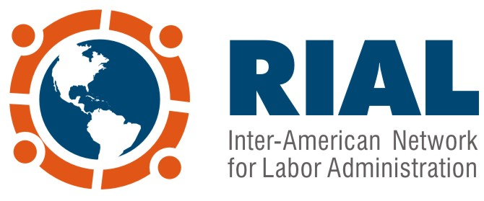

Logistics and Travel Information Bulletin

Meeting of the IACML Working Groups, RIAL Workshop on Fairer Labor Conditions and First Preparatory Meeting of the XVIII IACML

April 16 to 19, 2013 – Nassau, Bahamas

Venue: British Colonial Hilton Hotel
Address: One Bay Street, PO Box N-7148, Nassau, The Bahamas

In compliance with the Inter-American Conference of Ministers of Labour (IACML) Calendar of Activities for 2012-2013, the following events will take place consecutively in Nassau, Bahamas:

- RIAL Workshop “Towards fairer labor conditions: promoting labor inclusion with equity” April 16

- Second Meeting of the Working Groups of the XVII IACML April 17 & 18

- First Preparatory Meeting of the XVIII IACML April 19

Registration: For those who have not yet registered, we appreciate your doing so, by filling out the Registration Form enclosed in this bulletin and sending it to the IACML Technical Secretariat, as indicated.

Funding: Each delegate is responsible for his/her own travel expenses. However, the OAS may cover the travel expenses (airfare or accommodation and per diem) of officers from Ministries of Labor of small economies using resources from the Voluntary Contribution Fund of the RIAL in order to support their participation.

Lodging: Each participant is responsible for booking a room in the hotel of his or her preference, except those who will be granted financial assistance, in which case the OAS will make their reservations at the British Colonial Hilton Hotel.

Recommended hotels:

British Colonial Hilton Hotel (venue of the event)
Address: One Bay Street, PO Box N-7148, Nassau
Tel: 1(242) 302 9032
Rate: $ 189 USD, plus taxes – includes breakfast buffet
Contact person: Dwayne Turnquest, Sales Department
Participants not funded by the OAS, please make your reservation by April 9th by calling the above number or sending an e-mail to: Dwayne.Turnquest@hilton.com To obtain the negotiated rate, please say you are part of the “OAS Group”. Please note that after this date room availability is not guaranteed.

Sheraton Nassau Beach Resort Hotel
Address: PO Box N4914 West Bay Street
Tel: (506) 2543- 6000
Rate: $159 USD, plus taxes
Distance from venue: 20 minutes drive
Contact person: Fred Trimble
fred.trimble@sheraton.com

Atlantis Hotel, Paradise Island
Address: P.O. Box N-4777, Nassau
Tel: 1 (242) 363-6027
Rate: from $149 USD, plus taxes
Distance from venue: 25 minutes drive
Contact person Ted Adderley
Ted.Adderley@AtlantisParadise.com

Transportation to and from the airport: The Department of Labor of the Bahamas will provide this service to all participants. We thank you for sending your travel itineraries to Yvtte Treco (ytreco@oas.org) no later than April 1.

Arrival and departure requirements: Participants are responsible for meeting visa requirements established by The Bahamas. Consult the requirements for each country here.

Language: Simultaneous interpretation to English and Spanish will be provided at the Meeting.

Currency: The Bahamian currency is the Bahamian Dollar. The Exchange rate is USD $ 1 = BSD $ 0.99, approximately.

Weather: The temperature varies between 27 °C (80 °F) y 21 °C (70°F).

For further information on the Meeting, please contact:

OAS Department of Social Development and Employment
Att. Maria Claudia Camacho or Carolina Ahumada
Tel: (1202) 458-3207, (1202) 458-3446 – mcamacho@oas.org , cahumada@oas.org

In case of emergency please contact:
OAS National Office in The Bahamas
Mrs. Yvette Treco
Tel: 1(242) 393-7747

All information regarding the Workshop will be updated periodically at: www.sedi.oas.org/ddse

Events of the Inter-American Conference of Ministers of Labor (IACML)

April 16 to 19, 2013 – Nassau, Bahamas
Meeting of the IACML Working Groups, RIAL Workshop on Fairer Labor Conditions and First Preparatory Meeting of the XVIII IACML
Registration Form

Last Name |  | First Name
Title
Organization and country
Telephone | Fax |  | E-mail

Do you need financial assistance to participate in the meeting? *

Yes ___ No ___

If your response is affirmative, please indicate for which item (please select one option)

Plane Ticket ___ Food and lodging ___

Should you require financial assistance, please submit the registration form to the IACML Technical Secretariat no later than March 15, 2013. Otherwise the final deadline for submitting this form is April 5.

*The OAS, with resources from the RIAL Voluntary Contribution Fund, can cover travel expenses (plane ticket or food and lodging) of some Ministries of Labor of small economies to support their participation in these events. Given that these resources are limited, they should be complemented by resources from each Ministry. Requests will be analyzed on a first-come first-serve basis.

Send Form to:

E-mail: trabajoddse@oas.org
Tel: 1 (202) 458-3446
Fax: 1 (202) 458-3149

Government delegates should send their Registration Forms through the Permanent Missions of their country to the OAS.

