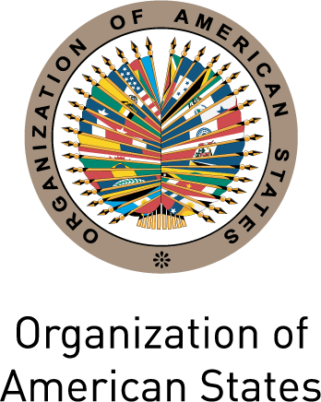
XLIV LECTURE OF THE AMERICAS
Regional Perspectives on Democracy:
Celebrating Ten Years of the Inter-American Democratic Charter

Friday, April 15, 2011

3:00-5:00 pm
Hall of the Americas, Organization of American States
Washington, D.C.

PROGRAM
3:00 p.m. Welcoming remarks by OAS Assistant Secretary General, Albert R. Ramdin
3:10 p.m. Introduction of the keynote speaker by Ambassador Gillian M.S. Bristol, Chair of the Permanent Council Permanent and Representative of Grenada to the OAS
3:15 p.m. Keynote speaker:
Jean Ping, Chairperson, African Union Commission (AU)
3:45 p.m. Comments by: Vidar Helgesen, Secretary General, International Institute for Democracy and Electoral Assistance (IDEA)
4:00 p.m. Question and answer session moderated by Irene Klinger, Director, Department of International Affairs, Secretariat for External Relations, OAS
To register please click here or send an e-mail to SER-DIA@oas.org

