BIOGRAPHY

Ron D. Burton
President, Rotary International
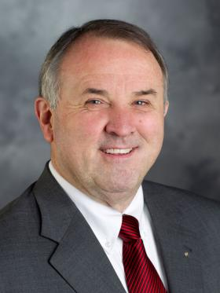
Ron D. Burton retired as President of the University of Oklahoma Foundation Inc. in 2007. He is a member of the U.S. Supreme Court Bar, the American Bar Association, the Oklahoma Bar Association, and the Cleveland County Bar Association. He was vice president of the Last Frontier Council of the Boy Scouts of America and received the Silver Beaver Award. He also received the Norman United Way and Junior League Volunteer of the Year Civic Award.
A Rotarian since 1979, Burton has served Rotary International as director, president’s aide, president’s representative, committee and task force member, Rotary information counselor, zone trainer, International Assembly group discussion leader and moderator, Council on Legislation representative, and district governor. He also chaired the 2011 New Orleans Convention Committee. As director, he served as chair of the Executive, Administration, and Audit Committees.
Due to his extensive service to Rotary International, Mr. Burton has received the Service Above Self Award and the Foundation’s Citation for Meritorious Service, Distinguished Service Award, and International Service Award for a Polio-Free World. He and his wife, Jetta, are Paul Harris Fellows, Benefactors, Major Donors, and members of the Paul Harris, Bequest, and Arch C. Klumph Societies.

