Secretariat for External Relations / Department of International Affairs
Organization of American States (OAS)

You are cordially invited to the
XXXIV OAS POLICY ROUNDTABLE:
To Celebrate the Inter-American Institute for Cooperation on Agriculture (IICA)

“IICA Day” 2011:
“The Impact of Youth and Innovation in Agriculture in Latin America and the Caribbean”
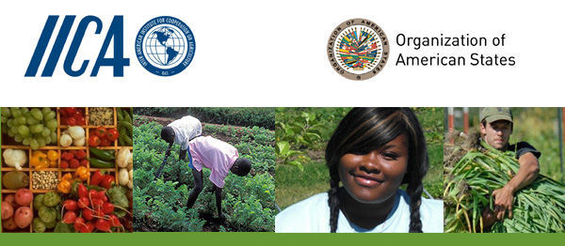

Wednesday, November 2, 2011
3:00 – 5:00 PM
Hall of the Americas, 17th Street and Constitution Ave. NW, Washington, DC 20006

Program

3:00 pm Welcoming remarks by Irene Klinger, Director of the Department of International Affairs, OAS

3:05 pm Introduction of the topics by David C. Hatch, IICA, Representative in the U.S.

3:10 pm Remarks on youth and agriculture by Ernesto Fernandez Polcuch, Senior Programme Specialist, UNESCO Regional Office for Science in Latin America and the Caribbean

3:25 pm Remarks on innovation and agriculture by Gustavo Manrique, President, SAMBITO, S.A.

3:40 pm Panel discussion with the youth moderated by Ambassador Albert Ramdin, Assistant Secretary General, OAS, on the topics:
    - Molding Youth as Agents for Change
    - Importance of Social Networks/Systems
    - Access to Resources
    - Policies and Capacities Necessary for Long Term Youth Involvement in Agriculture Development

Youth panelists:
    - Heather Fulton, Canadian Young Farmers Forum, Canada
    - Jorge Armando Alamo, GIPANA, J2xN, Peru
    - Martin Duran, Agronomist, Uruguay
    - Junior Ebanks, Becon, Jamaica

4:40 pm Question and answer session with the audience

5:00 pm Event closing by David C. Hatch, IICA, Representative in the U.S.

Reception to follow in the OAS Patio
Please register here or send an e-mail to SER-DIA@oas.org

