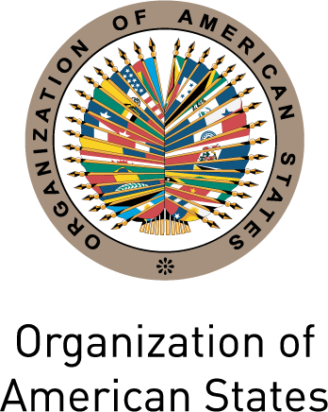
Secretariat for External Relations / Department of International Affairs

XXIV OAS POLICY ROUNDTABLE
"The Participation of Indigenous Peoples
in OAS Activities:
Recommendations and Next Steps”

Thursday, June 24th 2010
3:30 pm
Hall of the Americas
17th Street and Constitution Ave. NW
Washington, DC 20006

3:30-3:40 pm Opening remarks by Adam Blackwell, Secretary for External Relations, Organization of American States (OAS)

3:40-4:30 pm Presentations by indigenous peoples from the Americas (Southern, Central, and Northern subregions and the Caribbean) on their views and recommendations about participation mechanisms in the Inter-American System

Moderated by Dante Negro, Director of the Department of International Law, Secretary for Legal Affairs, OAS

4:30-5:00pm Question and answer session

5:00 pm Closing remarks by Jean Michel Arrighi, Secretary for Legal Affairs, OAS

Please register by clicking here or send an e-mail to SER-DIA@oas.org

