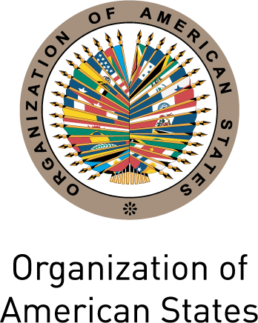 |  | 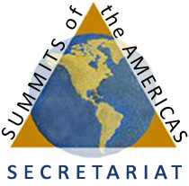

Secretariat for External Relations / Department of International Affairs
Summits of the Americas Secretariat
In preparation for the VI Summit of the Americas, cordially invite you to the
XXXII OAS POLICY ROUNDTABLE
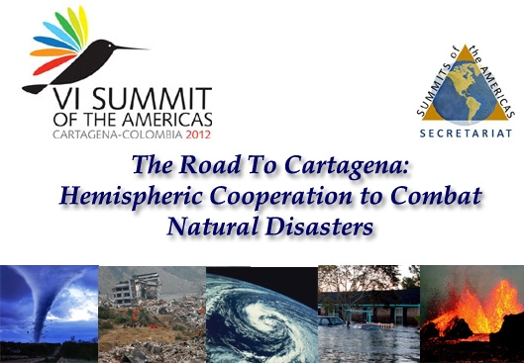
Thursday, October 6, 2011
3:00 PM
OAS Hall of the Americas, 17th Street and Constitution Ave. NW
Washington, DC 20006
Program
3:00- 3:10 pm Welcoming remarks by Ambassador Luis Alfonso Hoyos, Permanent Representative of Colombia to the OAS

3:10- 4:10 pm Discussion Panel moderated by Cletus Springer, Director of the Department of Sustainable Development, OAS

    - Carlos Alberto Villalba, Vice President and Coordinator of the White Helmet Commission, Ministry of Foreign Affairs of Argentina
    - Jean-Luc Poncelet, PAHO/WHO Area Manager in Emergency Preparedness and Disaster Relief for Latin America and the Caribbean
    - Durwood Zaelke, President and founder of the Institute for Governance and Sustainable Development and Director of the International Network for Environmental Compliance and Enforcement (INECE)

4:10- 4:50 pm Question and answer session

4:50-5:00 pm Event closing by Sherry Tross, Executive Secretary, Summits of the Americas Secretariat, OAS
Please register here or send an e-mail to SER-DIA@oas.org

