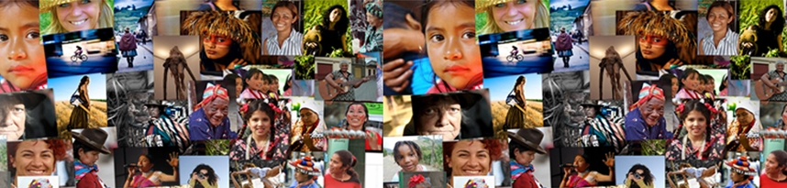
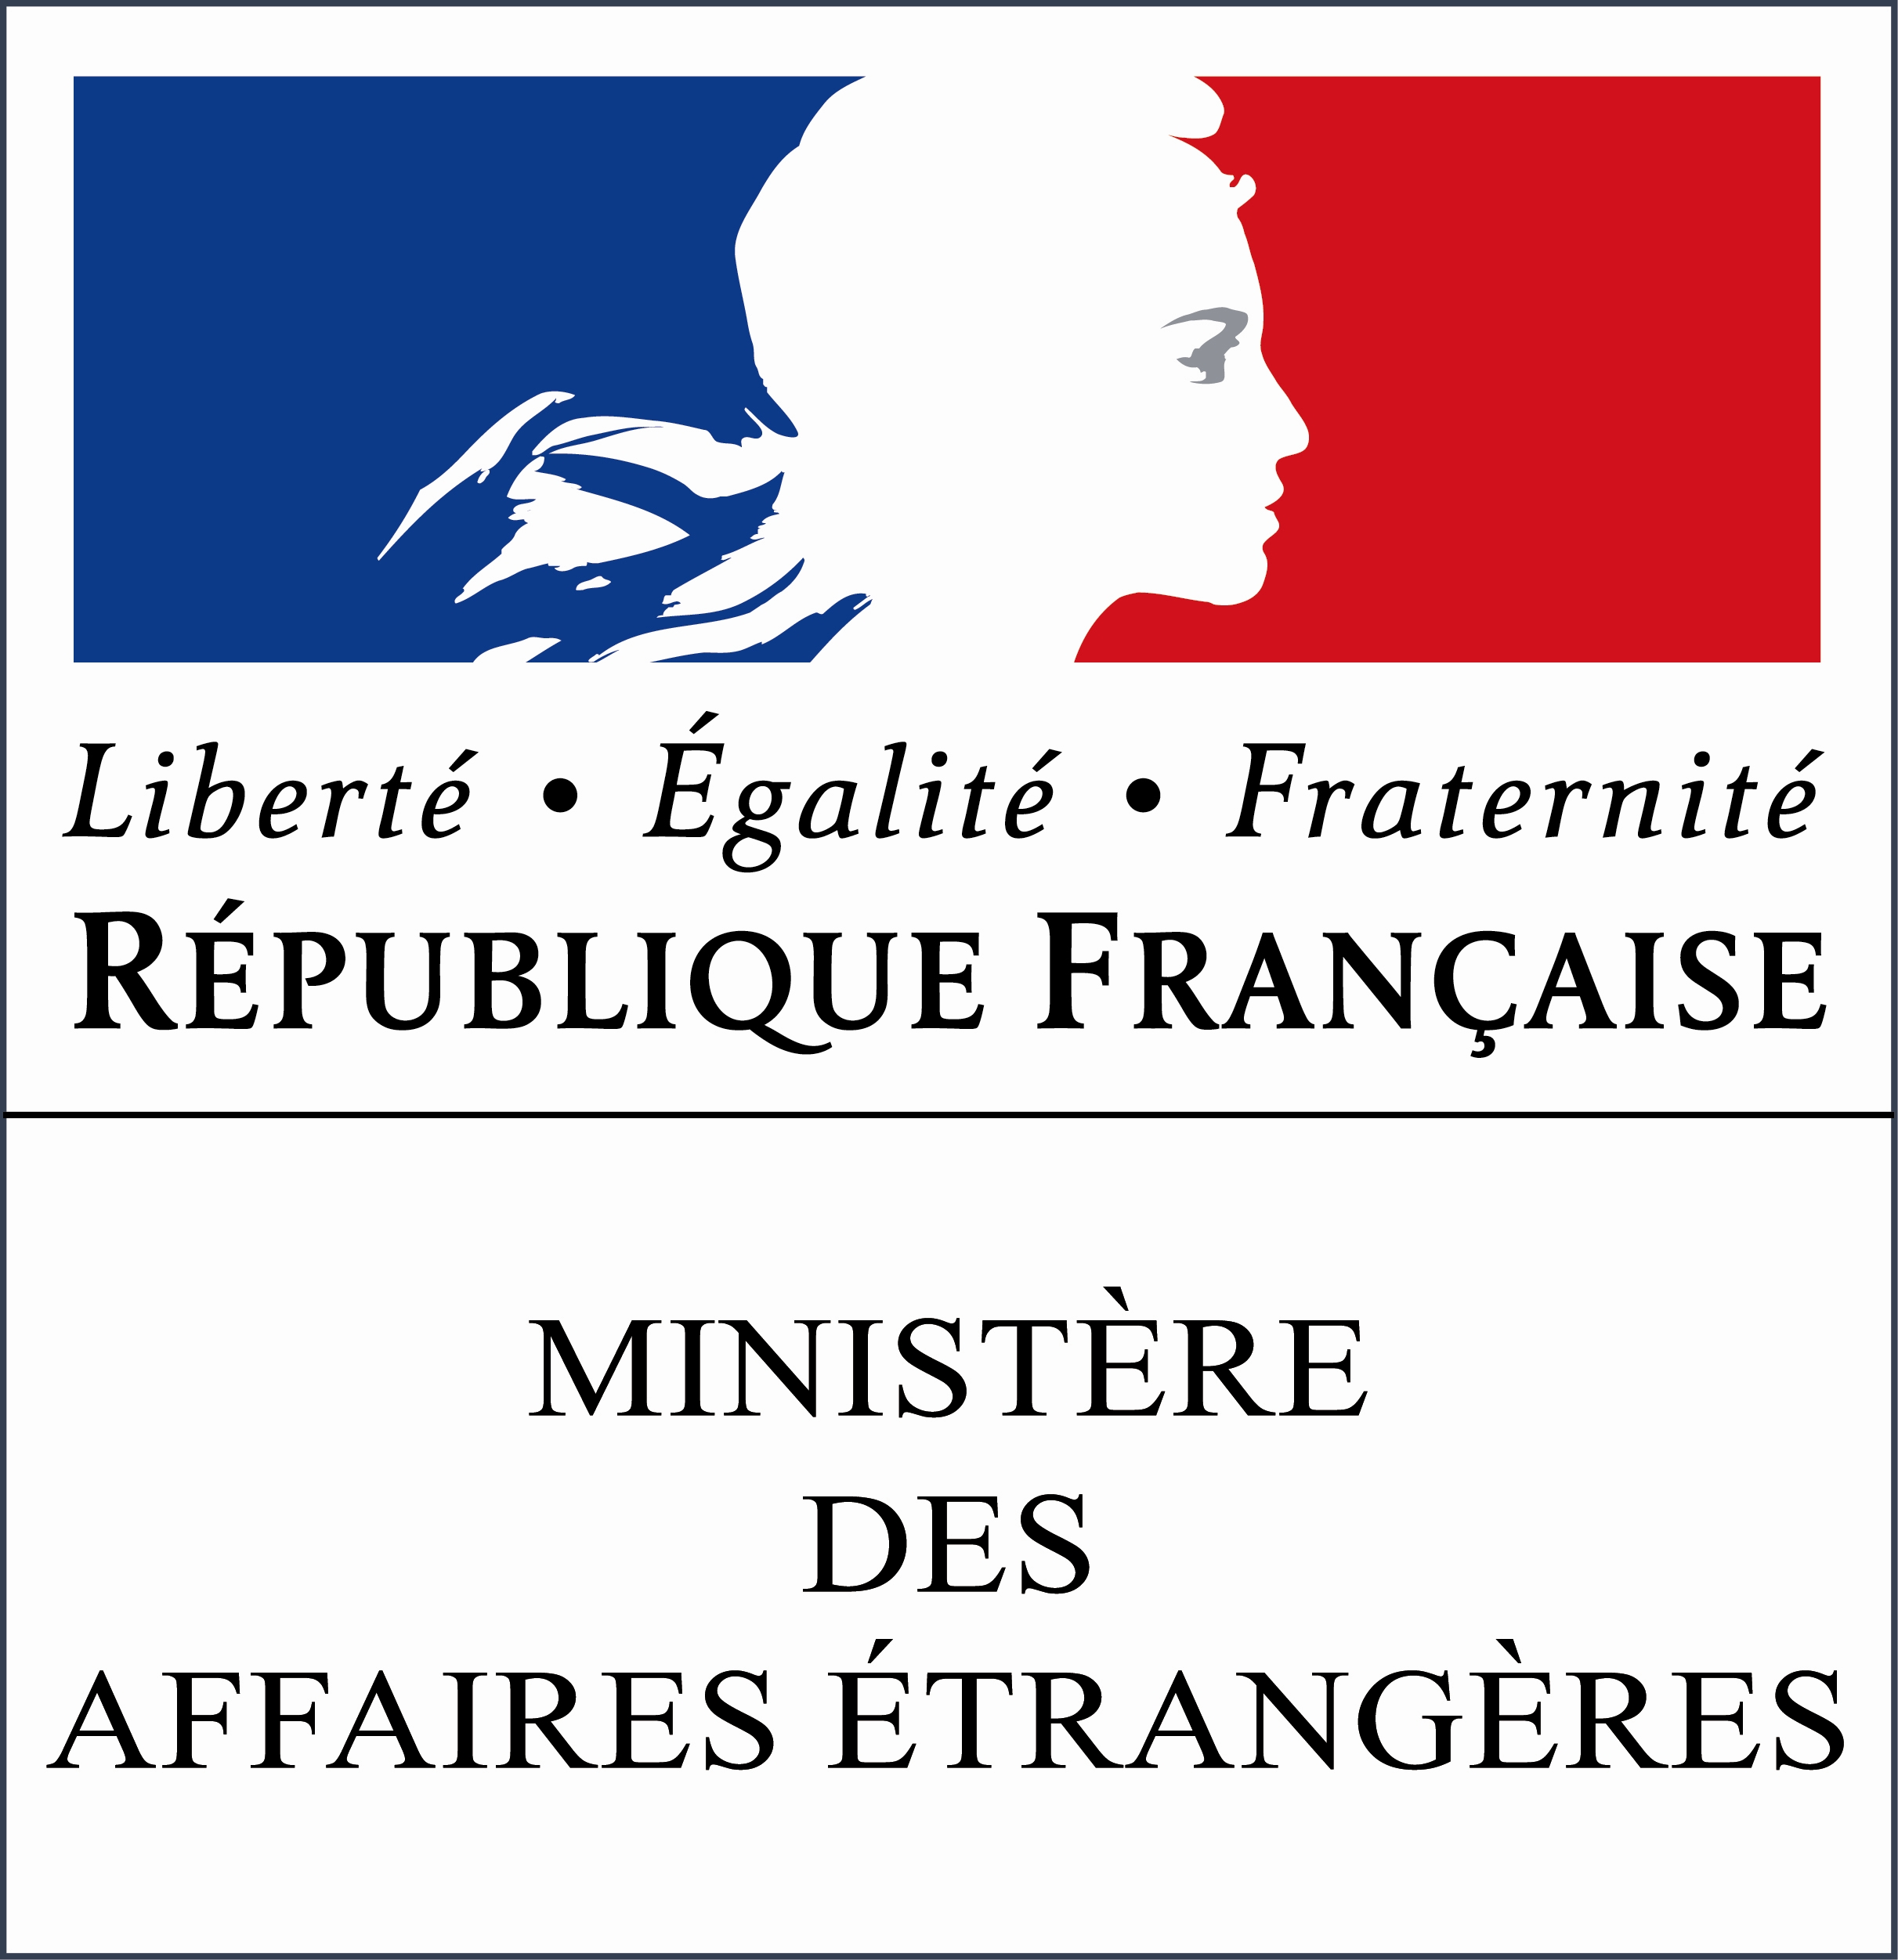

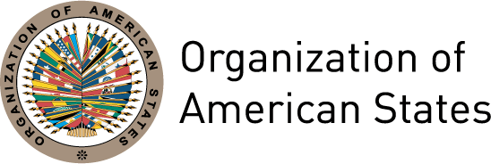
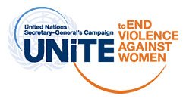
BIOGRAPHIES OF THE PANELISTS

XLII OAS POLICY ROUNDTABLE

“Priorities for action in combating violence against women”

July 11th 2012 – 3:00 pm

Elizabeth Quiroa is the Secretary for Women’s Affairs of Guatemala (2012-2016) and President of the Conference of States Party to the Belém do Pará Convention. Quiroa is an economist and holds a master’s degree in Political Science and Local Economic Development. She pursued graduate studies in Environmental Sociology, with a concentration in Disasters and Sustainable Development and Strategies in International Insertion and External Finances in Latin America.

She has held various positions in government, international cooperation agencies and private companies in areas such as economics, finance, planning, statistics, national accounts, markets, money markets, foreign trade, gender, femicide and trafficking in persons, among others.

With regard to public policy, she has been responsible for the design of public policy with a gender perspective from The Fund for Guatemalan Indigenous Development (FODIGUA), the National Commission on Disability (CONADI), the Ministry of Environment and Natural Resources and the Special Coffee Trade Federation of Guatemala.

Quiroa has done research on public budget with a gender perspective, femicide, implications of free trade agreements, maternal and child health and women’s contribution to a country’s economy, among other topics.
.

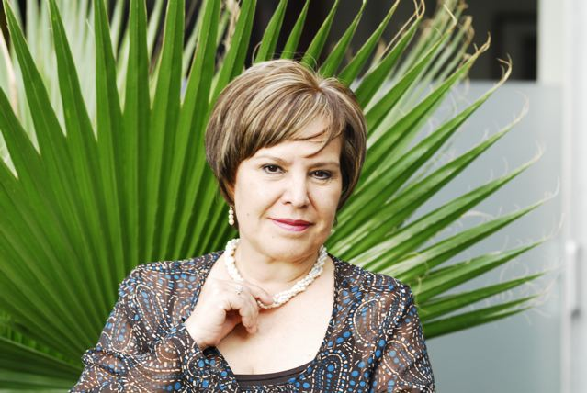
Patricia Olamendi is the Coordinator of the Follow-up Mechanism to the Belém do Pará Convention Committee of Experts. She studied law and teaches public safety at the Universidad Iberoamericana and graduate studies in law at Universidad Nacional Autónoma de México (UNAM), from where she graduated.

She has worked in Mexico’s public administration and international agencies, having served as Undersecretary for Multilateral Affairs and Human Rights at the Secretariat for Foreign Affairs, Chairperson of the UN Commission on Narcotic Drugs, Assistant Attorney for Victims of Crime in the Office of the Attorney General of the Federal District, Legal Coordinator of the Citizens’ Commission against Discrimination, Coordinator of the Program of the Federal District on Women's Equal Participation and a Federal Representative.

She is the author of several publications, among them: the “Protocol for the Investigation of Femicide and Crimes against Women,” "Body of Evidence” and "Human Rights, International Protection Instruments”.

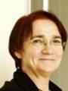
Maryvonne Lyazid is the Assistant Ombudsperson of France and Vice-president of the Department for the Fight against Discrimination and the Promotion of Equality.

She graduated from the Institute of Political Studies of Strasbourg and the National School of Public Health. She served as Assistant Director (from 1988 to 1992) and then Director (from 1992-1996) of the Department of Sanitary and Socials Affairs of the Bas-Rhin.

She was Director of the project “Human Dignity and Social Exclusion” at the Council of Europe and at the same time she was in charge of the Department of Social Action, responsible for disability and international issues at the Ministry of Labor and Solidarity from 1996 to 1998. Lyazid was also in charge of the Delegation of the European and International Affairs from 1997 to 2000. In 2000, she was project leader at the State Ministry for the Elderly and Disabled, and at the Centre for European Studies in Strasbourg. In 2002, Lyazid became Deputy Director of the Fondation Caisses d’Epargne pour la Solidarité.

Since February 2011, Lyazid is Vice President of the Department for the Fight against Discrimination and the Promotion of Equality. Since June 2011, she is Deputy Director of this institution.

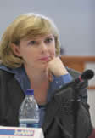
Elizabeth Abi-Mershed is the Assistant Executive Secretary of the Inter-American Commission on Human Rights (ICHR), an independent organ of the OAS, where she has served as a lawyer since 1992. Abi-Mershed examines and handles cases before the Commission, writes reports, and participates in the litigation of cases before the Inter-American Court of Human Rights.

She also supports the work of the Rapporteurship on the Rights of Women. A specialist in women’s rights, she teaches at the Washington College of Law at American University. She is a graduate of the Washington College of Law and Georgetown University and has published several articles on the human rights of women.

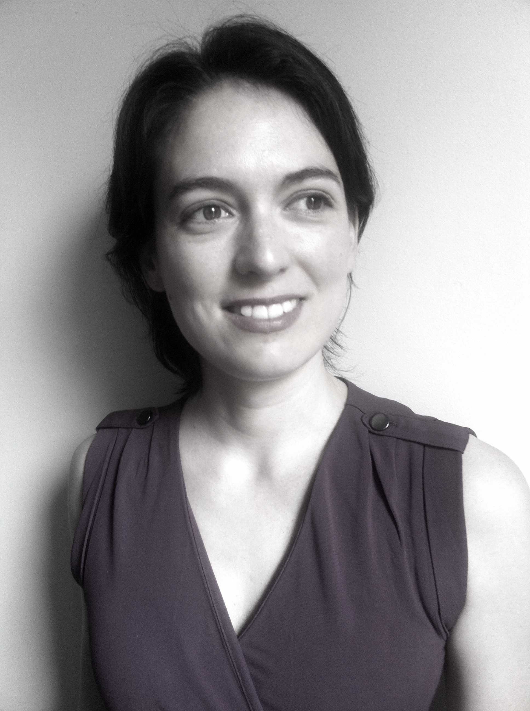
María Leticia Guelfi is a Programme Specialist at the Americas Division in UN Women, New York. Since she joined the UN in 2008, her work has focused on issues related to the design and implementation of programmes on areas such as Ending Violence Against Women, Aid Effectiveness & Gender Responsive Budgeting. In collaboration with other UN agencies she was responsible for developing the initial document of the SG Campaign “Unite To End Violence Against Women” for Latin American and the Caribbean, while coordinating inter-agency actions for its official launch in Guatemala in 2009. She is focal point for the SG Campaign LAC at head-quarters and collaborates with the campaign’s Secretariat in its implementation at regional level.
Before joining UN Women, she has worked on economic development policies, women’s political participation and social inclusion in other international organizations (i.e. OECD, Paris; IDB, Washington DC) and the public sector in Argentina.
Leticia holds an Honor’s degree in International Relations from the Universidad Del Salvador, Argentina; a Masters degree in Public Affairs from Science Po, Paris and a Masters in Public Administration with focus on Economic and Political Development from Columbia University.

