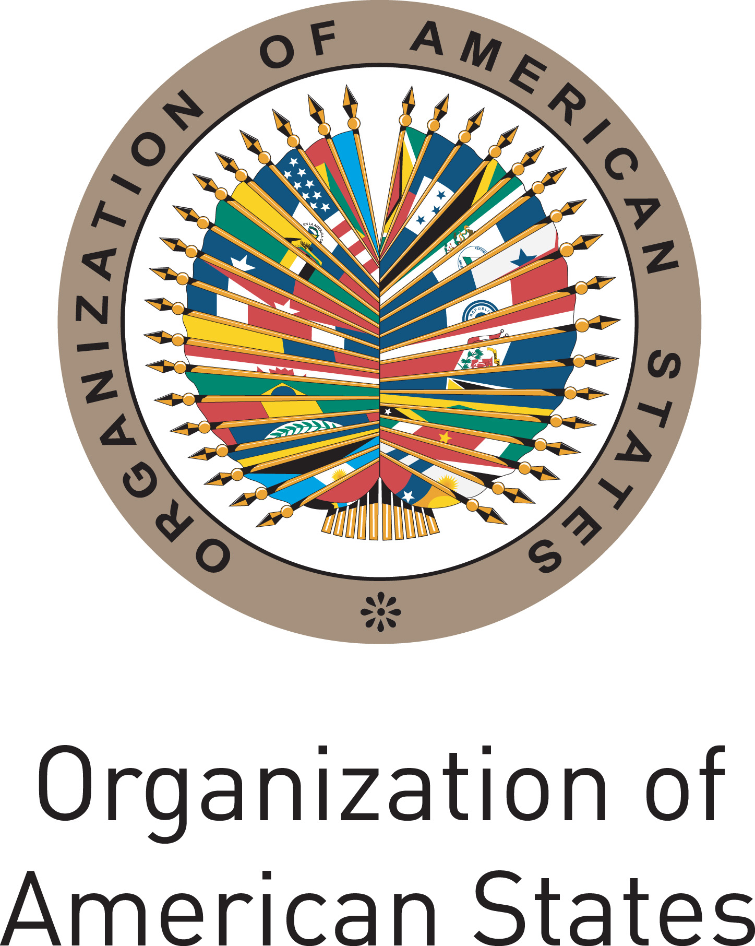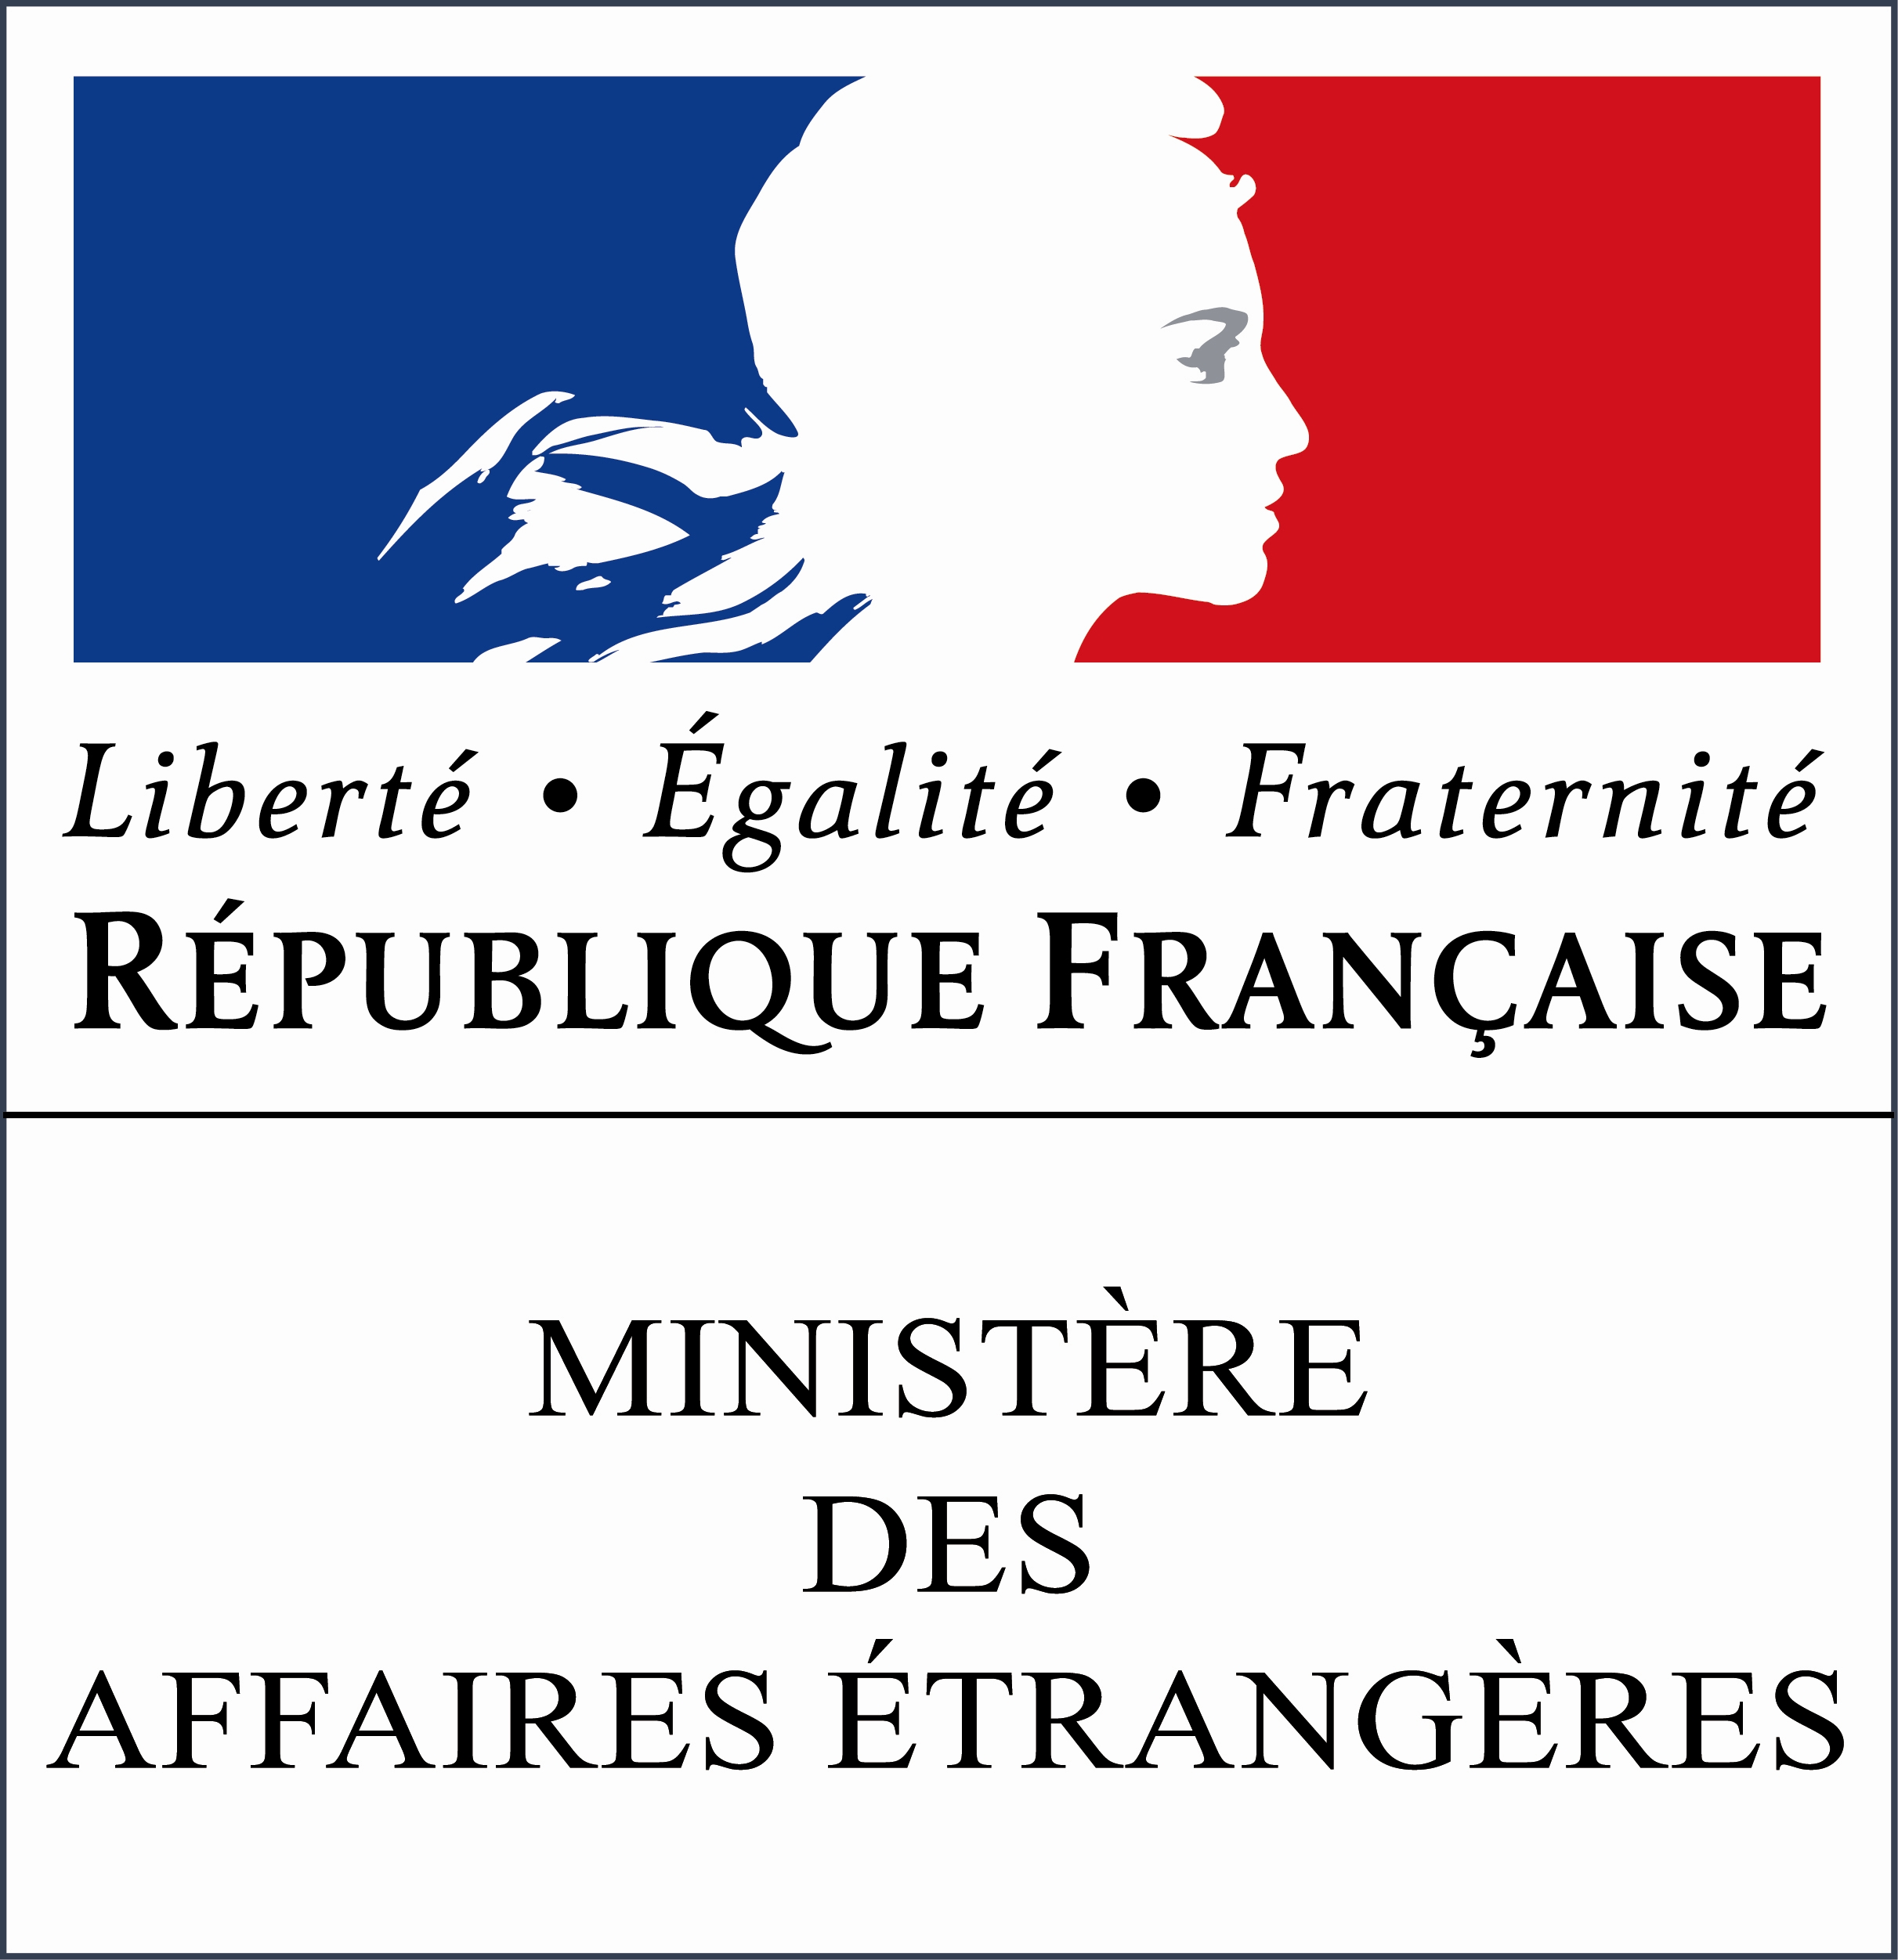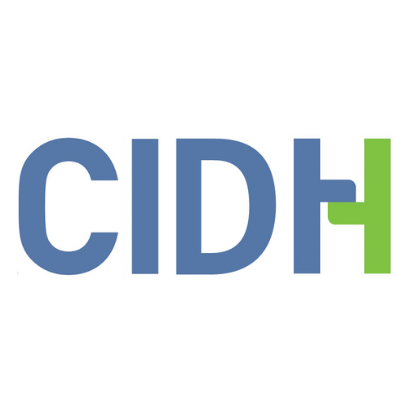

Secretariat for External Relations / Secretariat for Legal Affairs

XLVI OAS POLICY ROUNDTABLE
on the World Day against the Death Penalty
Thursday, October 11, 2012
10:00 AM
Hall of the Americas
17 St & Constitution Ave., NW, Washington, DC 20006

10:00 AM Welcoming remarks by OAS Secretary General, José Miguel Insulza

10:10 AM Panel: How much longer until the universal abolition of the death penalty? Moderated by Jean Michel Arrighi, OAS Secretary for Legal Affairs

    - Emilio Álvarez Icaza, Executive Secretary of the Inter-American Commission on Human Rights (IACHR), OAS
    - Ambassador Pierre Henri Guignard, Permanent Observer of France to the OAS
    - Susan L. Karamanian, Associate Dean for International and Comparative
Legal Studies, the George Washington University Law School

11:10 AM Question and answer session

11:30 AM Closing

Favor registrarse mediante este enlace o enviando un correo a SER-DIA@oas.org

