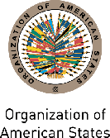 |  | 
Secretariat for External Relations / Department of International Affairs
Organization of American States (OEA)

XXXVI OAS POLICY ROUNDTABLE
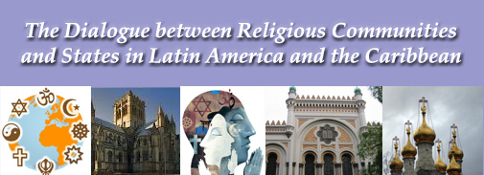

Monday, December 5, 2011
3:00 - 5:00 p.m.
Hall of the Americas, 17th Street and Constitution Ave. NW, Washington, DC 20006

3:00 p.m. Welcome from Irene Klinger, Director, Department of International Affairs, Secretariat for External Relations, Organization of American States (OAS)

3:10 p.m. First Panel: Religious freedom and non-discrimination, moderated by Nerea Aparicio, Specialist, Executive Secretariat, Inter-American Commission on Human Rights (IACHR)

Robert John Araujo, S.J., Professor, Loyola University School of Law

Muhammad Yusuf Hallar, Vice Moderator, Latin American and Caribbean Council of Religious Leaders - Religions for Peace and General Secretary, Islamic Organization for Latin America and the Caribbean (OIPALC)
Claudio Epelman, Vice Moderator, Latin American and Caribbean Council of Religious Leaders - Religions for Peace and Executive Director, Latin American Jewish Congress (CJL)

Questions and answers session

4:05 p.m. Second Panel: The contribution of religious leaders in the design of public policies, moderated by Evelyn Falck, Executive Committee Member, Latin American and Caribbean Council of Religious Leaders - Religions for Peace and Coordinator, Latin American and Caribbean Women of Faith Network

Rt. Rev. Julio Murray, Executive Committee Member, Latin American and Caribbean Council of Religious Leaders - Religions for Peace and President, Latin American Council of Churches (CLAI)

Rev. Galen Carey, Vice President, Government Affairs Department, National Association of Evangelicals (NAE) *** TBC

Ajq’ijab Cirilo Perez, Executive Committee Member, Latin American and Caribbean Council of Religious Leaders - Religions for Peace, Chief Elder, Continental Council of Indigenous Elders and Spiritual Guides of the Americas, and Extraordinary Itinerary Ambassador for Indigenous Peoples of Guatemala

Questions and answers session
4:55 p.m. Closing remarks by William Vendley, Secretary General, Religions for Peace International
Please register here or send an e-mail to SER-DIA@oas.org

