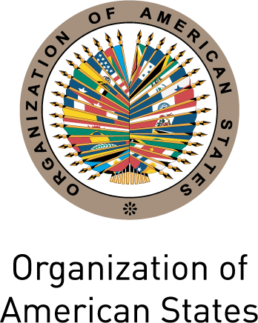 |  | 
Secretariat for External Relations / Department of International Affairs

XXV OAS POLICY ROUNDTABLE

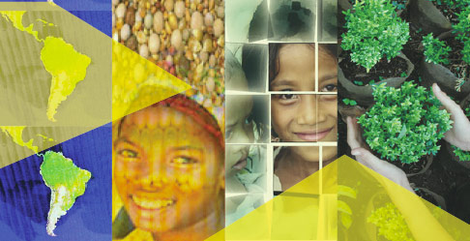
Presentation of the 2010 Report: Achieving the Millennium Development Goals with equality in Latin America and the Caribbean. Progress and challenges
Wednesday, September 8, 2010
9:30 AM
Hall of the Americas, 17th Street and Constitution Ave. NW
Washington, DC 20006

9:30-9:40 am Welcoming remarks by José Miguel Insulza, Secretary General of the Organization of American States (OAS)

9:40-10:40 am Presentation of the 2010 Millennium Development Goals Report by:
Alicia Bárcena, Executive Secretary of the Economic Commission for Latin America and the Caribbean (ECLAC)
Heraldo Muñoz, United Nations Assistant Secretary-General, Assistant Administrator of the United Nations Development Programme (UNDP) and Director for its Regional Bureau for Latin America and the Caribbean
Juan Manuel Sotelo, Manager, External Relations, Resource Mobilization
and Partnerships, Pan American Health Organization (PAHO)

10:40-10:55 am Comments by:
Arturo Valenzuela, United States Assistant Secretary of State for Western Hemisphere Affairs

10:55-11:55 am Question and answer session moderated by Irene Klinger, Director of the Department of International Affairs (DIA), Secretariat for External Relations, OAS
12:00 pm Closing remarks

Please register by clicking here or send an e-mail to SER-DIA@oas.org

