‘IICA Day’ 2011:
“The Impact of Youth and Innovation in Agriculture
in Latin America and the Caribbean”
Profiles of Participants

Heather Fulton – Canada
Nova Scotia-Newfoundland and Labrador Representative
Canadian Young Farmers Forum (CYFF)


Heather Fulton is a sixth generation farmer in Stewiacke, Nova Scotia, Canada. Upon completing her Agricultural Business Diploma from the Nova Scotia Agricultural College, she returned home to the family farm. The farm consists of sixty purebred milking holsteins, replacement heifers amnd calves, two hundred acres of land used to grow corn and grass silage for the cattle and extra hay to sell. Aside from working on the farm heather is very active in the agricultural community as well, she represents Nova Scotia and Newfoundland and Labrador on the Canadian Young Farmers Forum,She sits on the boards for both her local a and provincial holstein organization and represents Young Farmers on the provincial Agricultural Awareness Commitee. Heather enjoys being active and can be found doing numerous outdoor sports ranging from scuba diving to downhill skiing. She is very passionate about agriculture and is excited to learn all she can and exchange ideas.

Junior Ebanks – Jamaica
Agribusiness Entrepreneur

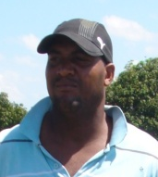
Mr. Junior Ebanks is a 33 years old agricultural entrepreneur who resides in the parish of St. Elizabeth Jamaica West Indies. The parish of St. Elizabeth is regarded by most Jamaicans as the “bread basket of Jamaica”, because of the high concentration of vegetable farmers.

Mr. Ebanks has been in Agriculture for over fifteen years. He operates a fifteen acre farm on which he grows water melons, tomatoes, cucumbers, peppers (hot and sweet) and onions.

In 2009 he was awarded first place in the IICA Agribusiness Awards. The IICA Agribusiness Awards gives annual recognition to selected youths who demonstrates a certain level of commitment and technical competence in their specific agri-enterprise.

Mr. Ebanks is the president of the Pedro Plains Water Users Association; the Pedro Plains is the largest vegetable producing belt in Jamaica. He is currently pursuing his Bachelor’s Degree in Crop Science at the College of Agriculture Science and Education. He is also pursuing a Diploma in greenhouse nursery production at the Ebony Park HEART Academy. He is married and is the father of three children.

Jorge Armando Alamo Toress - Peru
Young Agronomist and Entrepreneur
GIPAMA, J2xN

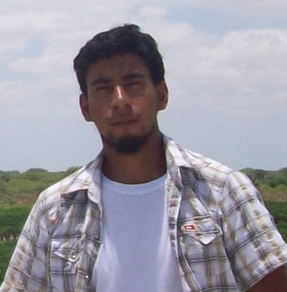
Jorge Armando Alamo Torres is a young agronomist and entrepreneur who graduated from the National University in Piura, Peru. He is the founder and Chairman of the GIPAMA Group a consortium of young scientist involved in agriculture and is also a member of the Latin American Network of Young Leaders.

Jorge and his colleagues were finalists in the 2011 OAS Young Americas Business Trust (YABT) Talent and Innovation (TIC) Americas Competition. Their concept is called J2xN and seeks to solve an environmental problem in rice producing areas where waste is a problem for the ecosystem. Over time, the group investigated the industrial use of the rice husk, discovering that this matter can produce an alcohol which can also be used as bio-fuel. Furthermore, different uses and qualities have been discovered, including applications in medicine for cancer treatment. Jorge spends the majority of his time in the rural areas of Peru.

Martín Durán – Uruguay
Technical Specialist in Agriculture

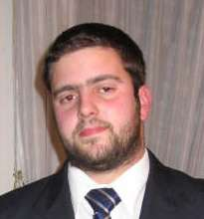
Martín Durán, a graduate in agriculture technology from the Labor University of Uruguay (Universidad del Trabajo del Uruguay) and the Universidad de la Empresa, is a Technical Specialist in Agriculture.
Over the years, Duran has worked tirelessly to influence policy related to agriculture development through involvement in the Young Rural Association of Uruguay (Asociación Rural de Jóvenes del Uruguay). The Young Rural Association is the largest agricultural youth union in Uruguay. Martin has been a member of the Board of Directors for the past 6 years. He has shared his experiences in agribusiness and policy development through participation in hemispheric forums, conferences, training including in extension services, and communications initiatives.

Over the years, Martin has worked with IICA and the Institute’s Leadership Center to open doors for rural youth carrying out agricultural projects and helping to strengthen inter-agency links.

Ernesto Fernandez Polcuch
Senior Programme Specialist,
UNESCO Regional Office for Science in Latin America and the Caribbean
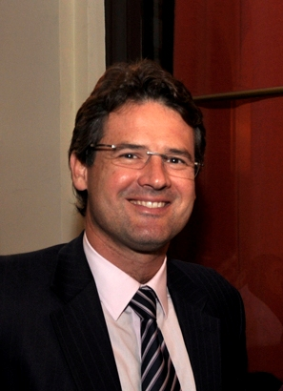
Ernesto Fernández Polcuch is a specialist in Science, Technology and Innovation Policy, with a M.Sc. in Science, Technology and Society from the National University of Quilmes, Argentina.

He currently serves as Senior Program Specialist, Science and Technology Policy and Capacity Building, at the UNESCO Regional Office for Science in Latin America and the Caribbean, based in Montevideo.

He has previously worked as a Program Specialist at the UNESCO Windhoek Office, managing UNESCO’s programs in fields such as Science and Technology Policy, Basic Sciences and Engineering, Freshwater, Environment, and Geology, for five Southern African countries.

From 2002 to 2008, he lead the Science and Technology Statistics team at the UNESCO Institute for Statistics, Montréal, and was responsible for producing world-wide S&T statistics, developing methodologies for S&T&I data collection in developing countries, and producing various analytical reports on issues such as Women in Science.

Before joining UNESCO he worked with RICYT, the Ibero American Network on Science and Technology Indicators, since its establishment in 1995, as Technical Secretary and later R&D coordinator, setting up the S&T indicators system in Latin America.

Other experience includes working as a researcher and as professor at the National University of Quilmes and other universities in Argentina and Latin America; adviser to the National Secretary for Science, Technology and Innovation in Argentina; and as a consultant to various National and International agencies, including UNESCO, the Organization of American States (OAS), the World Bank, and OECD.

He has published numerous papers related to science, technology and innovation statistics and policy; higher education policy in national and international peer reviewed journals; book chapters; and research reports. He has also presented several papers at international conferences and congresses, and has conducted training seminars and workshops in Latin America, Africa, Asia and transition countries in Europe.

Gustavo Manrique
President, SAMBITO, S.A.


Gustavo Manrique is an agrarian engineer who graduated in 1996 from EARTH University, located at Costa Rica. He was the Founding President of AGEARTH (Association of EARTH graduated, chapter Ecuador), from 1999 until 2006. In 1997, already in the professional world, he dedicated his time serving the Administration de Negocios S. A. (SEAN S. A.). Later he founded Agricola Fatty S. A., a company dedicated to the production, commercialization and export of cocoa, theca and plantain, of which he was the General Manager.

Convinced that environmental challenges represented an innovative business opportunity of high social impact, Manrique decided to form SAMBITO S. A. This company promotes eco – projects and specializes in developing and providing innovative solutions to environmental problems. SAMBITO works with both the public and private sectors, providing a series of quality services in order to help businesses become more profitable and sustainable through time. Actually SAMBITO has offices in Guayaquil and Quito.

In 2002, Manrique formed INNOVEX S. A. - a company working to assist with exports for small, middle and large producers, allowing them greater economic benefit and inviting them to be part of the final market.

Gustavo is also Chairman of Tropical Agricultural Industrial, AIT, a company that merged with Fatty Farm, which is designed to develop the agricultural sector in the region, growing and processing cocoa and teak for the global market. He is a member of the Board of Agrotropical Colombia on behalf of AIT.

In 2006, along with 14 friends, he decided to create Fusion S. A., of which is its founding President, its main objective the promotion and realization of several investments. In addition he is President of Maxpocorp, the first investment project of Fusion, whose main activities are the production of cocoa production and marketing of bio-fertilizers. He is also member ITCorp participatory, another company of Fusion, which specializes in computer services.

He was Managing Director of the Guayaquil Chamber of Commerce, one of the oldest institutions of the city, in three consecutive periods (from 2004 to 2010). In 2010 he was elected Vice - President, a position he held until the end of that year.

He is Member of the National Committee of INCAE in Ecuador, as well as Director of the UNO Foundation and Chairman of Corpei.

In 2009 he was elected as a member of the Board of Ecuaprimas, one of the most recognized insurance companies in Guayaquil. He is also Member of Executive Forums. In May 2010 was elected to be part of the Board of EARTH University Foundation in Washington DC. He is the President of C.I.M.A. (The International Summit on the Environment) and President of GM & m S. A., a company that administers and manages companies Sambito, Innovex, AIT and Fusion.
David C. Hatch
IICA Representative in U.S.

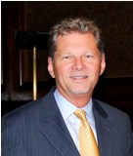
Mr. Hatch currently serves as IICA’s Representative in the United States. He also serves as IICA’s technical advisor and strategist for agricultural insurance in the Americas.

His career includes over 25 years in a unique range of business, government and inter-government positions. Prior to joining IICA he was president of a health insurance services company in California with a focus on developing self insured and partially self insured programs along the US/Mexico border.

He has served as a White House Appointee in Washington, D.C. as Associate Administrator of the Risk Management Agency that administered the $40 billion agriculture insurance program for the United States Department of Agriculture. While at the USDA he was responsible for leading the negotiation of the multi- billion dollar standard reinsurance contract on behalf of the US Government with 16 separate private sector companies; these negotiations were completed ahead of schedule despite significant political pressure. He also supervised field operations, adjudicated the most difficult and complex claims, developed new methodologies for evaluating the financial and operational fitness of each participating insurance company and implemented an improved corrective action process to help ensure the integrity and stability of this essential program for American farmers and ranchers.

Previously he served as president of multiple businesses where he pioneered new business, risk management and customer service models. Results included securing over $200 million in savings for global clients and the preservation of the aerospace business unit of Goodrich. David also has broad international experience and skills in such disciplines as managing business start ups and ramp ups; developing successful partnerships and alliances; leadership; creating value based organizational cultures; marketing; insurance product design; negotiation; reinsurance; risk financing; organizational change and, strategic planning. His international experience includes the British Isles, Caribbean, Europe, Middle East, and Latin America.

Mr. Hatch has also served on numerous private and public sector boards of directors throughout his career. He has also authored a book on the Latin American culture.
Mr. Hatch holds a M.A, degree in Organizational Behavior (Magna cum Laude) and a B.A. in Political Sciences – Emphasis in International Politics (Cum Laude) from Brigham Young University.

Ambassador Albert R. Ramdin
Assistant Secretary General, OAS
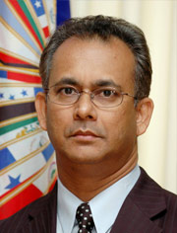
Albert R. Ramdin was reelected by acclamation for a second term as OAS Assistant Secretary General on March 24, 2010, Outlining his vision for this mandate, he called for greater unity in the Americas noting that “the only way we can move forward is if we dedicate ourselves individually and collectively to cooperate in advancing a positive common agenda that will foster meaningful progress.” Ambassador Ramdin has served as Assistant Secretary General since July 19, 2005.

The Surinamese diplomat has had a distinguished career in public service at the national and international level, serving before his election to the OAS as Ambassador at Large and Special Adviser to the Government of the Republic of Suriname on Western Hemispheric Affairs.

In Suriname, Ramdin served as Senior Adviser to the Minister of Trade and Industry, where he was intensively involved in restructuring the ministry and implementing an industrial development program. In the mid-1990s, he worked for two years in the private sector before returning to public service when he was appointed Adviser to the Minister of Foreign Affairs and the Minister of Finance.

In 1997, Ramdin became his country's Permanent Representative to the OAS, and two years later, he was also appointed to serve concurrently as Suriname's non-resident Ambassador to Costa Rica. As Ambassador to the OAS, Ramdin chaired the Permanent Council (January-March 1998) and the Inter-American Council for Integral Development (1999), and coordinated the Caribbean Community (CARICOM) Ambassadors Caucus during Suriname's chairmanship of the subregional group.

In 1999, he joined the CARICOM Secretariat as Assistant Secretary-General for Foreign and Community Relations, where he was responsible for coordinating CARICOM's foreign policy and strengthening relations among its member states. He played a leading role in increasing cooperation with the Central American Integration System and the Andean Community. Ramdin coordinated CARICOM's technical preparations for the Third Summit of the Americas and was instrumental in ensuring that key issues were included in its Declaration and Plan of Action.

In 2001, Ramdin was named Adviser to the OAS Secretary General, with special attention to the Caribbean. He continued his close engagement with the situation in Haiti, dealt with issues of priority for small states, monitored the hemispheric trade agenda and briefed the General Secretariat on Caribbean concerns.

Born in Suriname on February 27, 1958, Ramdin received his education in Paramaribo and in The Netherlands, at the University of Amsterdam and the Free University, where he studied geography of developing countries with a specialization in social and economic problems of smaller economies in Latin America and the Caribbean.

