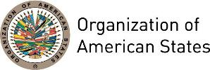


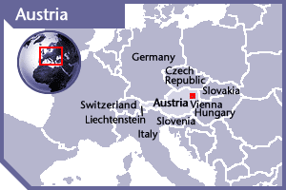

AUSTRIA
PERMANENT OBSERVER

Date of Entry: April 5, 1978
National Day: October 26
Capital: Vienna
Type of Government: Federal Republic
Head of State: President Alexander van der Bellen (January 26, 2017)
Head of Government: Federal Chancellor Christian Kern (May 17, 2016)
Federal Minister for Europe, Integration and Foreign Affairs: Sebastian Kurz (December 16, 2013)
Permanent Observer: Ambassador Dr. Wolfgang A. Waldner (January 11, 2016)

ECONOMIC INDICATORS | 2010 | 2011 | 2012 | 2013 | 2014 | 2015 | 2016
Population (in millions) | 8.36 | 8.39 | 8.42 | 8.47 | 8.54 | 8.63 | 8.74
GDP (US$ in billions) | 390.212 | 429.037 | 407.452 | 428.248 | 438.376 | 376.967 | 386.428
GDP per capita (US$) | 46,657.063 | 51,126.741 | 48,333.573 | 50,504.715 | 51,322.64 | 43,665.009 | 44,665.009
Source: www.tradingeconomics.com | The World Bank Group

FOREIGN RELATIONS POLICIES:
- Austria is committed to strengthening the European Union’s role as an international player and supports all steps directed at deepening the Common Foreign and Security Policy (CFSP), promoting external relations and developing the European Security and Defense Policy (ESDP).
- The Austrian foreign policy’s priorities are to:
- Strengthen trans-Atlantic relations based on the common values and economic ties,
- Consolidate the authority and structures of the United Nations,
- Make use of the instruments provided by the OSCE and the Council of Europe,
- Promote respect for international law, taking into account human rights and the rights of minorities,
- Promote the non-proliferation of weapons of mass destruction and strengthen relevant organizations and control regimes, as well as the ban of land mines and cluster munitions and the containment of small and light weapons,
- Combat international terrorism, and encourage the dialogue among civilizations.
- Apart from being a Member State of the European Union, Austria is represented in the Organization for Security and Co-operation in Europe (OSCE) and the Council of Europe. In the field of security cooperation, Austria participates in North Atlantic Treaty Organization’s (NATO) Partnership for Peace programme.
- Austria maintains diplomatic relations with 156 states, 117 of which have representations in Vienna, while Austria has embassies in 43 countries outside of Europe. In this context, Austria aims to complement its foreign policy not only with its partners within the European Union (EU) but also with representatives of states in other regions, promoting bilateral exchanges in the EU-LAC summits and the Asia-Europe Meetings (ASEM). Additionally, institutionalized dialogues are also maintained with USA, Canada, and countries of the Middle East and Africa.

AUSTRIAN DEVELOPMENT COOPERATION (ADC):
- Austrian Development Cooperation (ADC) supports countries in Africa, Asia, Central America and South Eastern and Eastern Europe in their sustainable social, economic and democratic development.
- The Federal Ministry for Europe, Integration and Foreign Affairs plans the ADC strategies.
- Austrian Development Cooperation aims at reducing global poverty, ensuring peace and human security and preserving the environment, and its principles (democracy, human rights, dialogue based on partnership with developing countries).
- Austria supports multilateral organizations through direct contributions, specific programs and by implementing joint projects with the United Nations, World Bank Group, Organization for Economic Co-operation and Development (OECD), and the development cooperation committees of the EU.
- Four policy pillars of bilateral and multilateral development cooperation are the Millennium Development Goals, the Paris Declaration, Accra Agenda for Action and the Busan partnership Document. Country strategies, sectorial and regional programs as well as guidelines for joint operations are developed in dialogue with partner countries.
- The thematic priorities of Austrian Development Cooperation are water and sanitation, energy, climate protection, agriculture and forestry, private-sector development, human security, human rights and governance.
- The principles for Austrian development programs and projects are:
- Ownership/Partnership;
- Integration in the socio-cultural context;
- Consideration for the needs of children and people with disabilities;
- Gender equality; and
- Support the economic, social and ecological development of south-eastern Europe.

AUSTRIAN DEVELOPMENT AGENCY (ADA)
- The Austrian Development Agency (ADA) is the operational unit of the Austrian Development Cooperation and Cooperation with Eastern Europe (ADC) responsible for the implementation of all bilateral programs and projects in the ADC partner countries and administers the corresponding budget.
- Its major goals are to reduce global poverty, safeguard peace and human security, and preserve the environment. As such, its priorities are water and sanitation; education and training, science and research for development; rural development; energy; promotion of investment; employment and promotion of small and medium-sized enterprises; conflict prevention and resolution, good governance and rule of law, development of democratic structures, decentralization, strengthening human rights and human security. Another focus of ADA’s operations is education and information in Austria to convey the issue of development cooperation to a broader public.

INVOLVEMENT WITH THE AMERICAS:
- Austria has diplomatic relations with all states in the Americas and maintains embassies in Argentina, Brazil, Canada, Chile, Cuba, Mexico, Peru, United States of America and Venezuela.
- Austria supports the bi-regional cooperation established through the European Union and Latin America and the Caribbean (EU-LAC) serving as the framework for cooperation between the two regions. Bilateral relations between Austria and Latin America and the Caribbean have intensified since the IV EU-LAC summit held in Vienna in 2006 during the Austrian EU-Presidency. Austria holds political consultations on a regular basis with five Latin American countries (Mexico, Brazil, Argentina, Chile and Cuba). The establishment of the EU-LAC foundation in November 2011 in Hamburg, Germany has been a decisive step in further intensifying bi-regional relations.
- Institutional relations have been established with CARICOM and the Organization for Eastern Caribbean States (OECS).
- Through cooperation with CARICOM and other Caribbean-based organizations, Austria supports programs designed to build capacity for disaster risk management, renewable energy and energy efficiency.

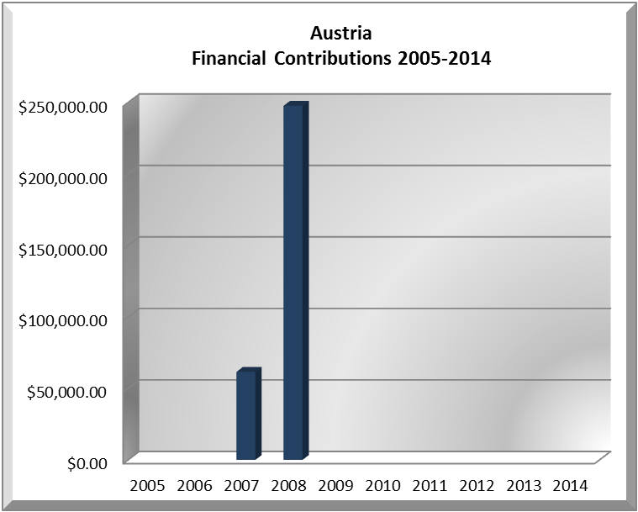
FINANCIAL CONTRIBUTIONS TO THE OAS 2007-2016:
YEAR | AUSTRIA | P.O. FINANCIAL CONTRIBUTIONS | %
2007 | $61,600.00 | $20,398,686.00 | 0.30%
2008 | $247,703.00 | $22,684,500.00 | 1.09%
2009 |  | $20,318,115.00 | 0.00%
2010 |  | $15,781,991.00 | 0.00%
2011 |  | $15,692,757.00 | 0.00%
2012 |  | $13,239,705.00 | 0.00%
2013 |  | $16,926,686.00 | 0.00%
2014 |  | $10,999,882.00 | 0.00%
2015 |  | $17,489,206.00 | 0.00%
2016 |  | $14,048,254.00 | 0.00%
Total US$ | $309,303.00 | $167,579,782.00 | 0.18%

AUSTRIA CONTRIBUTIONS:
YEAR | PROJECTS | FINANCIAL CONTRIBUTIONS | IN-KIND CONTRIBUTIONS  IN US$
2007 | Sustainable Development (Fresh Water Management) | $61,600.00
SUBTOTAL |  | $61,600.00
2008 | Sustainable Development (Regional Follow-up meetings on Freshwater Management in Latin America and the Amazon Basin) | $62,700.00
2008 | Executive Secretariat for Integral Development - International Airport in St. Vincent and the Grenadines | $185,003.00
SUBTOTAL |  | $247,703.00
TOTAL |  | $309,303.00

SOURCES:
FEDERAL PRESIDENT WEBSITE  http://www.bundespraesident.at/en/  FEDERAL CHANCELLERY OF AUSTRIA  http://www.bka.gv.at/site/3327/Default.aspx  MINISTRY OF FOREIGN AFFAIRS OF AUSTRIA  http://www.bmeia.gv.at/en | AUSTRIAN DEVELOPMENT AGENCY  http://www.entwicklung.at/en.html  WORLD BANK – TRADING ECONOMICS  www.tradingeconomics.com
This page was last updated on July 7, 2017.

