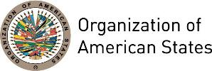
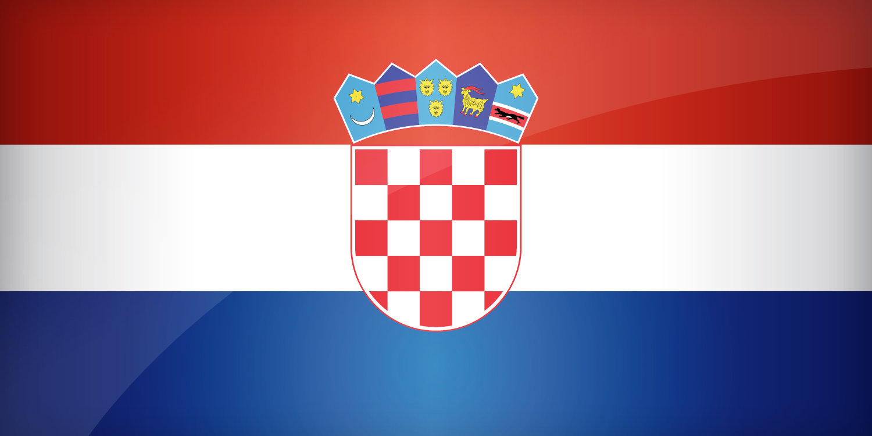
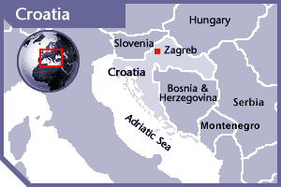


CROATIA
PERMANENT OBSERVER

Date of Entry: March 8, 1995
National Day: June 25
Capital: Zagreb
Type of Government: Parliamentary democracy
Head of State: President Kolinda Grabar-Kitarović (January 11, 2015)
Head of Government: Prime Minister Andrej Plenkovic (October 19, 2016)
First Deputy Prime Minister and Minister of Foreign and European Affairs: Marija Pejčinović Burić (November, 2016)
Permanent Observer: Ambassador Josip Joško Paro (April 19, 2012)

ECONOMIC INDICATORS | 2010 | 2011 | 2012 | 2013 | 2014 | 2015 | 2016
Population (in millions) | 4.41 | 4.28 | 4.26 | 4.25 | 4.23 | 4.20 | 4.17
GDP (US$ in billions) | 59.66 | 62.23 | 56.48 | 57.77 | 57.08 | 48.67 | 50.42
GDP per capita (US$) | 13,505.746 | 14,539.184 | 13,235.978 | 13,574.74 | 13,467.468 | 11,579.667 | 12,090.667
Source: www.tradingeconomics.com | The World Bank Group

FOREIGN RELATIONS POLICIES:
- Croatia’s basic foreign policy aims at the preservation and strengthening of peace and understanding between countries and nations, the consolidation of Croatia’s international position, the creation of conditions for the achievement of basic strategic priorities by joining the European and transatlantic political, security and economic integrations, fulfillment of the assumed international obligations, solving of all issues remaining after the breakup of the former Yugoslavia, establishing good neighborly relations and co-operation with neighbor countries based on the principles of equality and reciprocity, establishing friendly relations with the most important actors and countries in the world, as well as strengthening Croatia’s economic position, and promoting Croatia’s general image.
- Taking part in the activities of international organizations is one of Croatia’s most important foreign policy goals and the Croatian government is working to strengthen its role in those organizations that are of its interest: namely the European Union, the North Atlantic Treaty, the United Nations, the Council of Europe, and the Organization for Security and Co-operation in Europe (OSCE), among many others.
- Regional cooperation, as an integral part of good-neighborly relations, stability and prosperity in the region, will still have an important place in Croatia’s foreign policy activities, and Croatia will actively take part and contribute to the activities of regional organizations, forums and initiatives.
- In April 2, 2009, Croatia formally acceded to the North Atlantic Treaty (NATO). Prior to accession, Croatia had contributed significant logistical support to the Alliance’s operations in Kosovo, and had contributed approximately 300 personnel to operations in Afghanistan. This was accompanied by broad cooperation with the Alliance in terms of science and the environment, civil emergency planning, defense and security sector reform, and public diplomacy.
- In 2013, Croatia became the 28th European Union (EU) country and is expected to join the Schengen area by 2015. The country plans to change the Kuna for the euro when its economy meets all the required criteria by the European Union community.
- In 2013, Croatia defined its strategic thematic and geographic goals related to development cooperation. Geographically, Croatia wants to be present primarily in South-East Europe (with a focus on Bosnia and Herzegovina), the Southern Mediterranean (Morocco, Tunisia and Syria) and Afghanistan. Thematically, Croatia seeks to focus in supporting education, public health, tourism and the development of civil society.

Involvement with the AMERICAS:
- Croatia has diplomatic relations with the following OAS Member States: Antigua and Barbuda, Argentina, Barbados, Belize, Bolivia, Brazil, Canada, Chile, Colombia, Costa Rica, Cuba, Dominica, the Dominican Republic, Ecuador, El Salvador, Grenada, Guatemala, Guyana, Haiti, Honduras, Jamaica, Mexico, Nicaragua, Panama, Paraguay, Peru, Saint Lucia, Saint Vincent and the Grenadines, Trinidad and Tobago, the United States of America, Uruguay and Venezuela.
- Croatia maintains embassies in: Argentina, Bolivia, Brazil, Canada, Chile, Mexico, Peru, the United States of America, and Uruguay.

SOURCES:
OFFICE OF THE PRESIDENT OF CROATIA  http://www.predsjednik.hr/ivojosipovic-english  GOVERNMENT OF THE REPUBLIC OF CROATIA  http://www.vlada.hr/en  REPUBLIC OF CROATIA MINISTRY OF FOREIGN AND EUROPEAN AFFAIRS  http://www.mvep.hr/en/ | EMBASSY OF CROATIA IN THE UNITED STATES  http://us.mfa.hr  WORLD BANK – TRADING ECONOMICS  www.tradingeconomics.com

This page was last updated on July 10, 2017.

