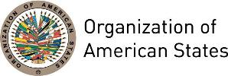

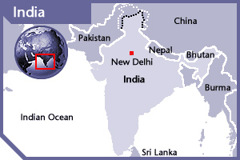
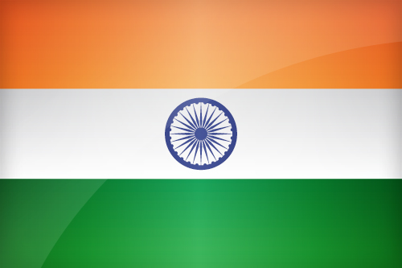

INDIA
PERMANENT OBSERVER

Date of Entry: May 9, 1991
National Holiday: 15 August
Capital: New Delhi
Type of Government: Federal Republic
Head of Government : Prime Minister Narendra Modi (May 26, 2014)
Minister of External Affairs: Sushma Swaraj (May 26, 2014)
Permanent Observer: H. E. Ambassador Navtej Sarna (November 5, 2016)

ECONOMIC INDICATORS | 2010 | 2011 | 2012 | 2013 | 2014 | 2015 | 2016
Population (in millions) | 1,166.23 | 1,186 | 1,210.57 | 1,217 | 1,233 | 1,302 | 1,324
GDP (US$ in billions) | 1,657.4 | 1,823.9 | 1,828.1 | 1,858.7 | 2,035 | 2,112 | 2,664
GDP per capita (US$) | 1345.8 | 1,461.7 | 1,447 | 1,452.20 | 1,573.00 | 1614 | 1709.4
Source: www.tradingeconomics.com | The World Bank Group

FOREIGN RELATIONS POLICIES:
- India's foreign policy has always regarded the concept of neighborhood as its center. In accordance with the philosophy an approach of friendship and cooperation with the aim of peaceful co-existence is the foundation principle of India’s development cooperation policy.
- India considers that the economic development of all countries is an obligation of the whole international community.
- India has been one of the founding members of several international organizations, most notably the United Nations, the Asian Development Bank, G20 industrial nations and the founder of the Non-aligned movement. India has also played an important and influential role in other international organizations like East Asia Summit, World Trade Organization, and the International Monetary Fund (IMF).
- India has taken part in several UN peacekeeping missions and is one of the largest troop contributors to the United Nations.

DEVELOPMENT ADMINISTRATION PARTNERSHIP (DPA):
- India's development assistance covers a large number of countries and focuses on sustaining its high rates of growth. It supports the country’s attempts to secure access to resources, particularly energy, and to develop new markets especially in Asia and Africa, developing closer ties with Asian economies and seeking a place in Asian economic integration.
- India is dependent on imported energy, particularly oil. Much of it comes from the Middle East, but the country is seeking to diversify its sources, and Indian companies have invested in oil production in numerous African states, including Nigeria and Sudan.
- India is committed to playing an active role in enhancing the voice of developing countries in global institutions and to promoting and participating in the self-organization of developing countries.

INVOLVEMENT WITH THE AMERICAS:
- India has diplomatic relation with all OAS Member States and maintains diplomatic missions in Argentina, Brazil, Canada, Chile, Colombia, Cuba, Guyana, Jamaica, Mexico, Panama, Peru, Suriname, Trinidad and Tobago, the United States and Venezuela.
- India's commonalities with developing nations in Latin America, especially Brazil and Mexico have continued to grow. India and Brazil continue to work together on the reform of Security Council through the G4 nations while have also increased strategic and economic cooperation through the IBSA Dialogue Forum. The process of finalizing Preferential Trade Agreement (PTA) with MERCOSUR (Brazil, Argentina, Uruguay, and Paraguay) is on the itinerary and negotiations are being held with Chile.

SOURCES:
Indian Government website
http://goidirectory.gov.in/index.php

Prime Minister of India
http://pmindia.gov.in/en/

Ministry of Foreign Affairs
http://www.mea.gov.in/

This page was last updated on July 11, 2017.

