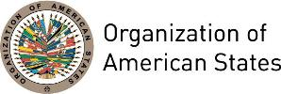

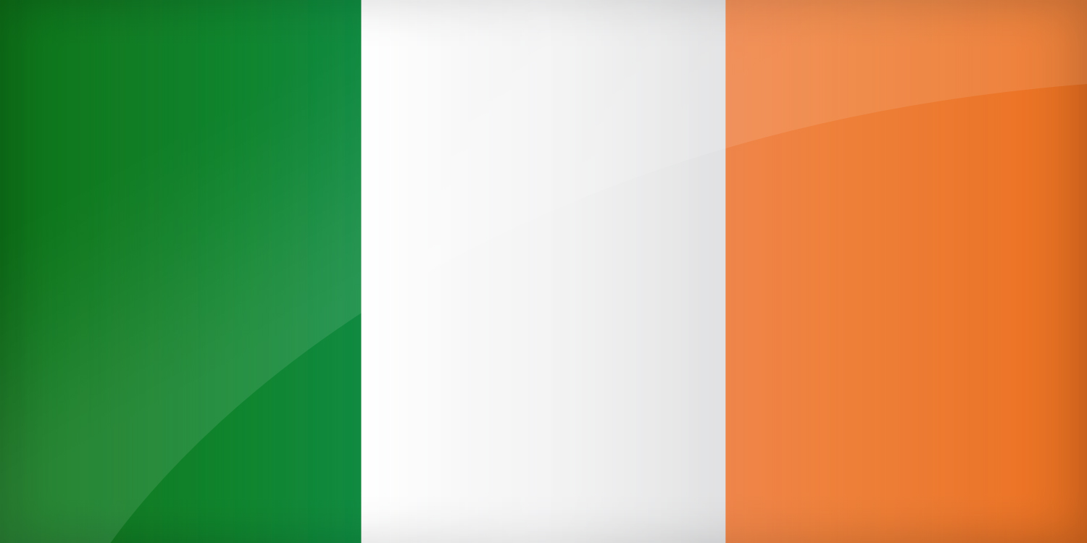
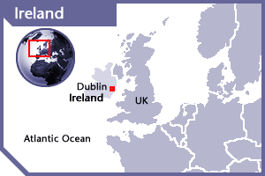

IRELAND
PERMANENT OBSERVER

Date of Entry: May 25, 2000
National Day: March 17
Capital: Dublin
Type of Government: Republic, Parliamentary Democracy
Head of State: President Michael Higgins (November 11, 2011)
Head of Government: Prime Minister (Taoiseach) Enda Kenny (March 9, 2011)
Tánaiste and Minister for Foreign Affairs & Trade: Charles Flanagan, TD (July 11, 2014)
Permanent Observer: Ambassador Anne Anderson (September 5, 2013)

ECONOMIC INDICATORS | 2010 | 2011 | 2012 | 2013 | 2014 | 2015 | 2016
Population (in millions) | 4.52 | 4.55 | 4.57 | 4.58 | 4.59 | 4.59 | 4.59
GDP (US$ in billions) | 221 | 240.6 | 225.8 | 239.3 | 256.3 | 283.72 | 294.1
GDP per capita (US$) | 48,538.64 | 52,567.34 | 49,231.62 | 52,034.77 | 55,503.27 | 60,664 | 61,606
Source: www.tradingeconomics.com World Bank

FOREIGN RELATIONS POLICIES:
- Ireland’s foreign policy is committed to an international order based on the rule of law and the peaceful settlement of disputes.
- From 2011-2014, the Irish Department of Foreign Affairs and Trade will focus its activity on economic renewal through the promotion of sustainable growth and investment through increased outreach to international partners to open for business, foreign investment and trade, especially through the European Union.
- Ireland prioritizes peace, security and conflict resolution, and plays an active role in peacekeeping efforts in the context of the United Nations and the Organization for Security and Cooperation in Europe (OSCE).
- The country also works closely with the Council of Europe and the European Union to promote cooperation on issues such as democracy, human rights and the rule of law. Such cooperation has been prominent in the Middle East Peace Process and encouraging reform and the construction of democratic institutions in the Middle East and North Africa.

IRISH AID:
- Irish Aid is the Government’s official aid program that supports development and provides humanitarian assistance to reduce poverty around the world.
- In the development field, Irish Aid programs have the following thematic areas: ending poverty, hunger, gender equality, environment/climate change, health, HIV and AIDS, governance, education, trade and economic growth, water and sanitation.
- Its key partner countries are mostly located in sub-Saharan Africa and Asia: Ethiopia, Lesotho, Liberia, Malawi, Mozambique, Palestine, Sierra Leone, South Africa, Tanzania, Timor L’este, Uganda, Vietnam, Zambia and Zimbabwe.
- 2% of Irish Aid’s bilateral cooperation in 2013 benefitted Latin America, primarily to strengthen civil society programs in Nicaragua and Honduras.
- Total Irish Official Development Assistance (ODA) in 2013, offered by Irish Aid and other government departments, amounted to €637.10 million or 0.46% of GNP. Ireland is committed to reaching the EU target of spending 0.7% of GNP on overseas development assistance by 2015.

INVOLVEMENT WITH THE AMERICAS:
- Ireland has formal diplomatic relations with all OAS Member States and maintains embassies in Argentina, Brazil, Canada, Mexico and the United States of America.

COOPERATION AGREEMENTS WITH THE OAS:
- Grant Agreement between the Minister for Foreign Affairs and Trade as represented by Irish Aid and the General Secretariat of the Organization of American States, Contract Number OAS12 01/GS/OAS by and through the Executive Secretariat of the Inter-American Commission on Human Rights (IACHR), to support the project Protecting the Rights of Human Rights Defenders in Colombia, Venezuela and Ecuador, within the IACHR’s Strategic Plan 2011-2014. Signed on December 18, 2012, for an amount of €100,000 for one-year period.

CASH CONTRIBUTIONS TO THE OAS 2005-2016:

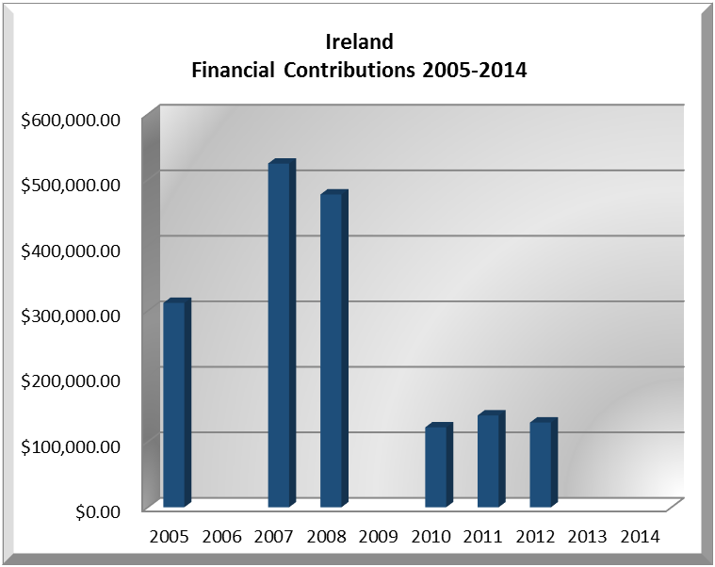
Year | IRELAND | FINANCIAL CONTRIBUTIONS P.O.s | %
2005 | $311,971.00 | $11,650,039.00 | 2.68%
2006 |  | $19,060,470.00 | 0.00%
2007 | $524,740.00 | $20,398,686.00 | 2.57%
2008 | $477,525.00 | $22,684,500.00 | 2.11%
2009 |  | $20,318,115.00 | 0.00%
2010 | $122,075.00 | $15,781,991.00 | 0.77%
2011 | $140,225.00 | $15,692,757.00 | 0.89%
2012 | $129,365.00 | $13,239,105.00 | 0.98%
2013 |  | $16,926,686.00 | 0.00%
2014 |  | $10,999,882.00 | 0.00%
2015 |  | $17,489,205.00 | 0.00%
2016 |  | $14,048,254.00 | 0.00%
Total US$ | $1,705,901.00 | $198,289,690.00 | 0.86%

IRELAND CONTRIBUTIONS:
YEAR | PROJECTS | FINANCIAL CONTRIBUTIONS  IN US$ | IN-KIND CONTRIBUTIONS  IN US$
1999 | Unit for Sustainable Development | $198,210.00
SUBTOTAL |  | $198,210.00
2005 | Department of Democratic Sustainability and Special Missions (DSDSM) – Mission to Support the Peace Process in Colombia (MAPP) | $155,996.00
2005 | Inter-American Commission on Human Rights (IACHR) – Support to Colombia | $155,975.00
SUBTOTAL |  | $311,971.00
2007 | Inter-American Commission on Human Rights (IACHR) | $164,885.00
2007 | Department of Democratic Sustainability and Special Missions (DSDSM) – Mission to Support the Peace Process in Colombia (MAPP) | $359,855.00
SUBTOTAL |  | $524,740.00
2008 | Inter-American Commission on Human Rights (IACHR) – Office of the Special Rapporteur for Freedom of Expression | $78,640.00
2008 | Inter-American Commission on Human Rights (IACHR) – Support to IACHR in Colombia | $223,670.00
2008 | Department of Sustainable Democracy and Special Missions – MAPP/OAS Mission to Support | $175,215.00
SUBTOTAL |  | $477,525.00
2010 | Department of Democratic Sustainability and Special Missions (DSDSM) – Mission to Support the Peace Process in Colombia (MAPP) | $122,075.00
SUBTOTAL |  | $122,075.00
2011 | Inter-American Commission on Human Rights – Protecting the Rights of Human Rights Defenders in Colombia, Venezuela and Ecuador | $140,225.00
SUBTOTAL |  | $140,225.00
2012 | Protecting the Rights of Human Rights Defenders in Colombia, Venezuela and Ecuador | $129,365.00
SUBTOTAL |  | $129,365.00
TOTAL |  | $1,904,111.00

SOURCES:
ÁRAS AN UACHTARÁIN  http://www.president.ie/  MINISTRY FOR FOREIGN AFFAIRS & TRADE  https://www.dfa.ie/  EMBASSY OF IRELAND IN WASHINGTON, D.C.  http://www.embassyofireland.org/home/index.aspx?id=30782 | IRISH AID  http://www.dci.gov.ie/  WORLD BANK – TRADING ECONOMICS  www.tradingeconomics.com

This page was last updated on July 11, 2017.

