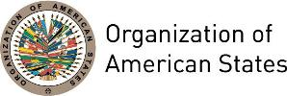
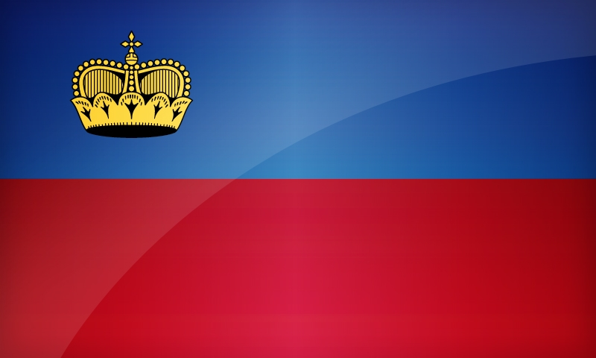
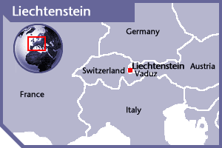
LIECHTENSTEIN
PERMANENT OBSERVER

Date of Entry: January 31, 2014
National Day: August 15
Capital: Vaduz
Type of Government: Constitutional hereditary monarchy
Head of State: Alois, Hereditary Prince of Liechtenstein (since August 15, 2004)
Head of Government: Prime Minister Adrian Hasler (since March 27, 2013)
Minister of Foreign Affairs, Education and Culture: Aurelia Frick (since March 27, 2013)
Permanent Observer: Kurt Jaeger (since August 2016)

ECONOMIC INDICATORS | 2010 | 2011 | 2012 | 2013 | 2014 | 2015 | 2016
Population (in millions) | 0.036 | 0.036 | 0.036 | 0.037 | 0.037 | 0.037 | 0.037
GDP (US$ in billions) | 5.08 | 5.74 | 5.456 | 6.392 | 6.664 | n/a | n/a
GDP per capita (US$) | 141,165.083 | 158,283.076 | 149,295.646 | 173,528.15 | 179,478.585 | n/a | n/a
Source: www.tradingeconomics.com World Bank

FOREIGN RELATIONS POLICIES:
- Prince Hans-Adam II represents Liechtenstein in its international relations.
- Liechtenstein’s basic foreign policy aims to preserve its sovereignty, independence and development of its international relations through international law.
- Under an agreement signed in 1919, Switzerland represents the interests of Liechtenstein on the diplomatic and consular level in those countries where it has foreign representations and Liechtenstein is not represented.
- Through a cooperation agreement signed with Austria in 1979, Liechtenstein’s citizens are represented by Austria in those countries where neither Liechtenstein nor Switzerland maintain diplomatic relations.
- The GDP depends on its industry and machine and tool production (36%), financial services (33%), general services (25%), and agriculture and households (6%).
- Foreign policy priorities include the European Neighborhood Policy, European integration, the rule of law, and international solidarity.
- Liechtenstein is active in international humanitarian cooperation and human rights with a focus on the rights of women and children, the fight against torture and the fight against arms and land mines.
- Cooperation priorities include sustainable development and environment, education, high-tech products, machine building, fighting money laundering and terrorism.
- Liechtenstein was admitted to the United Nations in 1990. It is also a member of most specialized organizations of the UN system, except UNESCO. Some of the memberships in inter-governmental organizations include:
  - Council of Europe (CE)
  - European Bank for Reconstruction and Development (EBRD)
  - European Economic Area (EEA)
  - European Free Trade Association (EFTA)
  - European Union (EU)
  - International Court of Justice (ICJ)
  - Organization for Security and Cooperation in Europe (OSCE)
  - Organization of American States (OAS)
  - Permanent Court of Arbitration (PCA)
  - World Trade Organization (WTO)

International Cooperation in Tax matters Program
- On March 12, 2009, the outgoing and incoming Prime Ministers together with the Prince of Liechtenstein issued a Declaration committing the country to global standards of transparency and exchange of information as developed by the Organization for Economic Cooperation and Development (OECD).
- Liechtenstein has signed various bilateral agreements to address international financial crimes and oversight.
- Liechtenstein has established financial regulatory mechanisms with the European Union, including the Saving Tax Agreement in 2005 and the EU Anti-Fraud Agreement (AFA).

INVOLVEMENT WITH THE AMERICAS:
- The Principality of Liechtenstein has formal diplomatic relations with the following OAS Member States: Antigua and Barbuda, Argentina, Bolivia, Brazil, Canada, Chile, Colombia, Costa Rica, Cuba, Ecuador, Guyana, México, Nicaragua, Panamá, Paraguay, Peru, Saint Kitts and Nevis, Saint Lucia, Saint Vincent and the Grenadines, the United States of America, Uruguay, and Venezuela among others.

CASH CONTRIBUTIONS 2014-2016
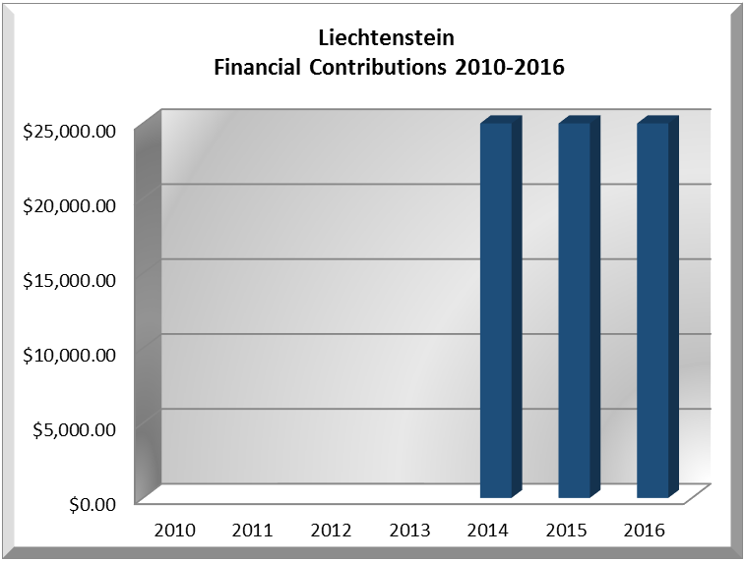
YEAR | LIECHTENSTEIN | P.O. FINANCIAL CONTRIBUTIONS | %
2014 | $25,000.00 | $10,999,882.00 | 0.23%
2015 | $25,000.00 | $17,489,205.00 | 0.14%
2016 | $25,000.00 | $14,048,254.00 | 0.18%
Total  US$ | $75,000.00 | $42,537,341.00 | 0.18%

CONTRIBUTIONS TO OAS PROGRAMS:
YEAR |  | PROJECTS | FINANCIAL CONTRIBUTIONS  IN US$ | IN-KIND CONTRIBUTIONS  IN US$
2014 |  | Inter-American Commission of Women - Virtual Training Course "Gender Justice for the Rights of Women" | $25,000.00
SUBTOTAL |  |  | $25,000.00
2015 |  | Inter-American Commission of Women - Strengthening Capacity of National Machineries for the Advancement of Women in Participating Countries to Advance Gender Mainstreaming | $25,000.00
SUBTOTAL |  |  | $25,000.00
2016 | The Permanent Secretariat of the Inter‐American Commission of Women CIM (34C), Strengthening National Mech. |  | $25,000.00
SUBTOTAL |  |  | $25,000.00
TOTAL |  |  | $75,000.00

SOURCES:
Ministry of Foreign Affairs of Liechtenstein  http://www.llv.li/amtsstellen/llv-aaa-home.htm  Government of Liechtenstein  http://www.liechtenstein.li/ | Embassy of Liechtenstein in Washington, D.C.  http://www.liechtensteinusa.org/  WORLD BANK – TRADING ECONOMICS  www.tradingeconomics.com

This page was last updated on July 5, 2017.

