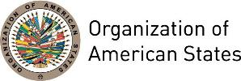

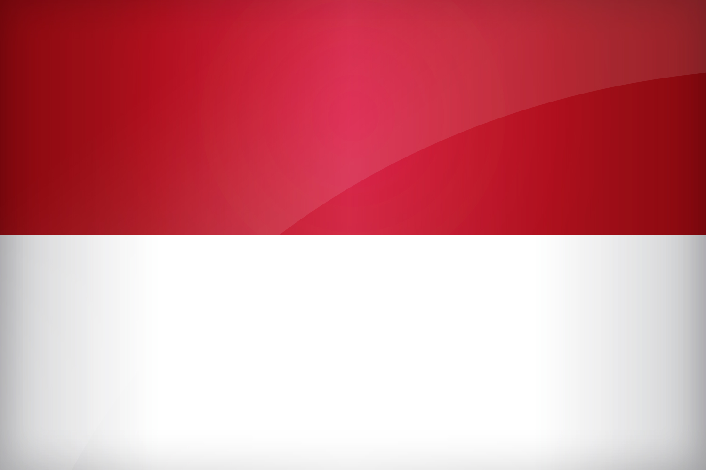
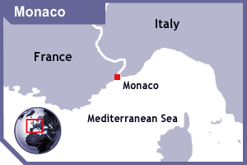

MONACO
PERMANENT OBSERVER

Date of Entry: September 15, 2010
National Day: 19 November
Capital: Monaco
Type of Government: Constitutional monarchy
Head of State: Prince Albert II
Head of Government: Minister of State Serge Telle (January 19, 2016)

Minister of Foreign Affairs and Cooperation: Gilles Tonelli (February 2015)

Permanent Observer: Ambassador Maguy Maccario-Doyle (December 20, 2013)

ECONOMIC INDICATORS | 2010 | 2011 | 2012 | 2013 | 2014 | 2015 | 2016
Population (in millions) | 0.037 | 0.037 | 0.037 | 0.037 | 0.038 | 0.038 | 0.038
GDP (US$ in billions) | 5.35 | 6.08 | n/a | n/a | n/a | n/a | n/a
GDP per capita (US$) | 144,246.396 | 162,009.878 | n/a | n/a | n/a | n/a | n/a
Source: www.tradingeconomics.com World Bank

FOREIGN RELATIONS POLICIES:
- The Prince represents the Principality with respect to foreign powers. Monaco takes part in many international conferences and is committed to support issues related to sustainable development and cooperation on the international scene. It is in this context the Monegasque Government implements the Sovereign Prince's policies through the Ministry of Foreign Affairs.
- The Principality has been a Member State of the United Nations Organization since 1993. It has forged links with most of the leading international organizations. The Monegasque Government's principles on intervention are determined by the Sovereign Prince, with a predilection for issues relating to the environment, human rights (such as the rights of women and children and discrimination) and achieving the eight Millennium Development Goals (MDGs) adopted by the United Nations in 2000.
- In this context, the Government’s international cooperation policy has the following objectives: maternal and infant health, the fight against pandemics and neglected diseases, food safety, education, gender equality and environmental sustainability.

INTERNATIONAL DEVELOPMENT COOPERATION:
- The Department of International Cooperation, within the Ministry of Foreign Affairs, is responsible for managing and implementing Monaco’s development cooperation.
- The Monegasque Government's actions meet the Millennium Goals through various activities relating to development aid and international cooperation. In this context, and with specific emphasis on the environment, the areas of intervention are the fight against desertification and aid for reforestation, access to drinking water and sanitation, urban development that respects the environment and the protection of biodiversity.
- In addition, many activities have been undertaken by the Monegasque Government with regard to promoting research and new environmental technologies, protecting the seas and oceans and, more generally, environment-related development cooperation, such as meeting commitments on carbon neutrality.
- The duties of the Department of International Cooperation include: participation in preparing and monitoring the Principality's policy on international cooperation, all aspects thereof and in particular the selection of projects, determining how they can be realized, and their legal, technical and financial frameworks; deploying, monitoring measures and actions decided as part of emergency humanitarian aid; relations with Monegasque and foreign non-governmental organizations working abroad on development aid; and all other work relating to international cooperation that may be entrusted to it.
- The Government of Monaco has pledged to increase Official Development Assistance (ODA) by 25% a year to reach the goal of 0.7% of Gross National Income (GNI) by 2015 at the latest.

INVOLVEMENT WITH THE AMERICAS:
- Monaco maintains an embassy in the United States of America and consulates or honorary consulates in 18 countries of the Americas: Argentina, The Bahamas, Brazil, Canada, Chile, Colombia, Costa Rica, Cuba, Dominican Republic, Ecuador, El Salvador, Guatemala, Jamaica, Mexico, Paraguay, Peru, United States of America and Uruguay.
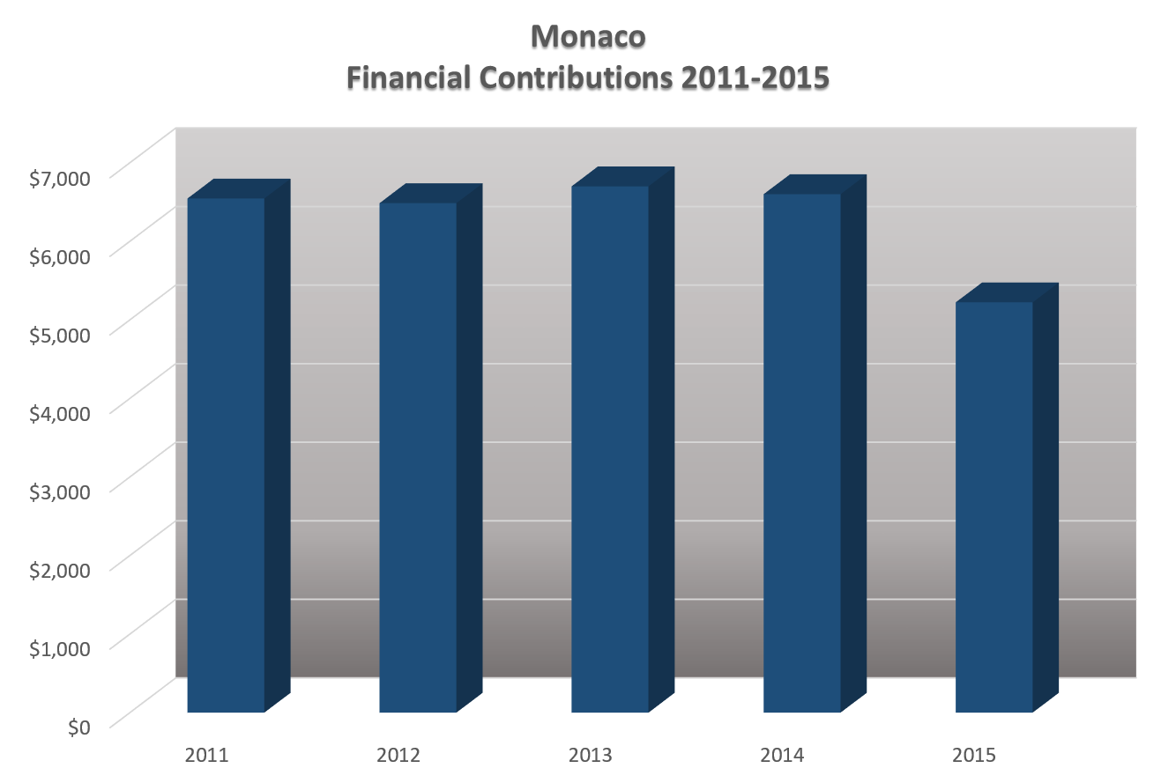
- In recent years, development cooperation in the Americas has focused on primary education and the fight against HIV/AIDS in Haiti.

CASH CONTRIBUTIONS 2011-2016:
YEAR | MONACO | P.O. FINANCIAL CONTRIBUTIONS | %
2011 | $6,545.00 | $15,766,616.00 | 0.04%
2012 | $6,486.00 | $13,239,105.00 | 0.05%
2013 | $6,700.00 | $16,926,000.00 | 0.04%
2014 | $6,600.00 | $10,999,882.00 | 0.06%
2015 | $5,223.00 | $17,489,205.00 | 0.00%
2016 |  | $14,048,254.00 | 0.00%
Total US$ | $31,554.00 | $88,469,062.00 | 0.04%

MONACO CONTRIBUTIONS:
YEAR | PROJECTS | FINANCIAL CONTRIBUTIONS  IN US$ | IN-KIND CONTRIBUTIONS  IN US$
2011 | SEDI / DSD - Cooperation in Conservation: Capacity Building under the Western Hemisphere Migratory Species Initiative (WHMSI) | $6,545.33
SUBTOTAL |  | $6,545.33
2012 | ReeFix: ICZM Ecosystem Services Valuation Capacity-Building Demonstration Project for the Caribbean | $6,485.93
SUBTOTAL |  | $6,485.93
2013 | Inter-American Children's Intitute / Rights of children and adolescents in disaster risk management. | $6,700.46
SUBTOTAL |  | $6,700.46
2014 | Inter-American Commission of Women - Virtual Training Course "Gender Justice for the Rights of Women" | $6,600.00
SUBTOTAL |  | $6,600.00
2015 | Strengthening Capacity of National Machineries for the Advancement of Women in Participating Countries to Advance Gender Mainstreaming | $5,223.00
SUBTOTAL |  | $5,223.00
TOTAL |  | $31,554.72

SOURCES:
THE OFFICIAL SITE OF THE PRINCELY GOVERNMENT  http://en.gouv.mc/  EMBASSY OF MONACO IN THE UNITED STATES  http://monaco-usa.org/ | WORLD BANK – TRADING ECONOMICS  www.tradingeconomics.com

This page was last updated on July 5, 2017.

