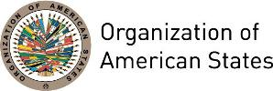

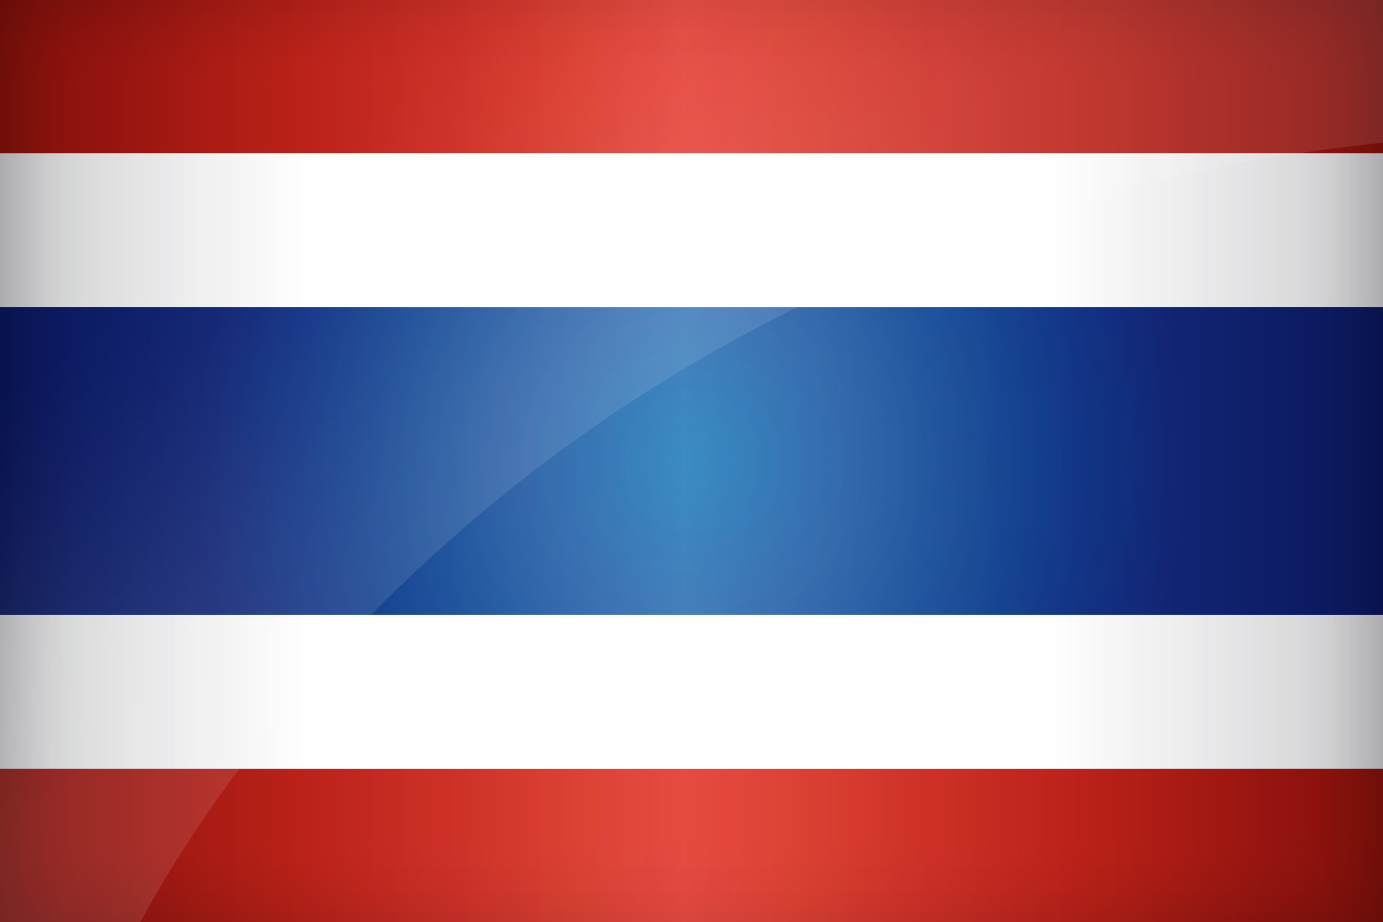
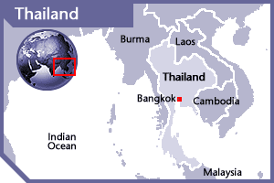

THAILAND
PERMANENT OBSERVER

Date of Entry: September 16, 1998
National Holiday: December 5
Capital: Bangkok
Type of Government: Constitutional Monarchy
Head of State: King Maha Vajiralongkorn (October 13, 2016)
Head of Government: Prime Minister Prayut Chan-o-cha (August 24, 2014)
Minister of Foreign Affairs: Don Pramudwinai (August 20 2015)
Permanent Observer: Ambassador Pisan Manawapat (February 23, 2015)

ECONOMIC INDICATORS | 2010 | 2011 | 2012 | 2013 | 2014 | 2015 | 2016
Population (in millions) | 67.21 | 67.53 | 67.84 | 68.14 | 68.42 | 68.66 | 68.87
GDP (in billions) | 341.105 | 370.82 | 397.56 | 420.529 | 406.522 | 399.235 | 406.84
GDP per capita (US$) | 5,075.3 | 5,491.16 | 5,859.91 | 6,172.26 | 5,914.84 | 5,814.87 | 5,907.91
Source: www.tradingeconomics.com | The World Bank Group

FOREIGN RELATIONS POLICIES:
- Foreign relations of Thailand are handled by the Minister of Foreign Affairs. Foreign policy main goals include:
- Expedite the promotion and development of relations with neighboring countries;
- Create unity and promote cooperation among the Association of Southeast Asian Nations (ASEAN) countries;
- Take on a creative role and promote the national interest in international organizations;
- Strengthen cooperation and strategic partnership with countries, groups of countries and international organizations that play important roles in global affairs;
- Encourage people-to-people contacts with foreign countries, as well as promote a positive image and technical assistance with developing countries;
- Promote public awareness and understanding of border issues and global changes that affect Thailand;
- Support ‘People Diplomacy’ to safeguard the interests of Thai nationals, and protect Thai nationals and Thai workers abroad;
- Utilize regional connectivity within the ASEAN region and sub-regions in order to expand the economic base in terms of production and investment;
- Coordinate the work of government agencies overseas in accordance with the ‘Team Thailand’ policy in order to carry out foreign affairs efficiently, effectively and with high quality; and
- Promote close cooperation with Muslim countries and Islamic international organizations.
- Thailand participates in international and regional organizations. It has developed close ties with other ASEAN members—Indonesia, Malaysia, the Philippines, Singapore, Brunei, Laos, Cambodia, Burma, and Vietnam—whose foreign and economic ministers hold annual meetings.
- Thailand works actively in the United Nations and regional organizations to preserve peace and security, promote the democratic process, human rights, humanitarianism, the environment and sustainable development, as well as cooperate to address all transnational issues that affect human security.
- Thailand also cooperates with the UNDP, UNICEF, Canada, and Japan’s Development Agency in order to provide more development assistance to developing countries.

THAILAND INTERNATIONAL DEVELOPMENT COOPERATION AGENCY (TICA):
- Thailand International Development Cooperation Agency (TICA) is responsible for implementing development cooperation programs. TICA provides both bilateral and multilateral aids in the form of technical cooperation for development projects, volunteer and expert programs, fellowships, scholarships and training programs.
- TICA promotes South-South cooperation and North-South-South cooperation under partnership programs with donor countries including non-governmental organizations and international agencies for development cooperation in developing countries. In addition, TICA provides funding support to Thai government agencies and private organizations in training courses and exchange of best practices in developing countries
- TICA also awards around 1,500 fellowships per year to developing countries.
- Aims to advance socio-economic conditions in developing countries by assisting their capacity building and human resource development.
- TICA offers technological assistance, fellowship opportunities for academic study/training and implementation of tailored development projects to developing countries around the world, including Latin America and the Caribbean.

INVOLVEMENT WITH THE AMERICAS:
- Thailand has diplomatic relations with all OAS Member States and maintains embassies in Argentina, Brazil, Canada, Chile, Mexico, Peru, and the United States.

COOPERATION AGREEMENTS WITH THE OAS:
- The OAS General Secretariat and the International Development Cooperation Agency, Ministry of Foreign Affairs of the Kingdom of Thailand signed a Memorandum of Understanding on July 27, 2012, which provided a framework for capacity-building and training courses in Thailand and in OAS Member States, as well as field technical assistance programs in the areas of professional development, tourism, management, economic and social development, and employment and poverty reduction. The MoU is in effect for two years and will automatically be renewed.

THAILAND CONTRIBUTIONS:
YEAR | PROJECTS | FINANCIAL CONTRIBUTIONS IN US$ | IN-KIND CONTRIBUTIONS  IN US$
2004 | 8 Scholarships |  | $29,100.00
SUBTOTAL |  |  | $29,100.00
2006 | PA-MAPP Colombia | $10,000.00
SUBTOTAL |  | $10,000.00
2009 | Secretariat for Integral Development / Department of Human Development, Education and Culture – Income Generation and Poverty Reduction for Development ) (2 Fellowships) |  | $7,400.00
2009 | Secretariat for Integral Development / Department of Human Development, Education and Culture – Tourism Management (2 Fellowships) |  | $14,800.00
2009 | Secretariat for Integral Development / Department of Human Development, Education and Culture – Grassroots Economic Development with One Tombon Tone Product (OTOP) (2 Fellowships) |  | $7,400.00
SUBTOTAL |  |  | $29,600.00
2010 | Secretariat for Integral Development / Department of Human Development, Education and Culture – Enhancing Entrepreneurship in SMD Development and Export Consortia (1 Fellowship) |  | $7,500.00
SUBTOTAL |  |  | $7,500.00
TOTAL |  | $10,000.00 | $66,200.00

SOURCES:
MINISTRY OF FOREIGN AFFAIRS, KINGDOM OF THAILAND  http://www.mfa.go.th/main/en/home  THAILAND INTERNATIONAL DEVELOPMENT COOPERATION AGENCY (TICA)  www.tica.thaigov.net/ | ROYAL THAI EMBASSY WASHINGTON D.C.  http://www.visetkaew.com/wp/  WORLD BANK – TRADING ECONOMICS  www.tradingeconomics.com

This page was last updated on July 6, 2017.

