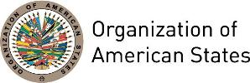

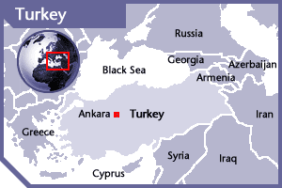
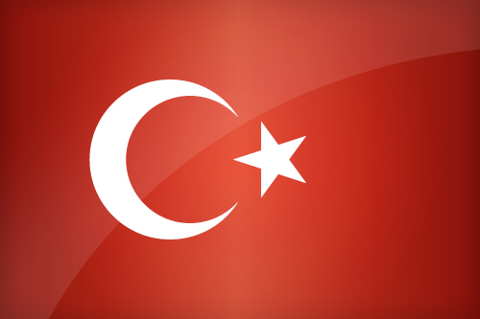

TURKEY
PERMANENT OBSERVER

Date of Entry: September 16, 1998
National Day: October 29
Capital: Ankara
Type of Government: Republican Parliamentary Democracy
Head of State: President Recep Tayyip Erdoğan (August 28, 2014)
Head of Government: Prime Minister Binali Yildirim (May 24, 2016)
Minister of Foreign Affairs: Mevlüt Çavuşoğlu (August 29, 2014)
Permanent Observer: Ambassador Serdar Kılıç (since April 15, 2014)

ECONOMIC INDICATORS | 2010 | 2011 | 2012 | 2013 | 2014 | 2015 | 2016
Population (in millions) | 72.32 | 73.41 | 74.56 | 75.78 | 77.03 | 78.27 | 79.51
GDP (US$ in billions) | 771.877 | 832.546 | 873.982 | 950.596 | 934.168 | 859.384 | 857.749
GDP per capita (US$) | 10,672.1 | 11,341.134 | 11,720.30 | 12,542.936 | 12,127.225 | 10,979.526 | 10,787.609
Source: www.tradingeconomics.com | The World Bank Group

FOREIGN RELATIONS POLICIES:
- Turkey's foreign policy aims to expand the sphere of peace and prosperity in its region; generate stability and security; help establish an order that paves the way for prosperity, human development and lasting stability. Turkish foreign policy is shaped by international legitimacy, economic interdependence, respect for human rights, the rule of law and social equity.
- Foreign policy priorities are: arms control and disarmament issues; promotion of human rights and the status of women; safeguarding and enhancing the wellbeing of children; preservation of the environment and contributing to sustainable development; and combating the illicit trade of narcotics substances, organized crime and corruption.
- In this framework, Turkey is determined to become a full member of the European Union, and to continue playing an important role in the peaceful resolution of disputes through the North Atlantic Treaty Organization (NATO), in its commitment to serving global peace.
- Turkey, as an emerging energy hub and a major transit country, plays an important role with respect to global energy security. Likewise, as an active member of the G-20 which gave a new impulse to the quest for global governance, Turkey is pursuing a more representative and democratic global system.
- Turkey and Spain are co-sponsors of the Alliance of Civilizations initiative. Turkey and Finland are Co-Chairs of The Group of Friends of Mediation, founded on September 24, 2010, which seeks to promote and advance the use of mediation in the peaceful settlement of disputes, conflict prevention and resolution, as well as to generate support for the development of mediation.
- The Group meets annually at the Ministerial level in the margins of the United Nations General Assembly. It also holds regular meetings in New York at the level of Permanent Representatives and Experts. Additionally, a network of focal points in the capitals/headquarters of the Members has been established in order to further coordinate efforts. The OAS General Secretariat has participated regularly in the meetings of the Friends of Mediation, Co-Chaired by Turkey and Finland, on the margins of the annual United Nations General Assembly.

Turkish DEVELOPMENT COOPERATION:
- Official development assistance (ODA) has increasingly become an integral part of Turkey’s proactive foreign policy. In line with the policy objective of contributing to the creation of a more peaceful and stable environment in its neighboring regions, Turkey has come forward as an active stakeholder in regional and global stability.
- As part of its policy of utilizing a wide range of soft power instruments such as assuming a mediator role in regional conflicts, Turkey also boosted its ODA to various countries affected by conflicts and other sources of instability such as natural disasters.
- Another priority of Turkey has been to foster good working relations with various international organizations in order to accentuate the country’s growing role in global cooperation. In that context, Turkey has been providing voluntary contributions to multilateral organizations, such as the Organization for Economic Co-operation and Development (OECD), the United Nations Development Programme (UNDP), the United Nations Industrial Development Organization (UNIDO) and the Food and Agriculture Organization of the United Nations (FAO).

INVOLVEMENT WITH THE AMERICAS
- Turkey maintains embassies in 12 countries of the Americas: Argentina, Brazil, Canada, Chile, Colombia, Cuba, Ecuador, Mexico, Panama, Peru, United States of America and Venezuela.
- Foreign policy objectives in the Americas give priority to the exchange of high level visits and meetings in order to strengthen political relations with countries of the region; concluding trade, economic, military, cultural and technical cooperation agreements to solidify the existing legal framework; establishing business councils, participating at fairs, initiating promotional activities to increase trade; and enlarging diplomatic representation and cultural interaction to ensure better and more accurate presentation.
- Political consultation mechanisms have been established between Turkey and 14 countries, including Argentina, Brazil, Bolivia, Ecuador, Guatemala, Costa Rica, Cuba, Colombia, Mexico, Peru, Chile, Paraguay and Venezuela.
- The Turkey Grand National Assembly has also established an Inter-Parliamentary Friendship Groups for 12 countries in Latin America and Countries to enhance parliamentary relations.
- Economic and Trade Cooperation agreements have been signed with 13 countries (Argentina, Brazil, Ecuador, Guatemala, Guyana, Jamaica, Colombia, Cuba, Mexico, Paraguay, Peru, Chile, and Uruguay). The first Free Trade Agreement (FTA) was signed with Chile in 2009 and entered into force on 1 March 2011. Negotiations continue for a FTA with Ecuador, Colombia and MERCOSUR. Turkey aims for negotiations to conclude FTAs with other countries such as El Salvador, Mexico, Guatemala, Honduras, Costa Rica, Nicaragua, Panama and Peru as well as with CARICOM.
- Turkey has observer status to the OAS and the Association of Caribbean States (ACS), and follows developments in other regional organizations: Union of South American Nations (UNASUR), Southern Common Market (MERCOSUR), the Community of Latin American and Caribbean States (CELAC), and the Caribbean Community (CARICOM).
- A “Memorandum for the Establishment of a Political Dialogue and Cooperation Mechanism between the Republic of Turkey and the MERCOSUR Member States and Associate Members” was signed at the MERCOSUR Summit on December 16, 2010.
- A “Memorandum of Understanding for the Establishment of a Consultation and Cooperation Mechanism between the Government of the Republic of Turkey and the CARICOM” was signed on September 21, 2011.

COOPERATION WITH THE OAS
- Framework Agreement on Cooperation between the Organization of American States and the Republic of Turkey, signed on August 25, 2004, establishes a mechanism of general and specific cooperation for coordinating activities through the exchange of technical know-how, information and experts, training programs, research activities and seminars in the field of environment, sustainable development, tourism, education, culture, science, technology, natural disasters, energy, social development, business development, industrial development, information technologies, physical planning, and other topics to be mutually agreed upon by the Parties.

FINANCIAL CONTRIBUTIONS 2005-2016:
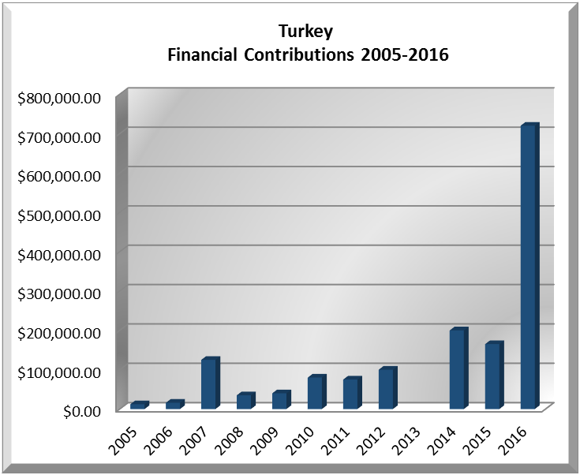
YEAR | TURKEY | P.O. FINANCIAL CONTRIBUTIONS | %
2005 | $9,000.00 | $11,650,039.00 | 0.10%
2006 | $12,000.00 | $19,060,470.00 | 0.08%
2007 | $125,000.00 | $20,398,686.00 | 0.61%
2008 | $30,000.00 | $22,684,500.00 | 0.14%
2009 | $40,000.00 | $20,318,115.00 | 0.20%
2010 | $80,000.00 | $15,781,991.00 | 0.51%
2011 | $75,000.00 | $15,692,757.00 | 0.48%
2012 | $100,000.00 | $13,239,105.00 | 0.76%
2013 |  | $16,926,686.00 | 0%
2014 | $200,000.00 | $10,999,892.00 | 1.82%
2015 | $165,000.00 | $17,489,205.00 | 0.94%
2016 | $720,000.00 | $14,048,254.00 | 5.13%
Total US$ | $1,556,000.00 | $198,289,700.00 | 0.78%
TURKEY CONTRIBUTIONS:
YEAR | PROJECTS | FINANCIAL CONTRIBUTIONS  IN US$ | IN-KIND CONTRIBUTIONS  IN US$
2000 | Unit for Sustainable Development and Environment (USDE) | $9,000.00
SUBTOTAL |  | $9,000.00
2002 | Department of Communications and External Relations (DCER) – Americas Magazine | $3,200.00
2002 | Office of External Relations – Children’s Corner Web Page | $3,500.00
2002 | Inter-American Commission against Terrorism (CICTE) | $5,000.00
2002 | Inter-Sectoral Unit on Tourism | $3,000.00
SUBTOTAL |  | $14,700.00
2003 | Unit for Sustainable Development and Environment (USDE) | $3,000.00
2003 | Inter-American Drug Abuse Control Commission (CICAD) – Education Program | $3,000.00
SUBTOTAL |  | $6,000.00
2004 | Fellowships | $3,000.00
2004 | Office of Education, Science, and Technology | $3,000.00
2004 | Inter-American Commission against Terrorism (CICTE) | $3,000.00
2004 | Department of Communications and External Relations (DCER) – Americas Magazine | $3,200.00
SUBTOTAL |  | $12,200.00
2005 | Department of Communications and External Relations (DCER) – Art Museum of the Americas | $6,000.00
2005 | Inter-American Commission against Terrorism (CICTE) | $3,000.00
SUBTOTAL |  | $9,000.00
2006 | Inter-American Commission against Terrorism (CICTE) | $4,000.00
2006 | Inter-American Drug Abuse Control Commission (CICAD) | $4,000.00
2006 | Office of Cultural Services – Museum Infrastructure Renovation | $4,000.00
SUBTOTAL |  | $12,000.00
2007 | Department for the Prevention of Threats Against Public Security | $15,000.00
2007 | Department of Democracy and Political Affairs (DDPA) | $100,000.00
2007 | Inter-American Commission against Terrorism (CICTE) | $10,000.00
SUBTOTAL |  | $125,000.00
2008 | Department of Sustainable Democracy and Special Missions (DSDSM) – Peace Fund – Prevention of Conflicts Belize-Guatemala Adjacency Zone | $30,000.00
SUBTOTAL |  | $30,000.00
2009 | Department of Sustainable Democracy and Special Missions (DSDSM) – Peace Fund – Education for Peace Workshops and Cultural Activities | $40,000.00
SUBTOTAL |  | $40,000.00
2010 | Inter-American Committee Against Terrorism (CICTE) – Counter-terrorism Financing Capacity Building Project | $40,000.00
2010 | Department of International Affairs (DIA) – OAS Lecture Series of the Americas | $40,000.00
SUBTOTAL |  | $80,000.00
2011 | Secretariat for External Relations – Fund for the Commemoration of the 10th Anniversary of the Inter-American Democratic Charter | $50,000.00
2011 | Secretariat for Political Affairs / Department of Sustainable Democracy and Special Missions – Peace Fund | $25,000.00
SUBTOTAL |  | $80,000.00
2012 | Secretariat of Multidimensional Security (CICAD) / Report on the Drug Problem in the Americas | $100,000.00
SUBTOTAL |  | $100,000.00
2014 | Secretariat for Political Affairs / Department of Electoral Cooperation and Observation – Electoral Observation Mission for the General Elections in Antigua and Barbuda | $12,000.00
2014 | Secretariat for Political Affairs / Department of Electoral Cooperation and Observation – Creation of an OAS-sponsored Electoral Accreditation Body for Certification of Electoral Authorities against ISO Electoral Standard | $20,000.00
2014 | Secretariat for Political Affairs / Department of Sustainable Democracy and Special Missions – Peace Fund Belize-Guatemala Adjacency Zone | $100,000.00
2014 | Executive Secretariat for Integral Develoment / Department of Human Development Education and Culture - Capacity Building for Growing Higher Education Institutions at Undergraduate Level: Enriching Curriculum to Develop Investigating Minds for Integral Development | $68,000.00
SUBTOTAL |  | $200,000.00
2015 | Secretariat for Political Affairs / Department of Electoral Cooperation and Observation – OAS Electoral Observation Mission Fund | $15,000.00
2015 | Secretariat for Political Affairs / Department of Sustainable Democracy and Special Missions – Mission to Support the Peace Process in Colombia (MAPP) | $150,000.00
SUBTOTAL |  | $165,000.00
2016 | The Department of Sustainable Democracy and Special Missions (64D), OAS Office Adjacency Belize ‐ Guatemala | $220,000
2016 | The Department of Sustainable Democracy and Special Missions (64D), Support Peace Process Colombia | $500,000
SUBTOTAL |  | $720,000
GRANDTOTAL |  | $1,604,100.00

SOURCES:
PRESIDENCY OF THE REPUBLIC OF TURKEY  http://www.tccb.gov.tr/  NORTH ATLANTIC TREATY ORGANIZATION (NATO)  http://www.nato.int/cps/en/SID-13830ECF-B4D80F8D/natolive/index.htm | REPUBLIC OF TURKEY – MINISTRY OF FOREIGN AFFAIRS  http://www.mfa.gov.tr/synopsis-of-the-turkish-foreign-policy.en.mfa  TURKISH EMBASSY IN WASHINGTON  http://vasington.be.mfa.gov.tr/Default.aspx  WORLD BANK – TRADING ECONOMICS  www.tradingeconomics.com
This page was last updated on July 7, 2017.

