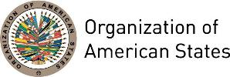
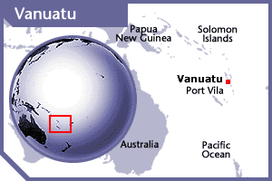
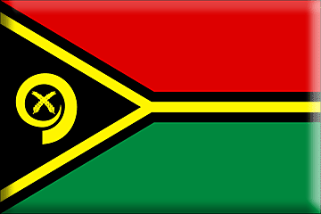


VANUATU
PERMANENT OBSERVER

Date of Entry: October 14, 2008
National Day: July 30
Capital: Port Vila
Type of Government: Parliamentary republic
Head of State: President Tallis Obed Moses (July 6, 2017)
Head of Government: Prime Minister Charlot Salwai (February 11, 2016)
Minister of Foreign Affairs and Trade: Bruno Leingkone (January 22, 2016)
Permanent Observer: Ambassador Donald Kalpokas

ECONOMIC INDICATORS | 2010 | 2011 | 2012 | 2013 | 2014 | 2015 | 2016
Population (in Thousand) | 236.30 | 241.87 | 247.49 | 253.14 | 258.85 | 264.603 | 270.402
GDP (US$ in billions) | 0.6 | 0.7 | 0.79 | 0.79 | 0.83 | 0.74 | 0.77
GDP per capita (US$) | 2,945.97 | 2,924.81 | 2,892.84 | 2,879.60 | 2,895.79 | 2805.83 | 2860.57
Source: www.tradingeconomics.com | The World Bank Group

FOREIGN RELATIONS POLICIES:
- The Ministry of Foreign Affairs is responsible for the conduct of Vanuatu's external relations and advancing the State’s national interests. It carries out its responsibilities by managing and maintaining friendly relations with bilateral partners, regional and international organizations and institutions, and national stakeholders. It also provides advice on regional and international issues as well as formulating sound policies and executing decisions affecting those relations in a manner that puts the interests of Vanuatu first.
- Furthermore, the Ministry is responsible for the promotion of tourism and investment opportunities in the Republic of Vanuatu, including identifying export markets for Vanuatu products, through the work program of Vanuatu's permanent overseas missions. In addition, it facilitates and provides protocol and diplomatic services to foreign dignitaries, both resident and visiting.
- Vanuatu joined the Commonwealth and the Pacific Islands Forum (then known as the South Pacific Forum) on independence in 1980. A year later it joined the United Nations. It is also a member of the World Bank, Asian Development Bank (ADB) and the International Monetary Fund (IMF).
- Vanuatu’s main priority is to continue implementing its Comprehensive Reform Program with aid from international donors in order to further domestic development. Vanuatu is also committed to the achievement of the United Nations (UN) Millennium Development Goals.
- As a member of the Africa Caribbean and Pacific (ACP) group, Vanuatu enjoys preferential trade links with the European Union.
- Vanuatu is a strong supporter of the Melanesian Spearhead Group (MSG), whose aims include establishing a Melanesian free trade area. Vanuatu takes a close interest in the West Papua issue, which stems from the incorporation of western New Guinea into Indonesia in 1969 and which remains controversial among certain indigenous groups, human rights groups, and some members of the United States Congress.

INVOLVEMENT WITH THE AMERICAS:

SOURCES:
GOVERNMENT OF VANUATU  http://www.vanuatugovernment.gov.vu/ | WORLD BANK – TRADING ECONOMICS  www.tradingeconomics.com

This page was last updated on July 6, 2017.

