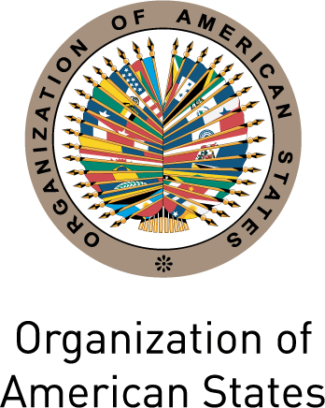
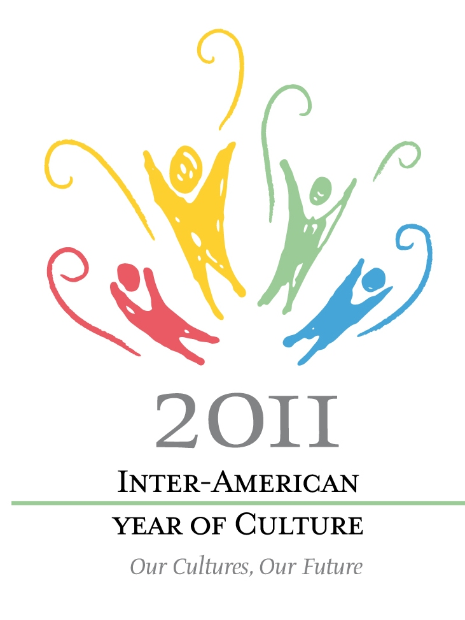

Analysis of the projects and activities registered by the OAS Member States
in the framework of the 2011 Inter-American Year of Culture

The following document intends to present an analysis of the projects and activities that were registered by the OAS Member States in the framework of the Inter-American Year of Culture.
In total, 111 initiatives were registered by 20 countries of the Americas. Of these, 11 countries were from South America, 4 from Central America, 3 from the Caribbean Region and 2 from North America.
In regards to language use, 77 initiatives were submitted in Spanish, 16 in Portuguese, 14 in English and 4 in French.
A total of 78 initiatives were submitted through an online survey prepared by the Office of Education and Culture of the OAS, which was sent to Member States. The rest of the initiatives were registered by phone or by email to our Office.
For technical and data collecting reasons, this paper will only analyze the projects that were submitted through the online questionnaire; hence it will compile the data from 78 initiatives from a total of 111.

Geographic coverage of registered projects and activities

More than half of the initiatives, a total of 45, were implemented on a national scale, while 26 were on a local scale (municipal level) and 17 on a multilateral scale (more than two countries involved in the project or activity).

Funding sources of registered projects and activities

The great majority of the projects and activities (66 initiatives from a total of 78) were funded by public national funds (Governments or national institutions). The second source of financing of the registered initiatives was provided by international organizations, funding 27 projects from a total of 78. Finally, on a smaller scale, 21 initiatives were funded by local public sources (municipalities), 20 by private sector sources (companies), 11 by foundations, and 5 by non-governmental organizations (NGO’s).

Gender of the population targeted by the registered projects and activities

Data shows that the majority of the initiatives submitted were aimed at both male and female genders, taking into account that 72 initiatives out of 78 were targeted at both men and women. It is important to note that 5 institutions did not answer this question.

Male
Female

Age of the population targeted by the registered projects and activities

Most of the registered projects and activities were aimed at young people (14 to 25 years old) and adults (26 to 60 years old), representing 71 and 72 projects respectively from a total of 78. Also, it can be noted that 54 projects were aimed at seniors (over 60 years old) while 31 projects were aimed at children (0 to 13 years old).

Socioeconomic status of the population targeted by
the registered projects and activities

Regarding socioeconomic status, 62 out of the 78 initiatives targeted populations from low socioeconomic class while 58 projects targeted middle-income populations and 46 targeted high-income populations.

Living environment of the populations targeted by
the registered projects and activities

Furthermore, 60 out of the 78 initiatives targeted urban populations while 43 were directed to rural populations.

Action areas of registered projects and activities

This analysis highlights that most of the initiatives were implemented in the areas of cultural and natural heritage (49), and creative and cultural industries (44). Next in order are the following action areas: performing arts (32), visual arts (30) and art education (21), literature (17), museums (17), tourism (17) and ​​gastronomy (10). The actions areas with less representation, but equally pertinent to the objective of the Year are: graphic design (6), architecture (6), intellectual property (6) and fashion (5).

Aspects of social and economic development affected by the registered projects or activities

Finally, the results of the surveys show that most of the initiatives are either linked to cultural diffusion (67), strengthening of identity (63), promotion of intercultural dialogue (57), cultural exchange between groups or regions (52) and actions related to cultural and natural heritage (50). Next in order of prevalence are: development of knowledge and skills (43), development of public policy (40), promotion of social inclusion (38) and citizenship education (29). Finally, mentioned to a lesser extent were the following aspects: generation of income (26), support for vulnerable groups (21), creation of jobs (17), fight against poverty (17), urban renewal (10) and conflict resolution (9) The graph below illustrates these results.

