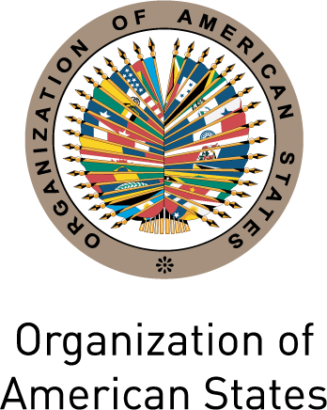
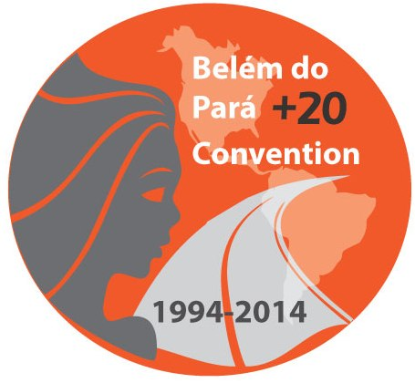
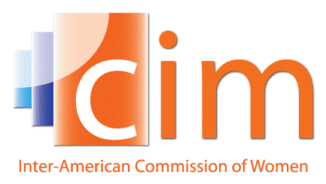

INTER-AMERICAN COMMISSION OF WOMEN

EXECUTIVE COMMITTEE 2013-2015 OEA/Ser.L/II.5.32
THIRD REGULAR SESSION CIM/CD/doc.17/14
Pachuca, Hidalgo May 16th 2014
May 16th 2014 Original: Spanish

AGREEMENTS ADOPTED BY THE THIRD REGULAR SESSION OF THE EXECUTIVE COMMITTEE OF THE CIM 2013-2015

Agreement 1

In light of the celebration of the Belem do Para +20 Hemispheric Forum “The Belem do Para Convention and the prevention of violence against women: Good practices and proposals for the future,” the Executive Committee agrees to:
- Through the President, conveys its warmest thanks and appreciation the Government and the people of Hidalgo for their extraordinary efforts in welcoming the Delegates and making the Forum a success; and
- Urge the States Party to the Convention, and those that are not party, to organize events in commemoration of the twentieth anniversary of the Convention, in order to raise its visibility and give States the opportunity to renew their commitment to its full implementation.

Agreement 2

In light of the kidnapping of over 200 girls in Nigeria, the Executive Committee agrees to:
- Condemn, in the strongest possible terms, this act of violence against women, and to urge the Government of Nigeria to increase its action to secure their safety and freedom; and
- Condemn the kidnapping and trafficking of women and girls in all its forms in those countries in the world where it occurs.

Agreement 3

In view of the current debates on the Strategic Vision of the OAS, and the progress report transmitted by the President of the Working Group on the Strategic Vision of the OAS, Ambassador Emilio Rabasa, the Executive Committee agrees:
- To send, through the President, a communication to the Chair of the Working Group on the Strategic Vision of the OAS in order to transmit the comments of the Delegates and to highlight the importance of the work of the CIM and of allocating the human and financial resources from the regular budget that are necessary to allow the Commission to fulfill its program of work; and
- Request that the Executive Secretariat keep the Delegates informed of the results of the work of this Group.

Agreement 4

In view of the draft Strategy for strengthening coordination between the CIM and civil society, contained in document CIM/CD/doc.6./13 rev.2, the Executive Committee agrees:
- Adopt the strategy, incorporating the comments of the Delegates, and request the Executive Secretariat to prepare a plan for its implementation, including a budget, for the consideration of the next session of the Executive Committee 2013-2015

Acuerdo 5

En seguimiento del informe de la CIM “Mujeres y drogas en las Américas: Un diagnóstico de políticas en construcción”, el Comité Directivo acuerda:
- Encomendar a la Secretaría Ejecutiva que siga trabajando sobre los diferentes aspectos de esta problemática para proporcionar a los Estados información actualizada y pertinente sobre sus dimensiones de género, con particular énfasis en el Caribe, a través de sus mecanismos nacionales;
input.doc
- A través de la Presidenta, presentar este informe al Comité de Seguridad Hemisférica del Consejo Permanente de la OEA;
- Preparar una propuesta para un evento paralelo, que formule a recomendaciones concretas sobre el impacto del tráfico ilícito de estupefacientes y sustancias sicotrópicas en las mujeres y las niñas, en el marco de la próxima Sesión Extraordinaria de la Asamblea General de la OEA, a celebrarse el 19 de septiembre de este año en La Antigua, Guatemala, y mantener informadas a las Delegadas sobre su desempeño y resultados.

Agreement 5

Following up on the CIM report “Women and drugs in the Americas: A policy working paper,” the Executive Committee agrees to:
- Instruct the Executive Secretariat to continue working on the different aspects of this issue in order to provide Member States with timely and relevant information on its gender dimensions, with a particular focus on the Caribbean, through their national machineries;
- Through the President, present this report to the Committee on Hemispheric Security of the Permanent Council of the OAS; and
- Prepare a proposal for a side-event, which will formulate concrete recommendations on the impact of the illicit trafficking of narcotic drugs and psychotropic substances on women and girls, in the framework of the next Special Session of the General Assembly of the OAS, to be held on September 19th of this year in La Antigua, Guatemala, and to keep Delegates informed of its organization and results.

