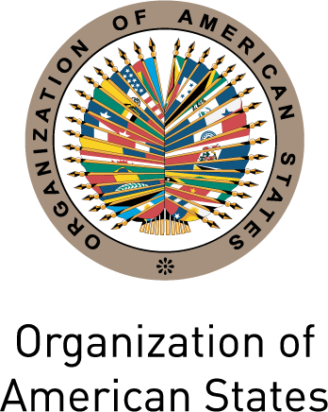
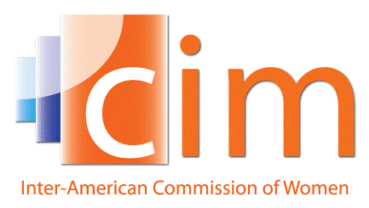

INTER-AMERICAN COMMISSION OF WOMEN

EXECUTIVE COMMITTEE 2013-2015 OEA/Ser.L/II.5.32
FIFTH REGULAR SESSION CIM/CD/doc.26/15
Washington, DC April 9th 2015
May 7th and 8th 2015 Original: Spanish

AGENDA OF THE THIRTY-SEVENTH ASSEMBLY OF DELEGATES OF THE CIM
(Draft)

- Election of authorities of the XXXVII Assembly of Delegates of the CIM

- Adoption of the Draft Agenda and Organization of Work

- Consideration of Reports:
- Report of the President, the Executive Committee and the Executive Secretariat
- National reports on the thematic axis of the XXXVII Assembly of Delegates of the CIM: Autonomy and exercise of women’s economic rights

- Panel on the thematic axis of the Assembly: Autonomy and exercise of women’s economic rights

- Election of authorities of the Commission:
- Consideration of the Report of the Committee on Credentials
- Election of the President
- Election of the Vice-Presidents
- Election of the members of the Executive Committee
- Place and date of the XXXVIII Assembly of Delegates of the CIM

- Triennial Program of Work of the CIM 2016-2018: Programmatic orientations

- Adoption of the Lima Declaration and Draft Resolutions

- Other matters
input.doc

