
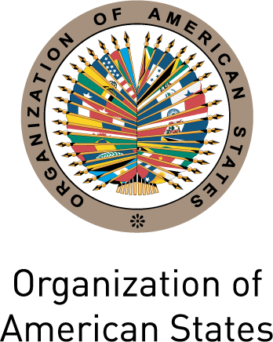

INTER-AMERICAN COMMISSION OF WOMEN

THIRTY-SIXTH ASSEMBLY OF DELEGATES OEA/Ser.L/II.2.36
October 29th to 30th 2012 CIM/doc.11/12
San José, Costa Rica September 28th 2012
Original: textual

NATIONAL REPORT: SURINAME

(Item 4) on the agenda)

REPUBLIC OF SURINAME

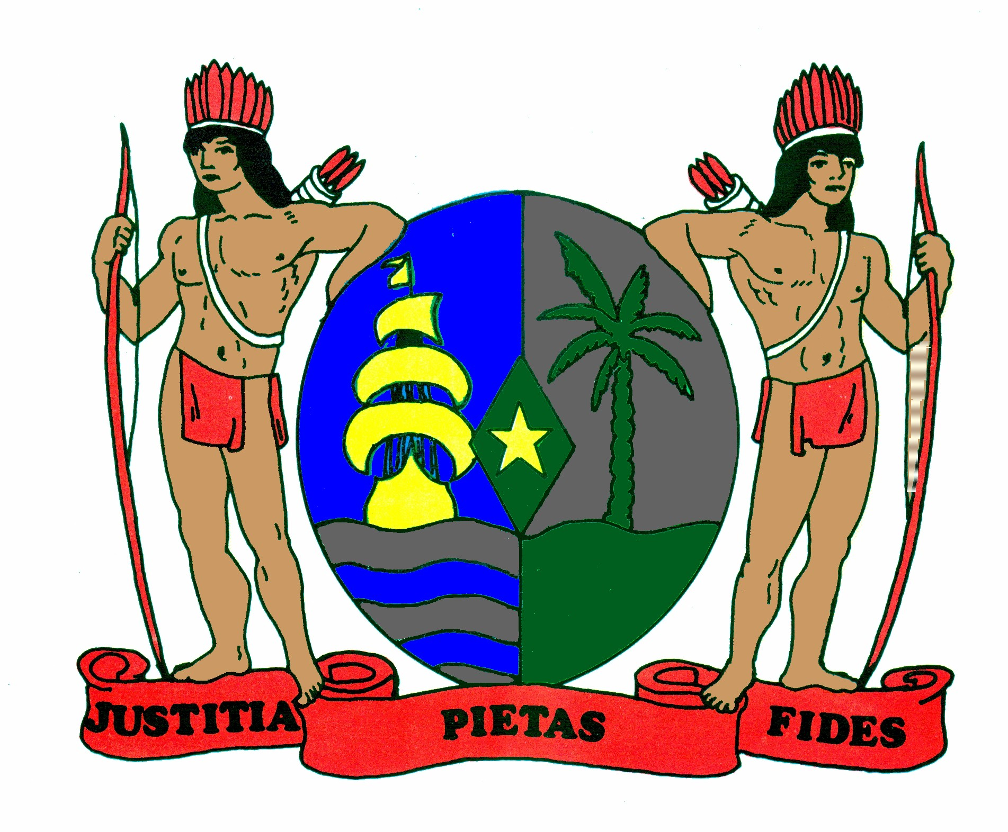

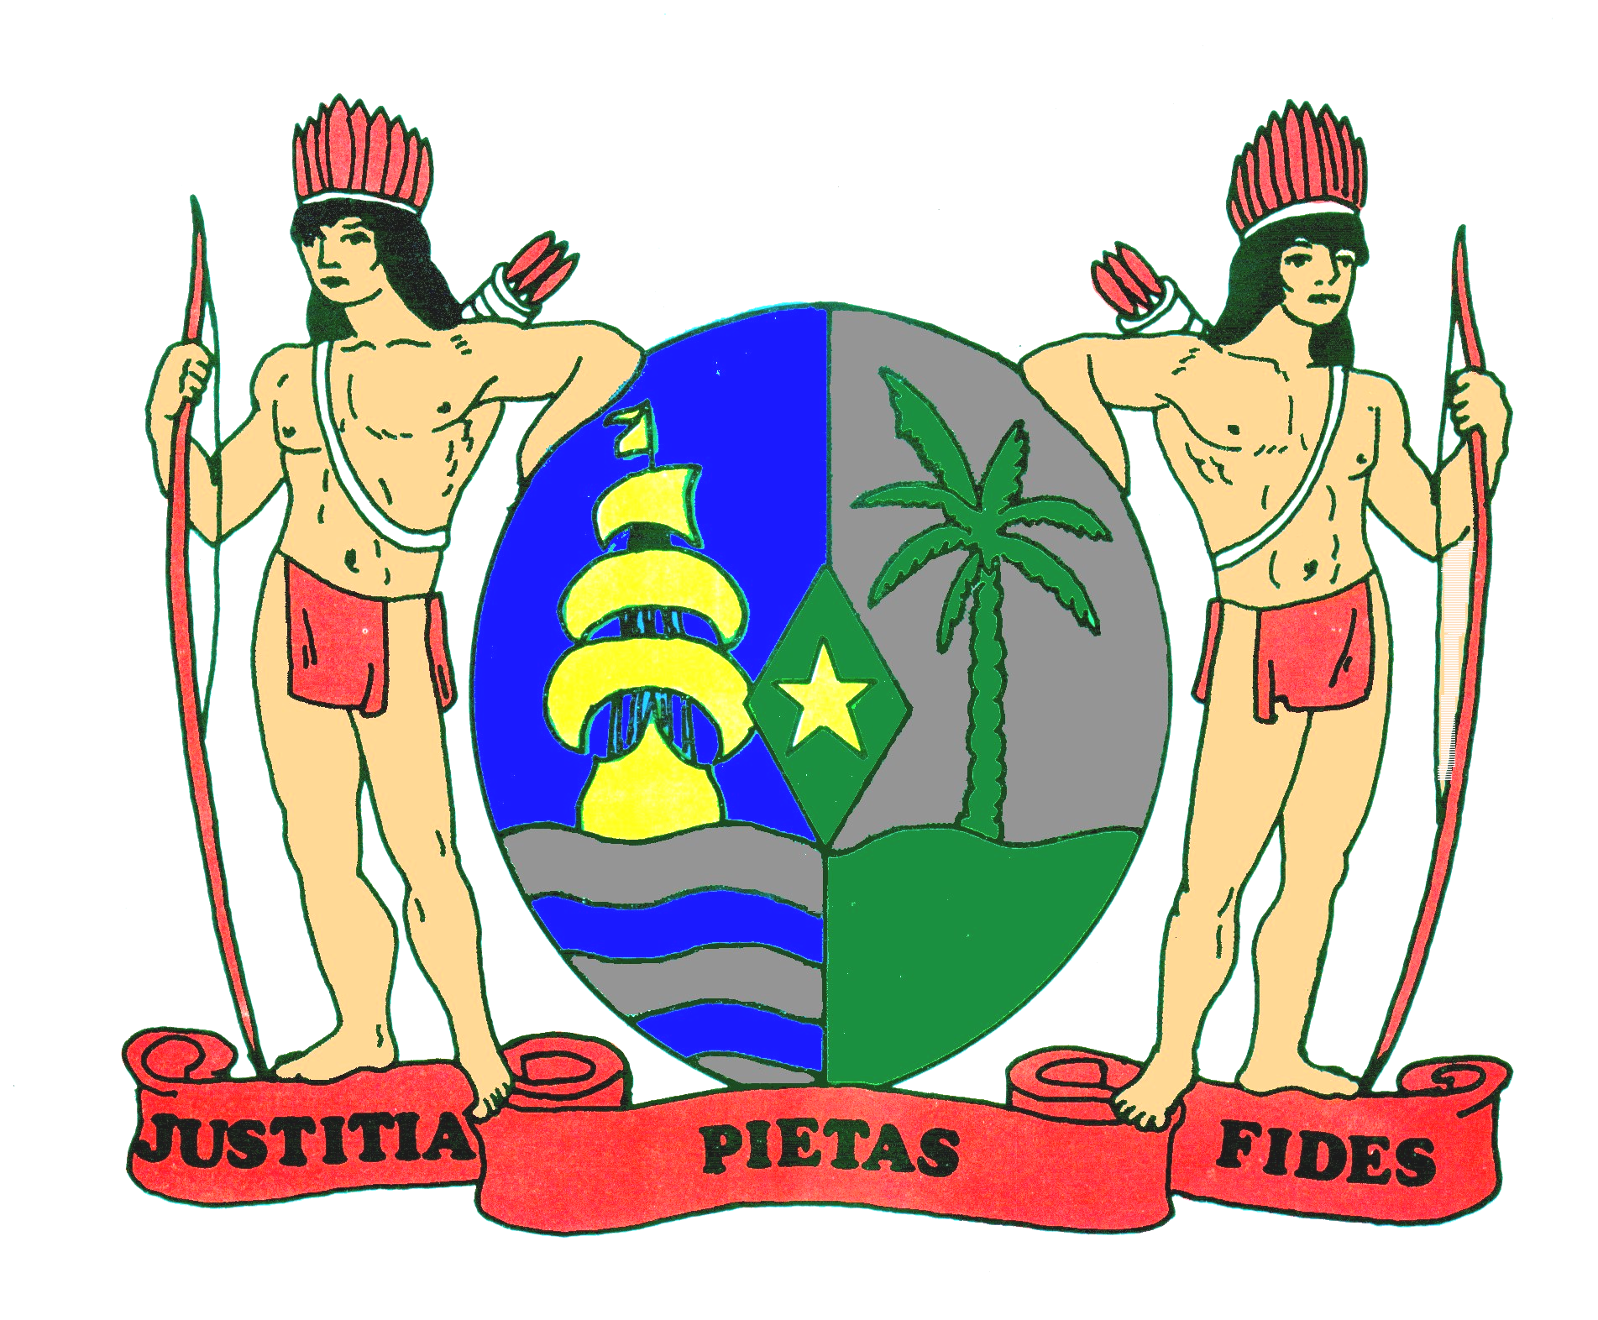

NATIONAL REPORT OF

THE REPUBLIC OF SURINAME AT
THE THIRTHY- SIXTH ASSEMBLY OF DELEGATES OF
THE INTER-AMERICAN COMMISSION OF WOMEN
(CIM)

September, 2012
I. GENERAL ASPECTS
This report presents the progress made at the national level with respect to the status of women and changes that have taken place since the last report submitted to the Assembly of Delegates in October 2010. Key activities from the period November 2010- August 2012 are included in this report.

The Government of Suriname formulated the Development Plan 2012 – 2016 called “Suriname in transformation”. The gender issue, as formulated in the Development Plan 2012 – 2016 goes beyond other main policy areas, thus playing a leading role. It highlights the importance of gender equality and equal opportunities for men and women in all sectors of society and recognizes the importance of granting priority to a number of important issues in our foreign policy that are high on the regional and international agenda, including women and development.
Furthermore, the Government shows its commitment through the separate chapter on gender in the Development Plan. In this chapter it is mentioned that a sustainable gender dialogue between the government and civil society is crucial to successful shape, implement and monitor gender policy. In this regard, the National Bureau for Gender Policy organized in collaboration with the foundation Projekta a master class introduction dialogue. The aim of the gender dialogue is to create a realistic and feasible national gender policy supported by the civil society. Currently preparations are being made ​​to organize follow –up "gender dialogue with stakeholders”.
In February 2011, the Situation Analysis on Gender Equality, Gender Relations and the Position of Women in Suriname (SITAN Women) was released. This report presents a situation analysis of gender relations and gender equity in Suriname. Although the study contains useful data regarding men and women, more in- depth analyses of the data in the report is necessary.
II. FOLLOW-UP ON THE IMPLEMENTATION OF THE INTER-AMERICAN PROGRAM ON THE PROMOTION OF WOMEN’S HUMAN RIGHTS AND GENDER EQUITY AND EQUALITY AND THE STRATEGIC PLAN OF ACTION OF THE CIM

A. Legal, political, and socio- economic situation

Legal
In April 2012, Suriname has submitted the act to ratify the Optional Protocol to the Convention on the Rights of the Child on the sale of children, child prostitution and Child Pornography and the Optional Protocol to the Convention on the Rights of the Child on the Involvement of children in armed conflict to the Secretary General of the UN.

The draft law “daycare facilities” has been submitted to the National Assembly in 2009 and was discussed with the Committee of Rapporteurs in 2011. The National Assembly has proposed amendments in 2012. The Ministry of Social Affairs and Public Housing is currently studying these proposed amendments.

In April 2012, the Stalking Bill has been approved by the National Assembly.

Political
Within the biennium 2010- 2012, after the General Elections on the 25th of May 2010, Suriname’s Government has a reshuffled cabinet with an increase of one female Minister and one female Vice-Minister.

Socio- economic situation
Social measures are taken to make life bearable for families with financial difficulties:
- the lowering of prices of about forty basic commodities.
- increase in the allowance of social services provided by the Ministry of Social Affairs and Public Housing (SoZaVo), such as General Child Benefits (AKB), General old age benefits (AOV) and the financial support for people with disabilities.
- a Conditional Cash Transfer program is in preparation with support from the Inter American Development Bank.
B. Outline of Public policies and progress made with respect to legislation
The draft Law Sexual harassment and the Sexual harassment on the workplace has already been presented to the Minister of Home Affairs and the Minister of Labour, Technological Development & Environment (ATM) and also to the chairperson of the National Assembly on March 22nd 2011 and waits approval of the National Assembly.

After approval of the Law "Combating Domestic Violence" in June 2009, the forms to submit protection orders have been issued in October 2010. In April 2012, on request of Non Governmental Organizations (NGO’s), a simple version of the form has been developed to make the application process accessible and easy. A brochure was recently published to guide individuals through the steps to get a protection order.

The Ministry of Justice and Police has formulated policies aimed at the prevention of sexual harassment in the workplace. The Ministry of ATM has recently signed a policy paper regarding this issue. The goal is to prevent and combat sexual molest within the Ministry of ATM.

C. Outline of public policies and progress in legislation, together with development programs aimed at implementing the Strategic Plan
Eradication of poverty
The Ministry of Trade and Industry (HI) launched the CARICOM-Canadian International Development Agency Trade and Competitiveness Project (CIDA Project). With regard to the Gender Analysis of the CARICOM Single Market and Economy (CSME) and its impact in Suriname, consultants were hired to review the different roles of men and women in the development of the CSME and carried out an analysis of the effects of the CSME free trade regime on men and women.

The Government is in the phase of implementing a Conditional Cash Transfer program in Suriname. This program will enable poor households, including the poor female headed households, to increase possibilities for a brighter future for themselves and their children.

On initiative of the National Parliament discussions have been started to work towards people centered budgeting. The Ministry of Home Affairs is one of the pilot ministries in which the training for gender budgeting will be held.
The Second "Low Income Shelter Program" (LISP-II) is a five-year program (2010-2015), created to support the Government of Suriname in its efforts to improve the living conditions of low income households.
Gender Based Violence
Suriname hosted the Artists UNITE-ing against Gender Based Violence Workshop (CARICOM/UN WOMEN) from 18-20 July 2011 which aimed at creating awareness on gender based violence and how to use edutainment to deliver the messages. Artists from Suriname, Guyana, and Belize took part in this workshop. From November 30th to December 1st, 2011 the Ministry of Home Affairs, the Foundation Stop Violence Against Women and the United Nations Population Fund (UNFPA) organized a two-day conference entitled "Working together to Prevent and Combat Domestic Violence: a necessity." This conference was held with the focus on prevention, cooperation and partnerships, sharing regional and international practices regarding domestic violence.

In connection with “16 Days of Activism 2011” the Minister of Home Affairs addressed the nation in a television appeal to stop all violence against women, girls but also men and boys. In a sixteen day campaign, politicians, role models and popular figures made a statement in regard to combat gender based violence.

The Ministry of Home Affairs hosted in March 2012, a workshop on domestic violence in the rural district Nickerie. The purpose of this workshop was to gain insight into the problem of domestic violence in this district, to obtain possible solutions that can contribute to the elimination of domestic violence, to highlight the issue of domestic violence and to obtain input for the preparation of an action plan on combating domestic violence.

At various times, information and training on domestic violence were given to various groups within the government and non-governmental organizations.
One of the most important developments in our legislation, regarding violence against women is the adoption of the law on the penalization of Stalking in April 2012. The law was published on May 7th 2012.
Education
The Ministry of Education and Community Development considers gender sensitivity in the development of the new curriculum. In this regard, textbooks from different disciplines have been made gender neutral as possible.
As part of the Basic Education Improvement Project (BEIP) all principals and deputy heads of primary and secondary schools and also kindergarten teachers were trained in gender.
Recently, several schools and classrooms were built in various districts for students to be able to visit a school in their vicinity. As from the upcoming school year (2012-2013), the entry fee for primary and secondary schools are eliminated in order to make education more accessible for boys and girls. Other measures include e.g. the purchase of new teaching materials, increase of effective teaching hours, the use of qualified teachers in lower grades and effectively dealing with teenage pregnancy.

Within the framework of the After-school Care and Supervision Project, more than 2,500 pupils from 17 selected primary schools throughout the country are being guided in order to improve their learning performance. The project components are homework supervision, promotion of reading, creative and cultural education, information and awareness, sport and play.

In order to improve the quality of basic education, the continuation of the Basic Education Improvement Project (BEIP), the 2nd BEIP, started in July 2012. The first BEIP project has delivered e.g. the Play and Work plan for nursery education, a new kindergarten curriculum development, including curriculum and learning materials.

Participation of women in power and decision-making structures
In February and June 2012, the National Assembly organized a workshop on quota policy and the participation of women in decision making. As outcome of both workshops, the Chair of the National assembly commissioned the political parties to develop an action plan on how to involve women in the decision-making position within their political party.

Situation of women in respect of work
The Government of Suriname (GoS) has prepared a housing program (nationwide) to alleviate the housing problem with which a substantial part of the population has to contend with. Thousands of houses will be constructed. There is an extra need for construction workers. Currently, vocational training programs are carried out by a working arm of the Ministry of ATM, the Foundation for Mobilization and Development (SAO), to train potential construction workers for a job in this sector. These trainings are not limited to men: enrollment of women is also possible.

The Minister of ATM has taken the initiative to prepare a Decent Work Country Program (DWCP) for Suriname with support from the ILO.

The new members for the Labour Advisory Board have been installed in July 2012 by the Minister of ATM. This institution offers its members the opportunity to give their views on the amendments in terms of the Labour Law. The amendment proposals which are being discussed in the Labour Advisory Board are the Minimum Wage, Social Security System and Paid Maternity Leave.

The Ministry of ATM started in August 2012 to register job – seekers in all districts in order for them to have the opportunity to register for a suitable job.

Gender and health
In December 2011, the Ministry of Health (MOH) organized in collaboration with the Pan American Health Organization a training “Strengthening the capacity for analysis of gender statistics”. The objective of this activity is to produce, analyze and use information disaggregated by sex and other relevant variables.
The National Health Sector Plan 2011-2018 has a sub paragraph on gender. In this paragraph it is mentioned that the Gender Focal Point of the Ministry of Health focuses on the planning unit to work on the implementation of the PAHO Gender Equality Policy, along the four strategic areas in the Plan of Action. The MOH also recognizes the importance of implementing a gender equality perspective in the development, implementation, monitoring and evaluation of policies and programs.

Democracy
One of the strategies of participation in decision making processes is through participation in political parties. A strategy to involve more women in politics is through the quota policy.

Political participation
Table 1.
Number of women and men currently occupying
the following public positions since the last election period:
Election period | President | Vice-President | Ministers | Parliament
2010-2015 | Male | Male | 15 male,  3 female | 45 male,  6 female

The districts council is headed by an appointed districts commissioner. In the period 2010-2012, 14 districts commissioners were appointed of which at this moment three are female.
Justice and human rights
Eighteen officials from the Government have successfully completed a program of human rights from June 2011 - March 2012. The purpose of the program was to contribute to the further integration of the international and regional human rights treaties and declarations in the national legal framework and the protection and promotion of human rights. This program is conducted by the Ministry of Justice and Police in cooperation with the United Nations Development Program (UNDP).
National Institutions responsible for the advancement of women
The National Bureau Gender policy (NBG) will be transformed into an efficient and effective national machinery. The NBG will in its new form focus more on research on gender issues, gender specific data-collection and sharing in collaboration with different stakeholders. Contact with local, regional and international organizations will be optimized and the compliance to treaties like CEDAW and Belem do Para will be met. At the moment, the Ministry of Home Affairs is preparing the job description of the NBG staff and the Gender Focal Points. The organizational structure of the Gender Bureau is also being formalized. One of the major changes will be a change in the name of the institution, from the National Bureau for Gender Policy to Bureau Gender Affairs.

Gender and Migration
A concept national strategy and a concept action plan have been developed to combat trafficking in persons for the period 2012-2016. Both concepts are currently being discussed with different stakeholders.

A concept penal code has been formulated in which Legal provisions are better in line with the Protocol to Prevent, Suppress and Punish Trafficking in Persons, especially Women and Children.

C. Measures undertaken to prevent, punish, and eradicate violence against women, as well as actions to implement the Inter-American Convention on the Prevention, Punishment, and Eradication of Violence against Women, “Convention of Belem do Para”

At various times, information and training on domestic violence is given to various groups by government and non - government organizations.

In august 2012, the Foundation Moiwana organized a conference on women’s rights. The theme of this conference was: Women rights, 10 years after ratification of the Belem do Para Convention.
During this conference, attention was paid to the state of affairs with regard to violence against women and the achievements of Suriname over the past 10 years to prevent punish and eradicate violence against women. Also the steps needed to be undertaken to end violence against women were addressed. This conference was co- funded by the Ministry of Home Affairs.

The Ministry of Home Affairs started the process to standardize and centralize data on domestic violence (with assistance from UNFPA) in the district Nickerie and also to conduct a qualitative study with the focus on perpetrators of domestic violence.

Folders have been developed to give publicity to the Inter - American Convention on the Prevention, Punishment and Eradication of Violence against Women in Dutch and English and articles in “De Overheid” a government newspaper published weekly in two (2) daily newspapers.

Information on women's rights and basic human rights is also given by government and nongovernmental organizations at various fora in the city and in districts.
The working Group “Counter-Trafficking in Persons” has developed a Policy Document “Counter Trafficking in Persons 2012-2016”.

III. FUTURE ACTIONS TO IMPLEMENT THE INTER-AMERICAN PROGRAM ON THE PROMOTIONS OF WOMEN’S HUMAN RIGHTS AND GENDER EQUITY AND EQUALITY AND THE STRATEGIC PLAN OF ACTION OF THE CIM

A. National level
The Government of Suriname will implement its international commitments such as the Belem do Para Convention and the CEDAW convention and will take into account the actions of the Strategic Plan of Action as much as possible considering the specific characteristics of the country.
Specifically, the Government of Suriname will focus on eliminating all forms of discrimination and inequality between men and women, making e.g. access to education, healthcare, sexual and reproductive health and labour market possible for all. An assessment of legislation that is discriminatory and detrimental to women will be carried out and more attention will be given to phenomena like domestic violence, sexual violence and gender based violence.
CIM03333T01
Under the authority of the Ministry of Home Affairs a qualitative study with the focus on perpetrators of domestic violence will be conducted in the district Nickerie.

In collaboration with the foundation Stop Violence Against Women, awareness on the importance of gender equality in education and gender based violence will be held for secondary education in the period October- December 2012.

In connection with “16 Days of Activism 2012” the Minister of Home Affairs will address the nation in a television appeal to stop all violence against women, girls but also men and boys. In a sixteen day campaign religious leaders will make a statement in regard to combat gender based violence.

B. Regional level
Suriname is committed to active participation in, and implementation of the plans and activities of the CIM, at the regional as well as the hemispheric level, depending on the resources it has at its disposal.

