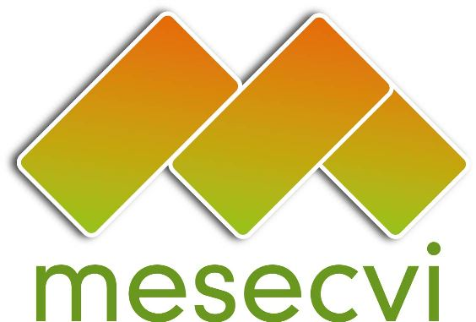
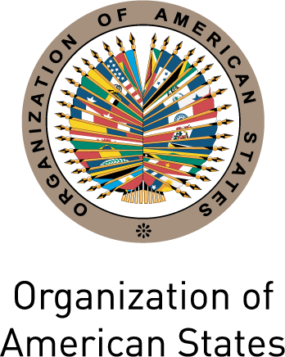

FOLLOW-UP MECHANISM TO THE OAS/Ser.L/II.7.10
BELEM DO PARA CONVENTION (MESECVI) MESECVI-VI/doc.116/15.rev1
SIXTH CONFERENCE OF STATES PARTY October 2nd, 2015
October 15th and 16TH, 2015 Original: Spanish
Lima, Peru

CALENDAR OF ACTIVITIES

(Draft)

Date: October 15th and 16th, 2015
Location: Hotel Sheraton - Av. Paseo de la República 170, Cercado de Lima - Independencia Room (Lima, Peru)

Thursday, October 15th:

8:30 Registration of participants

Meeting Room:

9:00-09:30 Adoption of the Draft Agenda and Calendar of Activities of the Sixth Conference of States Party (Item 1 of the Agenda)

9:30 – 10:00 Election of the officers of the Conference: President, First and Second Vice President and Rapporteur (Item 2 of the Agenda)

Plenary Room:

10:00 – 11:30 Opening Session: Tenth Anniversary of the MESECVI

Intervention by the President of Peru, Ollanta Humala

- President of the CEP
- Alejandra Mora Mora, President of the CIM, Minister for the Status of the Women, Costa Rica
- President of the CEVI
- Carmen Moreno Toscano, Executive Secretary, Inter-American Commission of Women, CIM/OEA

11:30 – 12:00 Break/ Official photograph

12:00 – 17:30 DIALOGUE BETWEEN COMPETENT NATIONAL AUTHORITIES AND THE COMMITTEE OF EXPERTS OF THE MESECVI (Item 3 of the Agenda) about:

12:00 – 13:30 Panel 1: International responses to violence against women

Keynote Speech: Silvia Pimentel, Member of the United Nations Committee on the Elimination of Discrimination against Women (CEDAW)

- Bridget O’Loughlin, Executive Secretary of GREVIO / Committee of States Party to the Istanbul Convention
- Andrew Morrison, Head of the Gender and Diversity Division (GDI), Inter-American Development Bank (IDB)
- Luiza Carvalho, Regional Director of UN Women for the Americas and the Caribbean, UN Women (TBC)
- Pamela Villalobos, Senior Social Affairs Officer, Division for Gender Affairs, ECLAC

Moderator: Ana María Mendieta, Vice-Minister for Women and Vulnerable Populations, National Competent Authority, Peru.

Dialogue/Questions and answers session

13:30 – 14:30 Lunch

14:30 – 16:00 Panel 2: Latin-America and the Caribbean: Building Bridges for the implementation of the Convention of Belém do Pará

- Eleonora Menicucci, Minister of the Special Secretariat of Policies for Women, Competent National Authority, Brazil
- Miselle O’Brien, Expert of the CEVI, Saint Kitts and Nevis
- Susana Chiarotti, Expert of the CEVI, Argentina
- Francine Foster, Expert of the CEVI, Grenada
- María del Carmen Alanís, Expert of the CEVI, Mexico
- DEMUS representative

Moderator: President of the CEVI

Dialogue/Questions and answers session

16:00 – 17:30 Panel 3: A regional view of structural violence against women

- Strereotypes and access to justice
Diana González Perrett, Expert of the CEVI, Uruguay
- Social and institutional tolerance of violence against women
Martha Ordóñez Vera, National Competent Authority, Presidential Advisor for Gender Equity, Colombia
- Femicide/Feminicide
Ana Maria Mendieta, Vice Minister of Women and Vulnerable Populations and Competent National Authority of Peru

Moderator: Ana María Baiardi, National Competent Authority, Minister of Women, Paraguay

Dialogue/Questions and answers session

17:30 – 18:00 Political Violence and Harassment against women (Item 4 of the Agenda)
- Presentation: Alejandra Mora Mora, National Competent Authority, President of the CIM, Minister for the Status of the Women, Costa Rica
- Consideration and Adoption of the Declaration on Political Violence and/or Harassment against women

18:00 Cultural evening

Friday, October 16th:

09:00 – 14:00 First Plenary Session

09:00 – 10:00 Advances and challenges with regard to the implementation of the Agreements of the Fifth Conference of States Party and the First Extraordinary Conference of States Party (Item 5 of the Agenda)

- Report of the outgoing President on adopted measures and achieved progress

- Report of activities of the Technical Secretariat of the MESECVI

Questions and answers session

10:00 – 12:45 Dialogue between Competent National Authorities. Exchange of experiences and strengthening the MESECVI (Item 6 of the Agenda)

Debate

13:00 – 14:00 Lunch

14:00-17:00 Second Plenary Session

14:00-15:00 Continuation of the debate

15:00 – 15:15 Definition of the date and offer to host the Seventh Conference of State Parties (Item 7 of the Agenda)

15:15 – 16:00 Consideration and Adoption of the Agreements of the Sixth Conference of State Parties of the MESECVI (Item 8 of the Agenda)

16:00 – 16:30 Other matters (Item 9 of the Agenda)

16:30 – 17:00 Rapporteur’s Report of the Conference (Item 10 of the Agenda)

17:00 – 17:30 Closing remarks

- Words of thanks by Carmen Moreno, Executive Secretary of CIM/OAS
- Closing remarks by Marcela Patricia María Huaita Alegre, Vice Minister of Women and Vulnerable Populations

17:30 – 18:30 Closing reception hosted by the Inter-American Development Bank (IDB)
input.doc

