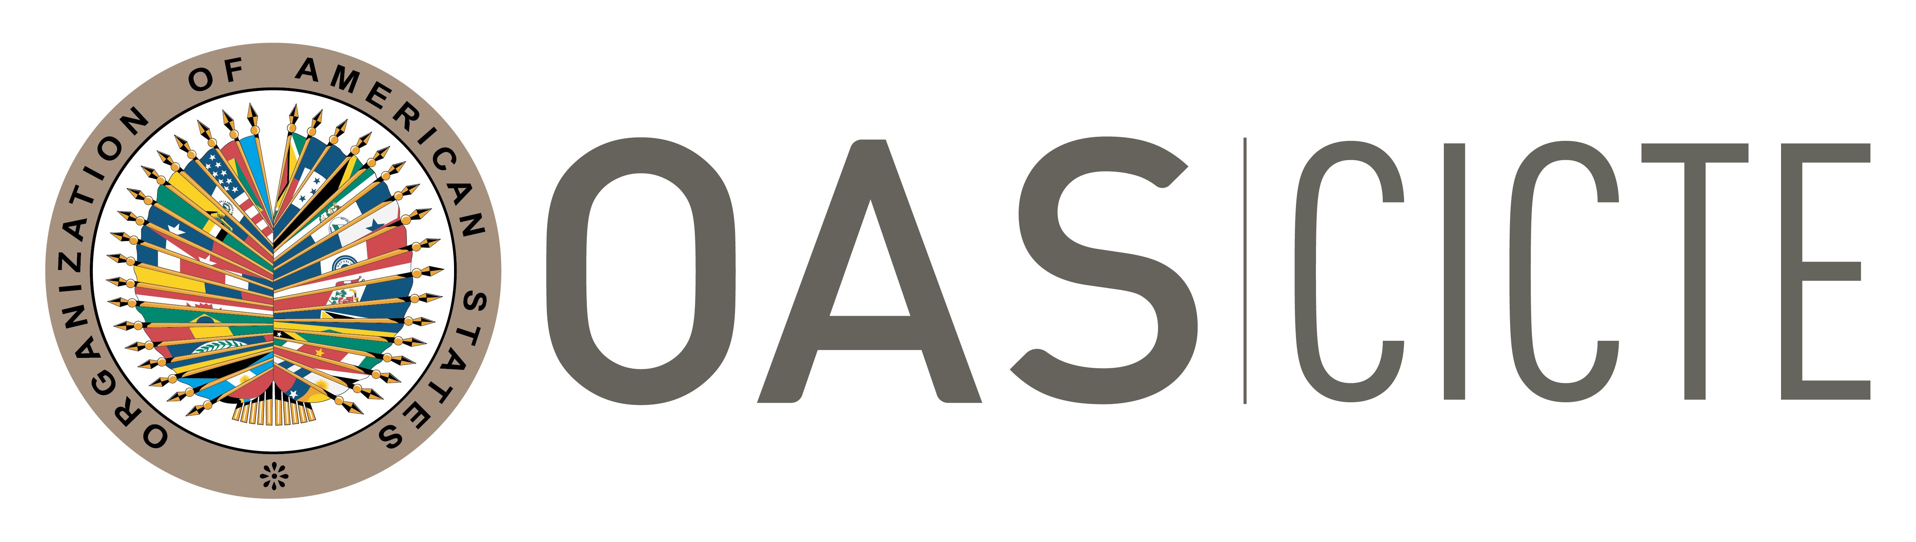
INTER-AMERICAN COMMITTEE AGAINST TERRORISM (CICTE)

EIGHTEENTH REGULAR SESSION OEA/Ser.L/X.2.18
May 3 and 4, 2018 CICTE/RES. 2/18
Washington, D.C., United States 4 May 2018
Original: Spanish

RESOLUTION

DATE AND PLACE OF THE NINETEENTH REGULAR SESSION
OF THE INTER-AMERICAN COMMITTEE AGAINST TERRORISM
input.doc
(Approved at the fourth plenary session held on May 4, 2018)

THE INTER-AMERICAN COMMITTEE AGAINST TERRORISM,

BEARING IN MIND:

That Article 18 of its Statute stipulates that “the headquarters of CICTE shall be that of the General Secretariat of the Organization of American States”;

That Article 19 of said Statute stipulates also that “the Inter-American Committee against Terrorism (CICTE) shall hold one regular session each year”;

That Article 20 of said Statute further stipulates that “[a]ny member state of the Organization may invite CICTE to meet in its territory” and that CICTE “shall decide whether to accept invitations to meet away from headquarters”; and

That Article 16 of its Rules of Procedure provides that CICTE “shall hold one annual regular session”;

RESOLVES:

To convene the nineteenth regular session of CICTE at OAS headquarters in Washington, D.C., on May 2 and 3, 2019; and two one-day preparatory meetings to be held at OAS headquarters on February 28, 2019 and April 11, 2019, as well as a meeting to be held in the second semester of 2018, either onsite or virtual, to promote the exchange of information between national points of contact and the CICTE Secretariat, discuss advances in the implementation of the CICTE Work Plan, and learn about new threats and the needs of the countries in this area.

